Elvis Presley - still "the King"
Although he died almost half a century ago, Elvis Presley, the "King of Rock 'n' Roll" , is still a hero for millions all over the world and Graceland, his home in Memphis, is a major tourist attraction
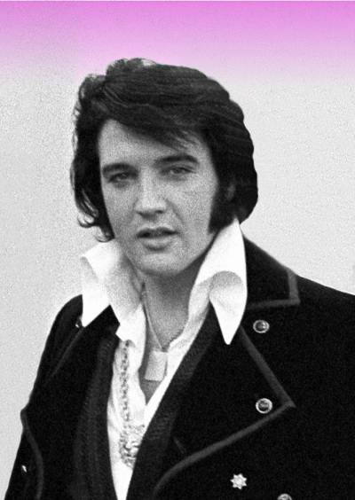Elvis towards the end of his life
It's hot and sticky in the summer in Memphis, Tennessee. The sea is hundreds of miles away from this city on the Mississippi river, yet that doesn't stop the tourists from coming. Some come just once, others make the trip regularly. These are the real fans, those for whom rock 'n' roll has only one voice, that of "the King" himself: Elvis Presley.
Memphis is the city where Elvis lived for most of his professional life; and though he died in 1977, Memphis has not forgotten him. On the contrary, America's most famous rocker (the only one to have had his picture on a set of U.S. postage stamps!) has become the city's most famous son — and seems to get more and more important as the years go by.
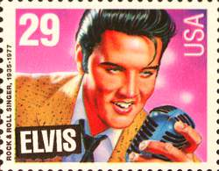
Beside Highway 51, just south of the city is Graceland; this is the house which Elvis bought after he became a star, and which he kept till the day he died. Today it belongs to his daughter Lisa Marie, but is run as an Elvis Presley museum: it is the second most visited house in the U.S.A., after the White House. The people who work at Graceland seem to be some of Elvis's biggest fans. They live and breathe Elvis! In the café, there is day-long Elvis on the music system; and as visitors are taken round Graceland, their guides talk about Elvis as if he were more than the King — more like the God of rock 'n' roll.
"Is it true Elvis died of drugs?" asks a non-believer in the crowd of visitors being shown round the house.
Most of the other visitors look at her angrily or in astonishment, as if she has said something terrible.
"Oh no," says the tour guide. For a moment her permanent cheek-to-cheek smile changes into a frown of discontent. "Oh no, that's just a story, made up to discredit him. You know, Elvis had plenty of friends, but he sure had some enemies too. They made up a whole bunch of stories about him. There's no way Elvis took drugs. You know, he was even a federal agent. You'll see his card downstairs."
Then the guide's 180° smile springs back, and she changes the subject, plunging into eulogies about the wonderful style with which Elvis decorated his house.
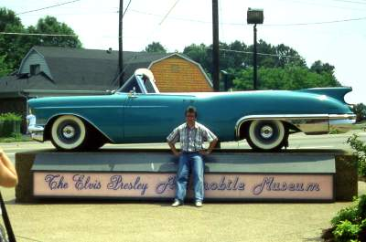Elvis loved Cadillacs, and his Automobile Museum at Graceland is a popular attraction
For a poor boy brought up in a two-room shack in rural Mississippi, it probably was fairly good style. Elvis's tastes were brash, rather like those of many other ordinary unsophisticated folk. He liked the good things in life: girls, guitars and Cadillacs — and he sang about them regularly. That was one of the reasons why he became such a star.
The other reason was, of course, that Elvis really was a good artist, and he really did change the face of American popular music. Before Elvis, the only real rock 'n' roll singers were black, and their style was not quite the same as that of Elvis. Elvis was the first white rocker, and thus — in an age where black music, except jazz, was not widely appreciated outside the black community — he opened up a whole new branch of American popular music.
As a young rocker, he was America's biggest star, and this reputation followed him into middle age. His energy and his looks, however, did not. By the time he was forty, Elvis was a sick man, dependent on drugs. The thin athletic youth had become a fat prematurely-aged man. It was not surprising, really, that he did not survive beyond the age of 42.
As for his reputation, that is a different story. Elvis may have died in 1977; his influence, and his reputation, are still very much alive today.


WORD GUIDE
run: managed, operated - astonishment: great surprise - frown: scowl, angry look - discredit: give a bad reputation to - bunch (slang): crowd - plunge: jump - eulogy: flattering words - shack: hut, very small house - brash: unrefined, uncultured - folk: people - prematurely-aged : old before he should be

Student Worksheet

Elvis Presley - still "the King"
Imagine that you have just met a young lady called Tiffany who works as a guide at Graceland. Referring to the article, imagine how she would answer your questions. (All answers must have at least five words.)
YOU: Where is Graceland, exactly?
TIFFANY:
YOU: And does Elvis still live there?
TIFFANY:
YOU: How did Elvis die?
TIFFANY:
YOU: Do you get a lot of visitors at Graceland, then?
TIFFANY:
YOU: I've heard that Elvis had rather poor taste. Is that true?
TIFFANY:
YOU: What sort of things did Elvis like, then?
TIFFANY:
YOU: Why do people say he was such an important figure in the history of rock?
TIFFANY:
YOU: And do you, personally, like Elvis's music?
TIFFANY:

