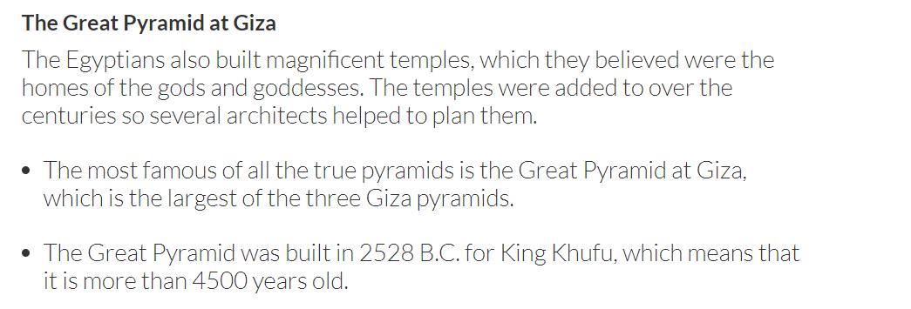
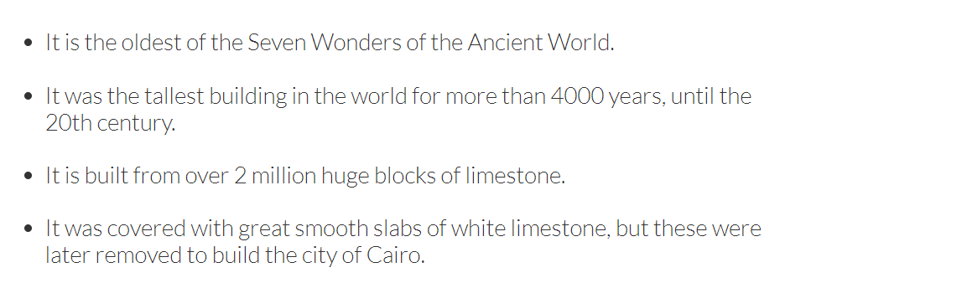
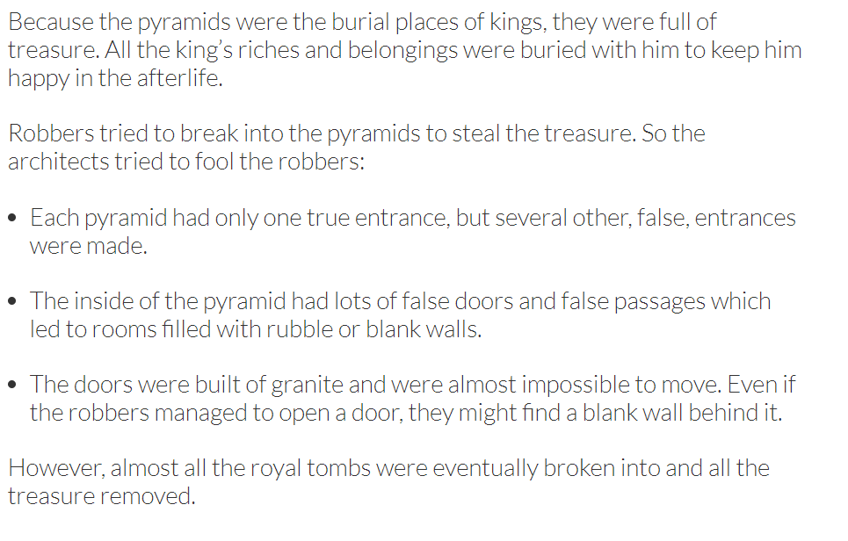
Text taken from: https://www.historyforkids.net/ancient-egyptian-architecture.html

