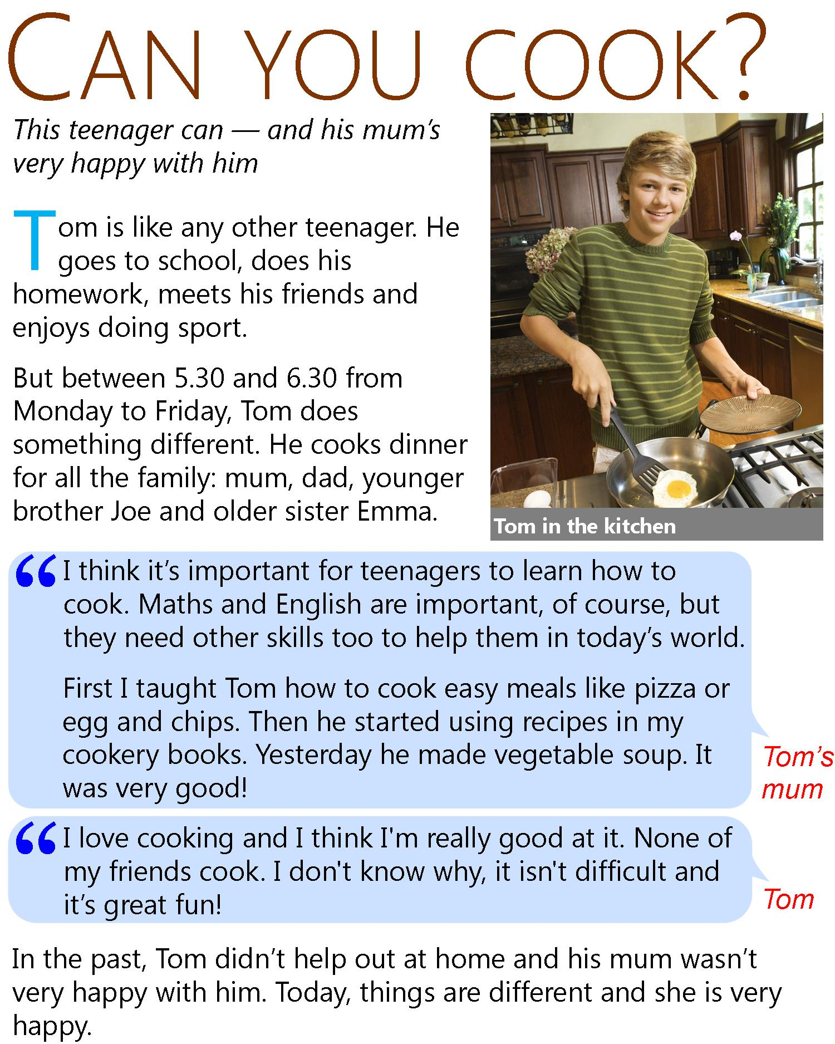
READ THE TEXT AND DO THE FOLLOWING EXERCISES
- TRUE OR FALSE
- Tom's mum was happier when he didn't cook. TRUE FALSE
- Tom's mum thinks learning to cook is good for teenagers. TRUE FALSE
- Tom learned some recipes from his grandmother. TRUE FALSE
- Tom's vegetable soup was not good. TRUE FALSE
- Tom says he is a good cook. TRUE FALSE
- Tom's friends like cooking now too. TRUE FALSE
- MULTIPLE CHOICE
- Today things are different and SHE is very happy. A. Tom’s sister B. Tom’s mum
- Maths and English are important of course but THEY need other skills too to help THEM in today’s world. A. maths and English b. teenagers
- Yesterday he made vegetable soup. IT was very good! A. tom b. the soup
- He started using recipes in MY cookery books. A. tom’s mum’s b. tom’s
- I love cooking and I think I'm really good at IT. A. cooking b. being a teenager

