LESSON 5
ACTIVITY 1

Grammar A1-A2: Question forms: 1
Complete the questions.
- you
- did
- Where
- Does
- Is
- Can
- Did
- do

1. ….. your friend a scientist? – No, he's an artist.

2. …… Núria live in Valencia? – No, she lives in Barcelona.

3. When ……..you get home? – I got home yesterday.

4. What time ……you get up? – I get up at 6.00.

5. ……………the children go to the park? – Yes, they went there after school.

6. Are ……..going to the office? – No, I'm going home.

7……………….you speak Korean? – Just a little.

8. ………. did you grow up? – I grew up in Addis Ababa.
ACTIVITY 2

Actions
Match the words and pictures.
- type
- eat
- write
- touch
- smile
- read
- sleep
- speak
- listen
- draw
- cry
- look

Toggle Audio

Toggle Audio

Toggle Audio

Toggle Audio

Toggle Audio

Toggle Audio

Toggle Audio

Toggle Audio

Toggle Audio

Toggle Audio

Toggle Audio

Toggle Audio

ACTIVITY 3
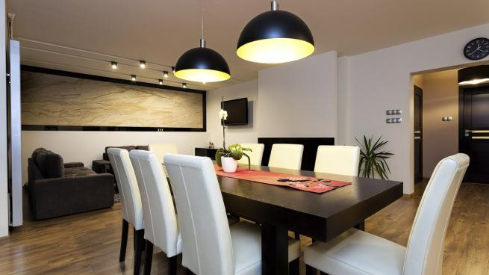
Beautiful two-bedroom city flat five minutes' walk from the cathedral. Fully equipped kitchen, living room with a large sofa and chairs, big TV and balcony. The balcony has space for four people to sit and gets the sun in the mornings, and the flat is light and warm. It has Wi-Fi and fast internet. The upstairs bedroom sleeps four people, with two double beds; the downstairs bedroom sleeps two in single beds. The flat is perfect for families and is near shops, bars and restaurants.
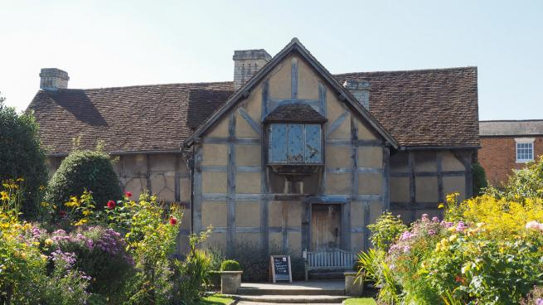

Farmhouse
Four-bedroom farmhouse in the countryside. All of the four double bedrooms are en suite with luxury shower and bath. Farm kitchen with barbecue, tables and chairs outside. Great for groups of friends. The supermarket is half an hour by car and you can take a train from the village into the city. Escape from normal life for a few days as we have … NO INTERNET and you can only use mobile phones at the bottom of the garden!

Reading A1: Holiday home adverts – 2
Put the words and phrases in the correct group.
- Near the shops
- Has internet
- You can sit outside
- In the city
- Has four bedrooms
- Far from the shops
- For eight people
The flat:
The farmhouse:
Both places:

ACTIVITY 4
Which place would you choose for a holiday? Why?

