FAMILY
STEP 1
Look at the painting below and do the activities that follow
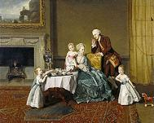
John, Fourteenth Lord Willoughby de Broke, and his Family, Johann Zoffany, 1766

ACTIVITY A
Answer the questions
• Who are the parents? How do you know?
• How big are the children in relation to the parents?
• What is the family wearing?
• What does your family wear?
ACTIVITY B
Read the information about the painter and answer the question
Johann Zoffany was known for painting informal group portraits. The people in the painting look like they're in the middle of doing something together.
• What does your family like to do together in your home?

STEP 2
Read the text describing a family and do the exercises
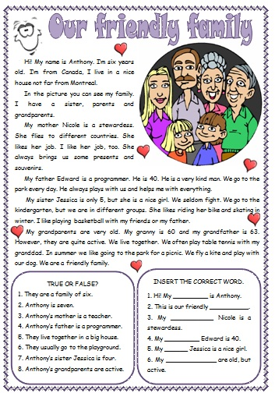
STEP 3
Use this link https://www.youtube.com/watch?v=lDZA54Bi8sg to watch a video about a family
Now, write:
Members of family:………………………………….
Age:…………………………………………………..
Job:…………………………………………………….
Interests:…………………………………………………
Step 4
Writing
Write about your family or write a story about a family (80-100 words)

