9-11-2020
Exercise A
Συμπληρώστε τα κενά με τις παρακάτω λέξεις
Model, mobile phone, discount, queue, faulty, guarantee, brand name, gadgets, refund

- You have to wait in the …………………..to pay.
- Mobile phones and tablets are my favourite …………………..
- You need a ……………………….to chat with your friends.
- If the product is ……………………it means that it is not working.
- When you ask for your money back, you ask for a ………………….
- What’s the …………………..of your mobile phone?
- My laptop has a ………………….for 2 years.
- My phone is old. I need to buy a newer …………………….
- When you buy two products, you get a ……………………….
Exercise B
Βρείτε τα gadgets στην φωτογραφία
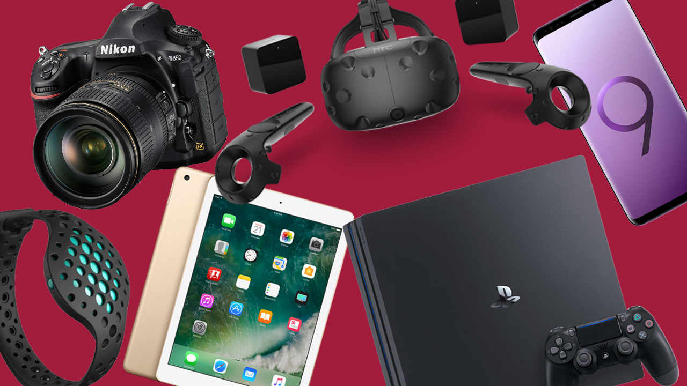
- …………………………..
- …………………………
- ……………………………
- …………………………..
- …………………………….

GRAMMAR
Την παρακάτω θεωρία της Γραμματικής θα την χρειαστείτε για το επόμενο μάθημα
