MODAL VERBS
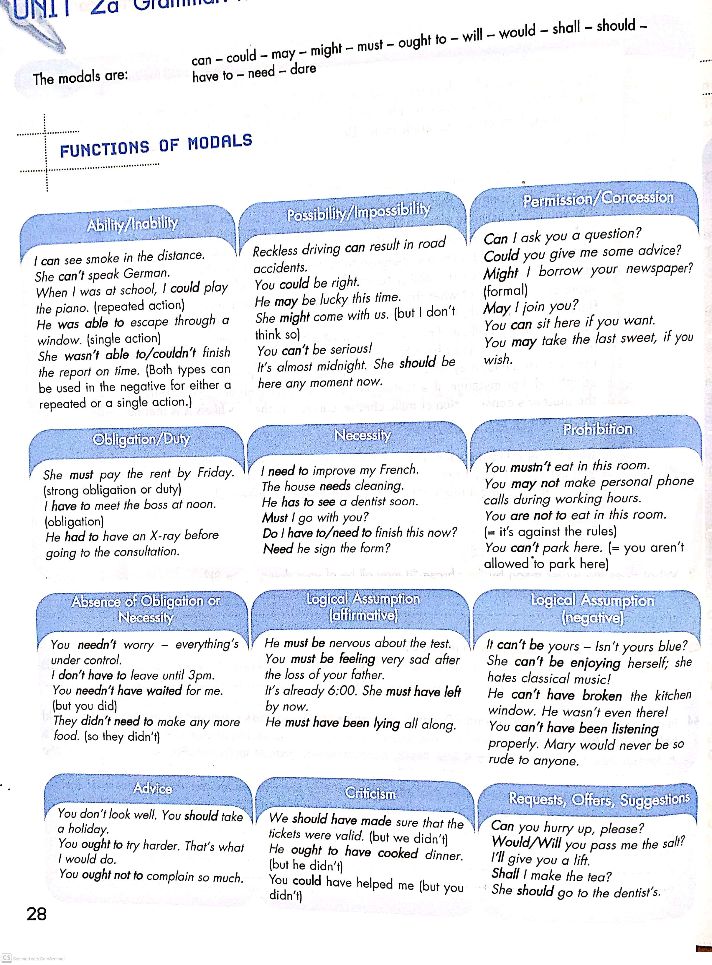

EXERCISE 1:Fill in the blanks with the correct form of can, be able to, must or have to.
- Students…….pass an entrance examination in order to be accepted by this college.
- Our father told us that we…………..be home by 10 pm.
- Despite his lack of experience he……………….get the job.
- You………………….get a visa to travel to the USA.
- You……………be careful with electricity.
- Brian……………buy his new car as he’d been given a bonus at work.
- If you want to be a member of the club, you………register with the secretary.
- I gave up French as I………………..get down to studying.
- She was so short she………………….reach the door handle.
- We………………go yet. It’s not that late.

EXERCISE 2: Rewrite the following sentences using the words in capitals as in the example.
- It’s possible that Eve forgot about the meeting. MAY
Eve may have forgotten about the meeting.
- Would you like me to help you? CAN

- Give this message to Mrs Bates, please! WILL

- I don’t believe the president made such a contradictory statement. CAN’T

- Is it possible to pay in installments? COULD

- Do you want to have a look at my article before I hand it in? WOULD

- Aunt May cooked chicken soup for us, even though we told her we were eating out. NEED

- He didn’t make sure he had a spare tyre and he got a puncture miles from anywhere. SHOULD

- It is extremely dangerous to strike a match at a petrol station. MUST

- It’s a good idea to get a dental check-up every six months. OUGHT

- Is there any possibility of the flight being cancelled? LIKELY

- Is it possible to pay by credit card? MAY

- There’s a possibility Paul will come to the party this evening. MIGHT

- It is necessary for governments to take action against tax evasion. MUST

- Sue didn’t leave home in time and now she is running late for work. SHOULD

- I believe business is now experiencing a severe recession. MUST

- I don’t believe Harry spent the whole evening studying for the French exam. CAN’T

- Is it really necessary for me to make the presentation tomorrow? HAVE

- It is doubtful whether he will be appointed Minister of Health. MIGHT

- It is not advisable to make personal phone calls at work. OUGHT

- It was wrong of you to rely on Michael’s support. SHOULD

- Perhaps she was behaving so arrogantly because of her insecurity. MAY

- Is it a good idea to apply for the junior accountant’s post? SHOULD

- It wasn’t very polite of you not to notify them about the change of plans. COULD

May (=perhaps)
Must (=I think/suppose, I strongly believe)
Can’t (= I don’t think, I don’t suppose)

Simple present  Perhaps he works as a teacher. | Present infinitive  He may work as a teacher.
Present continuous  I suppose he is working hard. | Present continuous infinitive  He must be working hard.
Simple future  I don’t think he will win. | Present infinitive  He can’t win.
Future continuous  Perhaps they will be playing tennis. | Present continuous infinitive  They may be playing tennis
Simple past  I don’t think he worked very hard. | Perfect infinitive  He can’t have worked very hard.
Past continuous  I don’t believe she was working last week. | Perfect continuous infinitive  She can’t have been working last week.
Present perfect simple  Perhaps he has left work. | Perfect infinitive  He may have left work.
Present perfect continuous  I think they have been living here for years. | Perfect continuous infinitive  They must have been living here for years.
Past perfect simple  Perhaps he had forgotten about the appointment. | Perfect infinitive  He may have forgotten about the appointment.
Past perfect continuous  I don’t think he had been studying hard enough. | Perfect continuous infinitive  He can’t have been studying hard enough.

Exercise 3: Read the following situations and write sentences using the modals in the list above.
Example: I don’t think Madonna’s new CD has been released yet.
Madonna’s new CD can’t have been released yet.
- I strongly believe David is not lying this time.

- George is thinking of buying a house this year but he’s not sure whether he will.

- I’m sure Linda is earning a high salary.

- I think Mary was living in Spain at the time.

- Perhaps you will need to hand in a research paper.

- I strongly believe he wasn’t just speculating when he said that prices will rise.

MUSTN’T/NEEDN’T
mustn’t (=it’s forbidden/not allowed) | needn’t (-it’s not necessary)
You mustn’t eat in the library.  You are not allowed to eat in the library.  You may not eat in the library. | You needn’t learn it by heart.  It’s not necessary for you to learn it by heart.  You don’t need to learn it by heart.  You don’t have to learn it by heart.

Exercise 4:Read the following situations and write sentences using mustn’t or needn’t.
Example: You aren’t allowed to use a dictionary during the exam.
You mustn’t use a dictionary during the exam.
- It isn’t necessary for Brian to finish the reports quickly.

- It isn’t necessary for Mary to go to work tomorrow.

- Eating and drinking is prohibited on the Metro.

- It’s not necessary to submit my proposal so early.

DIDN’T NEED TO/NEEDN’T HAVE
Didn’t need to shows that it wasn’t necessary for something to happen and it didn’t happen.

Needn’t have shows that it wasn’t necessary for something to happen but it did happen.
He didn’t need to go to work on Sunday.  She needn’t have bought so many eggs. | It wasn’t necessary for him to go to work on Sunday so he didn’t.  It wasn’t necessary for her to buy as many eggs as she did.
Exercise 5: Read the following situations and write sentences using didn’t need to or needn’t have.
Example: It wasn’t necessary for Andrew to take so much money for his holiday because everything was less expensive than he expected.
Andrew needn’t have taken so much money on holiday with him.
- It wasn’t necessary for Mrs Smith to cook an evening meal for her family last night as they went out to dinner.

- It wasn’t necessary for Mr Jones to collect his wife from the airport yesterday as his son volunteered to pick her up.

- It wasn’t necessary for Jane to stay up all night. The exam she was studying for was cancelled.

