WORKSHEET 2
UNIT6, LEADERS BORN OR MADE, BOOK 2
16. You volunteer for the local town council. The head of community affairs is trying to find ways to improve deprived neighbourhoods in your town. He/She has asked you to write a proposal suggesting how this can be achieved. Write what kind of improvements could be implemented in each area and outline the benefits for the residents in it. Write a proposal (130-180 words) and submit it to the town council.
Write your proposal on the common goggle doc:
https://docs.google.com/document/d/1bM3VQ9SdTiVd2SBDh644Jew-BqYL0hXrhR7TQwn7UsY/edit?usp=sharing
and after you receive feedback post it on the following padlet: https://padlet.com/thanospapadopoulos2020/h76l2g6f65d52olq
Understanding the topic
1. What is the purpose of your proposal?
To suggest ways to improve deprived neighbourhoods
2. Who is the proposal submitted by?
A volunteer for the local town council.
3. Who is the target reader?
The head of the community affairs, and eventually, the local town council.
4. What register will you use?
Formal
5. How many paragraphs should you write?
5 paragraphs (Introduction, Stating the problems, Presenting solutions, Mentioning expected outcomes, Conclusion)
6. What information should you include?
Concrete information with specific examples and clear suggestions

Proposal report paragraph plan:
Beginning:
To:
From:
Subject:
Date:

Introducton (prg 1):
State the purpose and content of the proposal
(The purpose/aim/intention of this report is to discuss/present…)

Main body (prg 2-4):
State problems in separate paragraphs together with suggestions/solutions, expected outcomes/impact
(first, first of all, secondly, moreover, in addition, also additionally, apart from that..,
one way of solving the problem…, a good idea would be to…,measures should be taken…,the situation could be improved by…,
therefore, as a result, in this case, this means that, consequently, in this way)
Conclusion (prg 5):
Summarise your suggestions
(In conclusion, To conclude,…)

Further Practice:
• You are eager to perform community service in order to help homeless people. Write a proposal (130-180 words) to the town council suggesting ways to help deal with the problem referring to the expected outcomes.
Write your proposal on the common goggle doc:
https://docs.google.com/document/d/1bM3VQ9SdTiVd2SBDh644Jew-BqYL0hXrhR7TQwn7UsY/edit?usp=sharing
and after you receive feedback post it on the following padlet: https://padlet.com/thanospapadopoulos2020/h76l2g6f65d52olq

USEFUL RESOURCES:
https://www.coalitionforthehomeless.org/about-cfh/
https://www.treehugger.com/ways-you-can-help-the-homeless-4868830

Some ideas:
- Build shelters for homeless people
- Engage doctors and psychologists
- Make an appeal for volunteers
- Create lists for donations (money, clothes, furniture etc.)
- Organize a homelessness prevention programme
- Hire homeless people to work for the community

• The schools in your area are organizing an annual conference event about “Citizenship: a gateway to an inclusive society”. Write a speech to be delivered during the conference in order to persuade your classmates to get actively involved in the community.
Write your speech on the common goggle doc:
https://docs.google.com/document/d/1bM3VQ9SdTiVd2SBDh644Jew-BqYL0hXrhR7TQwn7UsY/edit?usp=sharing
and after you receive feedback post it on the following padlet: https://padlet.com/thanospapadopoulos2020/h76l2g6f65d52olq
USEFUL RESOURCES:
https://www.wordreference.com/engr/citizenship
https://www.schooleducationgateway.eu/en/pub/theme_pages/citizenship.htm
https://www.researchgate.net/publication/301559628_Citizenship_Education_Inclusion_and_Belonging_in_Europe_Rhetoric_and_Reality_in_England_and_Norway
Some ideas:
- Any form of segregation is morally unacceptable
- Any of us could become a member of a minority group at some point
- Any form of exclusion is arbitrary and artificial, it is not based on nature
- People should not suffer because of their skin colour, gender, religion, beliefs
SPEECH EXAMPLE:
RUBRIC (ΕΚΦΩΝΗΣΗ):
Imagine you are representative of Coalition for the Homeless and you are encouraging teens to sign up to participate in a fundraising event. Give a presentation at a school assembly about the organization, its aim and the event.
Good afternoon everybody. My name is Peter Jones and I’m a representative of Coalition for the Homeless. Picture this: a teenager arrives for his first day of school. However, he doesn’t have a bag to put his books in. He doesn’t even have a pencil to write with. His clothes are torn and faded and he looks hungry. This teen is just one of the many homeless people in our city and he needs our help.
Coalition for the homeless helps people who don’t have a house to live in. The truth is that many people living in shelters or on the street have a university education and once had a well-paid job and a comfortable life. But poverty brought them to this terrible situation. Someone who loses their job can quickly and easily find themselves without a residence. The goal of Coalition for the homeless is to provide food, clothing and blankets to meet their immediate needs. In addition, we provide training courses so people can learn the skills they need to find new jobs and get themselves out of poverty.
The event I would like to talk to you about today is called ‘Project: Back to School’. Many people without homes have families, and these children need to go to school to get an education. Obviously, their parents can’t afford to buy them school supplies. That’s where you come in! We are having a fundraising event to collect money for the school supplies that these children will need to start the school year. ‘Project: Back to School’ begins today and will continue throughout the month of September, so don’t forget to participate in the progarmme and donate what you can to help those in need!
Through Coalition for the Homeless and ‘Project: Back to School’, you can do your part to help end homelessness. After aa, doesn’t everyone deserve a chance to have a home to call their own?
Now, I would like to hear from you. What do you think of ‘Project: Back to School? Do you think it is a good way to help homeless kids?...
Are there any questions?... Thank you for your attention.
TIPS ON PREPARING A PRESENTATION (SPEECH):

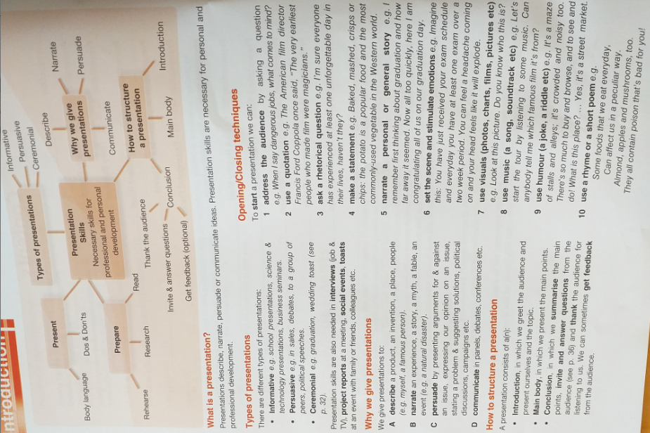
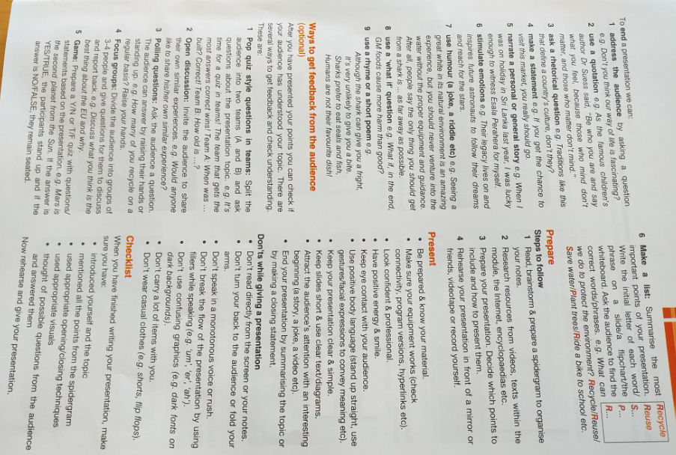

Body language is very important when you give a presentation It is part of communication and helps you maintain your audience’s attention and interest.
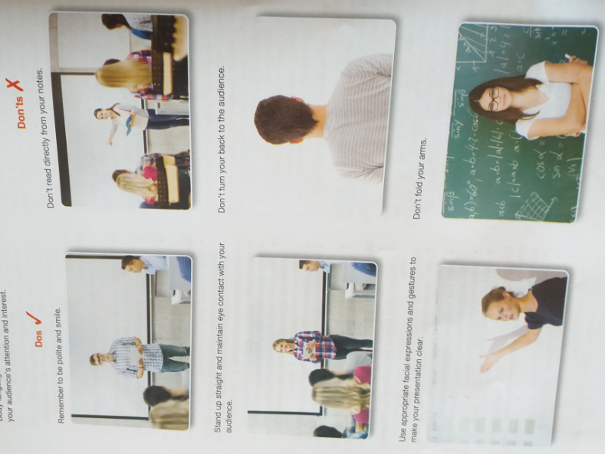
Using presentation software: To engage your audience’s attention, you can use presentation software, like PowerPoint. This way you can support and highlight your message, and make your whole presentation more interesting



