WORKSHEET

READING COMPREHENSION-GRAMMAR PRACTICE

Lionel Messi’s routine (5-7 minutes)

Exercise1: Put the following verbs in Present Simple Tense
Lionel Messi is a world wide famous football player. He is thirty-three years old. He ……………………. (live) in Paris, France, but he is from Rosario, Argentina. Antonella Rocuzzo is his wife, and they ………………………. (have/ got) three children. He ……………… (get/ up) at five o’clock and …………………. (have) breakfast with his family. He ……………………….. (not/ have) a shower in the morning. Later, his children …………………… (go) to school and Messi ……………………. (go) to football training. Then he …………………….. (have) lunch. His children ……………………….. (not/ play) after school. They …………… (do) their homework. Thiago ……………… (play) football and Maten and Cirio ………………. (play) video games in the afternoon. Messi and his family ……………. (have) dinner at half past nine. His favourite dessert is rice pudding with dulce de leche. They ……………………… (not/ watch) TV. They …………….. (eat) and …………………. (talk). They ………………. (go)to bed at eleven o’clock.

Exercise 2: Choose the correct answer (Multiple choice)
1) How old is Messi?
a) forty b) thirty-five c) forty-two.

2) Where does he live?
a) Barcelona b) Argentina c) Paris.

3) What time do they have dinner?
a) half past nine b) 8 o’clock c) 9 o’clock.
4) Where is Messi from?
a) Portugal b) Argentina c) Spain.

5) What time does he get up in the morning?
a) half past seven b) five o’clock c) eight o’clock.

6) How many children do Messi and Antonella have?
a) three b) four c) two.
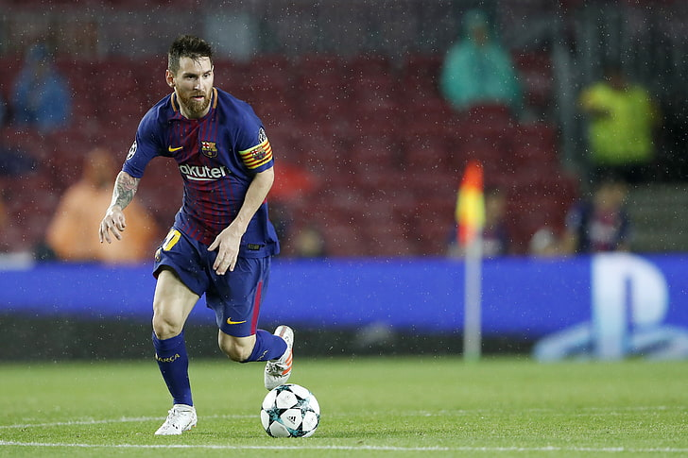

GOOD LUCK KIDS!!!

