3rd grade revision – A term

Exercise 1
Write the following words in small letters:
- GARDEN: ________________
- QUEEN: ________________
- BEAR: ________________
- OCTOPUS: ________________
- HARE: ________________

Exercise 2
Draw lines and match the picture with the right word:
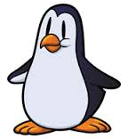 | 2.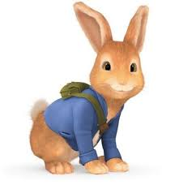 | 3.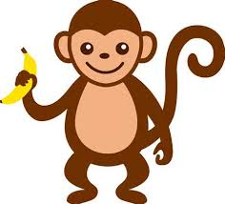 | 4.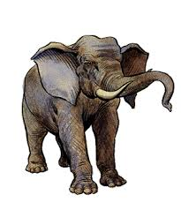 | 5.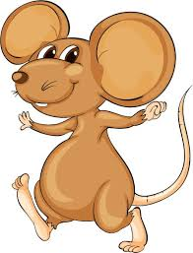
elephant | monkey | mouse | penguin | rabbit

Exercise 3
Use the article a or an before the following words:
- ____ orange
- ____ nest
- ____ telephone
- ____ ant
- ____ Indian

Exercise 4
Write the missing letter:

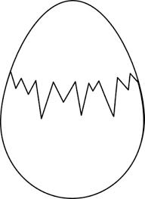 | 2.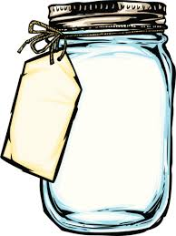 | 3. | 4.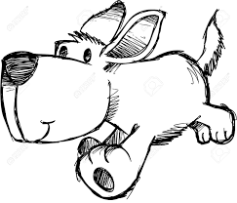 | 5.
__ gg | ___ ar | ___ gloo | ___ og | __ mbrella

Exercise 5
Find and circle the words. Then write them down. The pictures will help you.

Indiancatfishkitetiger


 
 

