We describe a bedroom (Περιγράφουμε ένα υπνοδωμάτιο)
Look at the picture and read the text.
Παρατηρώ την εικόνα και διαβάζω το κείμενο.
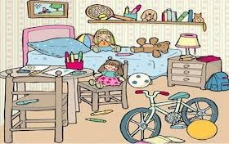

This is a picture of a messy but fun bedroom.
There is a bed in the room. There is a light blue blanket on the bed. There is a large, brown teddy bear on the bed, next to a doll with long hair. There is also a colorful ball and a small toy on the bed.
There is a shelf above the bed. There are many interesting things on the shelf. For example, there is a tennis racket and there are some pencils in a cup. There is a small picture above the shelf on the wall.

There is a small table and a chair next to the bed, on the left. There is some paper and a crayon on the table. There are also some crayons in a pink cup on the table. A doll is sitting on the chair.
There is a small chest of drawers on the right side of the bed. There is a lamp on the drawers. There is a blue backpack next to the chest of drawers, on the floor.
There is a white and blue bicycle in front of the bed. There is a yellow ball and some colorful pencils on the floor, all around the room.

