D’ CLASS – SEASONS
SPRING 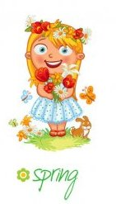
In Spring, in March, April and May, the world comes alive and insects start to play. Birds start to sing and flowers start to bloom. And, don’t forget, we ride our bikes, too.
SUMMER 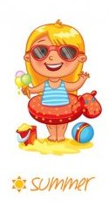
In June, July and August, Summer is here. No school after June, so we all go to the beach. We swim in the sea and have picnics in the parks. We play all day long and have lots of fun.

AUTUMN / FALL 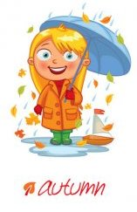
In September, October and November, it is Autumn, we have to remember. Every day we go to school, we learn lots of things and see our friends, too. In the Fall, the leaves turn orange, red and yellow, and they fall from the trees to prepare for December.
WINTER 
When December comes around, snow starts falling and school stops for a while. In January and February, it is cold and rainy, but Spring is near, so let’s get ready.

By Marianthe Hassapis

