

A Midsummer Night’s Dream

What’s the word?
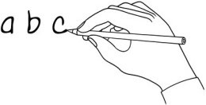
Write the word under the pictures.

love | forest | follow | fairy | flower | eyes
wake up | play | head | donkey | spell | dream

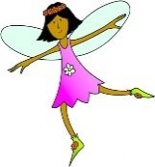 |  | 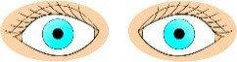 | 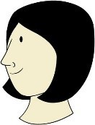 | 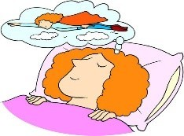 | 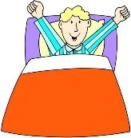
 | love
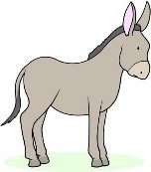 | 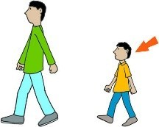 | 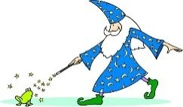 | 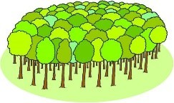 | 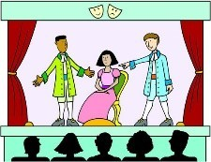 | 

Match them up!
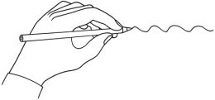
Watch the story. Draw a line to match the character and their name.

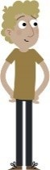1 | 2. | 3.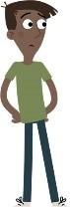 | 4.
5.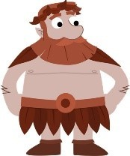 | 6.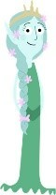 | 7.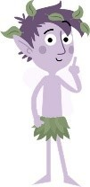 | 8.

a.Puck | b.Demetrius | c.Helena | d.Titania
e.Hermia | f.Bottom | g.Oberon | h.Lysander
www.britishcouncil.org/learnenglishkids
© British Council, 2017 The United Kingdom’s international organisation for educational opportunities and cultural relations. We are registered in England as a charity.

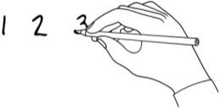
What’s the order?
Watch the story and put the sentences in order.

Oberon puts the magic juice on Demetrius, so now Lysander and Demetrius love Helena. Puck puts the magic juice on Lysander, then Lysander falls in love with Helena.
1

At first, Demetrius loves Hermia, Hermia loves Lysander and Helena loves Demetrius.

The next morning, Demetrius and Helena are in love and Lysander and Hermia are in love. Puck and Oberon take the magic spells away from Lysander, Bottom and Titania.
Hermia and Lysander run away and Demetrius and Helena follow them.

Puck changes Bottom’s head into a donkey’s head, then Titania falls in love with him. Oberon puts magic juice on Titania’s eyes so she’ll fall in love with the first thing she sees.

True or false? 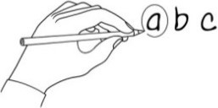
Watch the story. Circle true or false for these sentences.

- Demetrius loves Hermia but Hermia loves Lysander.  - Hermia, Lysander, Demetrius and Helena go to the mountains. | true  true | false  false
c. Oberon wants to play a trick on Puck. | true | false
d. The juice from the magic flower makes you love the first thing you see. | true | false
e. Puck thinks Lysander is Demetrius. | true | false
f. Helena is the first thing Lysander sees. | true | false
g. Oberon is the first thing Titania sees. | true | false
h. Lysander and Demetrius want to fight because they both love Helena. | true | false
i. Oberon takes the magic spell away from Lysander. | true | false
j. The next morning, everybody remembers what happened. | true | false

www.britishcouncil.org/learnenglishkids
© British Council, 2017 The United Kingdom’s international organisation for educational opportunities and cultural relations. We are registered in England as a charity.

