
Characters

Story

Theseus, the Duke of Athens is engaged to be married with Hippolyta.
Egeus wants his daughter Hermia to marry Demetrius. Hermia does not want to marry him. She loves another man named Lysander. Hermia and Lysander decide to run away. Demetrius follows them. Helena, Hermia's best friend, is in love with Demetrius. She follows him. All four become lost in the woods near Athens.
Meanwhile, Oberon and Titania are having an argument. Oberon decides to teach Titania a lesson. He puts a love potion into her eyes while she is asleep. This potion will make her fall in love with the first thing she sees when she wakes.
Oberon finds Helena and Demetrius. He tells Puck to give Demetrius some of the love potion so that he will love Helena. Puck makes a mistake and puts the potion in Lysander's eyes. When Lysander wakes up, he loves Helena instead of his real sweetheart Hermia!
The workmen are practising a play in the woods for the upcoming marriage of Theseus and Hippolyta. Puck plays a trick on Nick Bottom by giving him donkey ears. The other actors run away, so Bottom goes to sleep. He is sleeping near Titania. She wakes up and falls in love with him.
Oberon realises everything is all mixed up. He gives some of the love potion to Demetrius. Now Demetrius and Lysander both love Helena. Sad and confused, all the lovers fall asleep. At last, Puck rights all the wrongs. He makes Lysander love Hermia again, and makes Demetrius love Helena. Everyone is happy.
The workmen perform their play after the wedding of Theseus and Hippolyta. Oberon has stopped Titania being in love with Bottom. They are happy with each other again. The fairies use their magic to bless all the lovers.

The Court at Athens:  - Theseus, Duke of Athens, engaged to Hippolyta  - Hippolyta, Queen of the Amazons, engaged to Theseus  - Egeus, father of Hermia  The Lovers:  - Hermia, beloved of Lysander and daughter to Egeus  - Lysander, beloved of Hermia  - Helena, in love with Demetrius  - Demetrius | 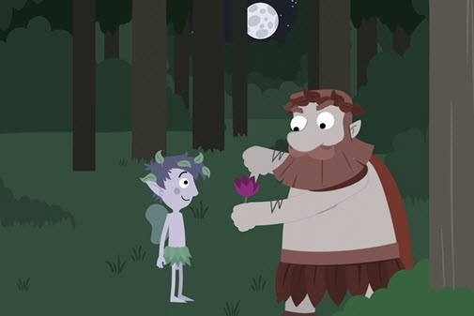  The Fairies:  - Oberon, King of the Fairies  - Titania, Queen of the Fairies  - Puck, Oberon's servant  The amateur group of actors:  - Nick Bottom, a weaver  - Peter Quince, a carpenter

