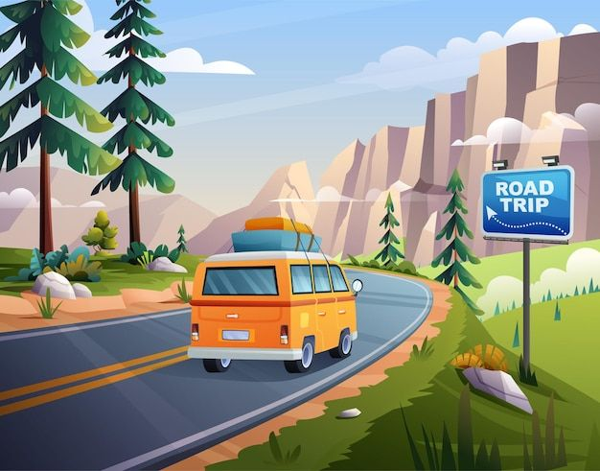


This story is about an adventurous girl and some of her friends Keith, Jane and Elliot. They go on a very questionable adventure…..

Hey, my name is Zoe and last month I went on a fantastic adventure! Let’s not waste our time and get right into it! I woke up at 3 pm in my college dorm with my three roommates and best friends. I yawned as I packed my bag, dressed up, ate breakfast and waited for my friends. They woke up a few minutes later. We were now in Maths lesson and I was so bored. Finally, we had a 15 minute break and I was able to talk to my friends.
“What are you doing this weekend ?“, I asked.
“Nothing much”, Keith replied.
“I’m going on a road trip to Los Angeles” Elliot joined in!
I forgot to mention that we love pretty far away…We’re in New York!
“Cool!! Can we come?” Jane , Keith and I said simultaneously .
“Sure!” Elliot answered.
After a few hours of lessons and breaks , we ended up in our dorm packing our bags for our road trip that would have been in two days. I slept peacefully as I waited impatiently fore the weekend.
The day to start our road trip had come and we all woke up at 9 o’clock ready to leave. We were now in the car and Elliot’s dad was driving. We arrived in Pennsylvania and most of my friends were asleep. Meanwhile, I was playing Pokemon on my Nintendo switch. We stopped at a restaurant nearby, we ate some chicken nuggets and we continued our trip. We stopped again at a gas station where Jane refilled the gas so we could start moving again and so we did! We were getting out of the state now, heading towards Saint Louis.
As we stopped at a parking lot for the night, we all got comfortable and soon we slept. When we woke up, Elliot’s dad was getting snacks from the nearby market. We all got out of the car, stretched and had a conversation.
“Are we still in Saint Louis?” I asked.
“We are almost in Kansas, so probably not!” Jane replied.
“Well, at least, we are getting closer” Keith said.
After an hour in the gas station, we headed to Colorado. We passed through Wyoming, stopping at Rock springs and we arrived at the hotel we’ve booked. It was pretty fancy!
We slept at some comfy beds and we enjoyed the luxury of having nothing to do! The next morning, we ordered some smoothies and sandwiches which were fantastic! We got ready, got back in the car and started our trip once again.
“ How many hours do we have until we arrive in L.A.?” Jane asked
“About six more hours” Keith answered.
Elliot groaned in tiredness, already looking grumpy about going back to the car.
“Six hours?? Ughhh…” Elliot replied.
As we were heading to Utah, something unexpected happened…. Suddenly, a car crashed into us!
“Watch out” I yelled but it was too late. I lost consciousness and I woke up in a hospital bed, having wires all over me. I started panicking when the nurse entered my room.
“Are my friends okay?” I asked in panic.
“They survived the major injuries “the nurse replied. I sighed in relief.
“What about me?”
“Your injuries left you with no survival rate, but you did survive.’’ The nurse said with a “good job” look on her face.
“Seriously?”I asked.
“Yeah it’s a miracle you even survived” the nurse said.
We had to stay in the hospital with my friends and I felt so miserable. This was supposed to be a fun trip…how did we end up in a hospital room?
“You need surgery too”, the nurse said to me snapping me out of my thoughts.
“Oh, okay…” I replied with fear in my eyes. They put me under anesthesia. After I woke up, I couldn’t realize what had happened. I survived….thankfully!
After two weeks we were all safe and healthy except for Elliot’s dad. He was old so it was clear he wouldn’t survive. Elliot sobbed for days, grieving his death. We rented a new car and I started to drive. We stopped in Nevada since Elliot had to call his mum in order to plan the funeral….We ate at a restaurant but Elliot didn’t have an appetite. We were all so worried since he used to be so bubbly all the time.
“Are you ok?” Jane asked.
“I’ fine” Elliot mumbled.
“Are you sure?”
“ I said I am fine!” Elliot growled. He was getting angry, so we let the conversation fall, as we all ate silently our food. Back in the car Keith and Jane talked quietly…
At the funeral, all of Elliot’s family were sobbing loudly. I left early, lying about having to do something. I changed into my pajamas and fed my cat. I started scrolling through social media , lying on the couch. A new adventure was about to begin…..

