Yesterday – “The Beatles”

Listen to this song and complete the lyrics with the past simple of the verbs in the box.
USE- COME- SEEMS- BE- HAVE- SAY

Yesterday,
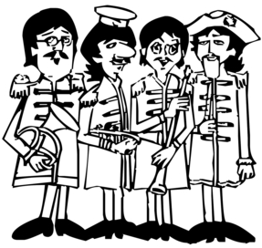
all my troubles ______________ so far away.
Now it looks as though they're here to stay.
Oh, I believe in yesterday.
Suddenly,
I'm not half the man I ______________ to be,
There's a shadow hanging over me,
Oh, yesterday ______________ suddenly.
Why she ______________ to go,
I don't know she wouldn't say.
I ______________ something wrong,
now I long for yesterday.
Yesterday,
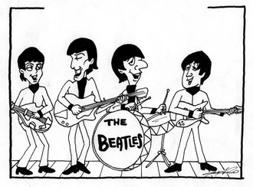
love ______________ such an easy game to play.
Now I need a place to hide away.
Oh, I believe in yesterday.
Why she ______________ to go
I don't know, she wouldn't say.
I ______________ something wrong,
now I long for yesterday.
Yesterday,
love ______________ such an easy game to play,
now I need a place to hide away.
Oh, I believe in yesterday.
Mm mm mm mm mm mm mm.

