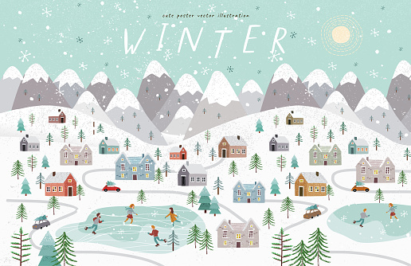 winter
What is the weather like?
Is it cold?
What clothes do we wear in winter?
