Multiple Choice Quiz - "Visit the British Isles". 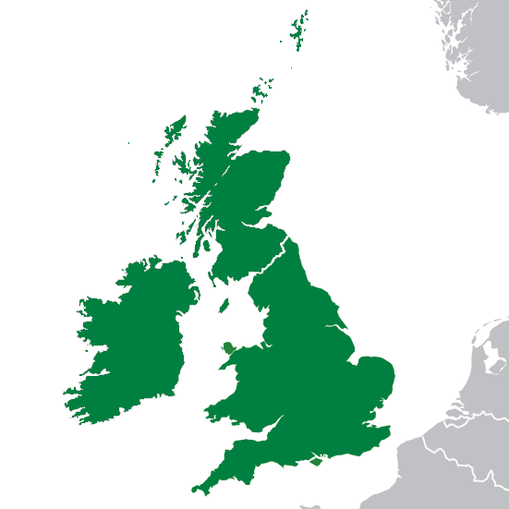
Read the text and choose the correct answer

1. Where are the British Isles located?
A. On the east side of Europe
B. On the west side of Europe
C. In the middle of Europe
D. On the south side of Europe

2. How many main islands make up the British Isles geographically?
A. One
B. Three
C. Two
D. Four

3. What are the names of the two main islands?
A. Great Britain and Ireland
B. England and Scotland
C. Wales and Northern Ireland
D. London and Dublin

4. What is the population of the United Kingdom?
A. About 3.7 million
B. About 10-12 million
C. About 59 million
D. About 100 million

5. Which countries are included in Great Britain?
A. England, Scotland and Northern Ireland
B. England, Wales and Ireland
C. Scotland, Wales and Northern Ireland
D. England, Scotland and Wales

6. What is the capital of the United Kingdom?
A. Dublin
B. Edinburgh
C. Cardiff
D. London

7. How many people live in London?
A. About 3-4 million
B. About 10-12 million
C. About 59 million
D. About 6 million

8. What is the capital of the Republic of Ireland?
A. London
B. Belfast
C. Dublin
D. Cork

9. What is the national flower of Scotland?
A. The rose
B. The thistle
C. The daffodil
D. The shamrock

10. Which country has the shamrock as its national flower?
A. England
B. Wales
C. Scotland
D. The Republic of Ireland

Answer Key
- B
- C
- A
- C
- D
- D
- B
- C
- B
- D

