MAGIC BOOK 2
UNIT 1: KELLY- LESSON 1 (Come and play!)
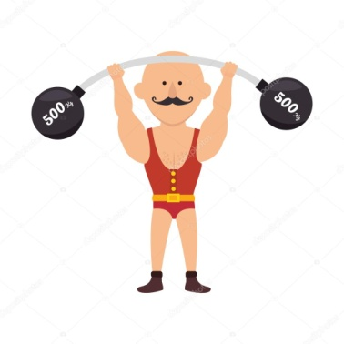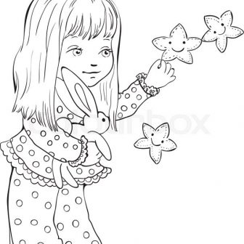
happy=_________ strong=__________ little=___________
girl=___________
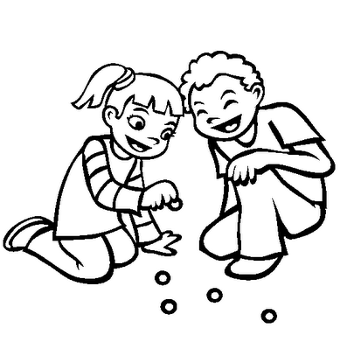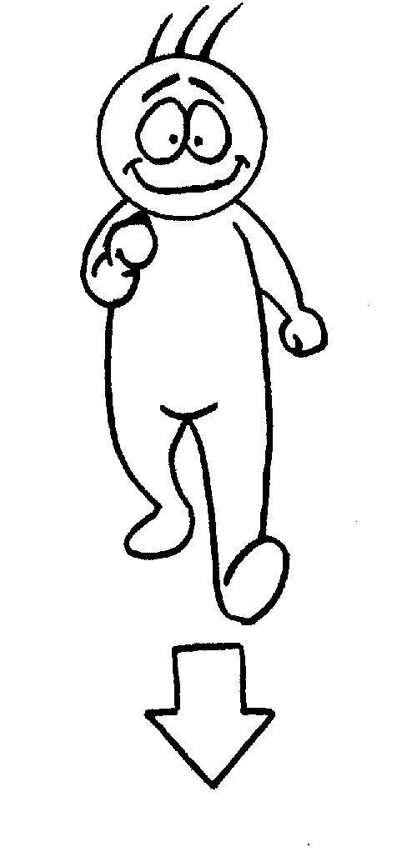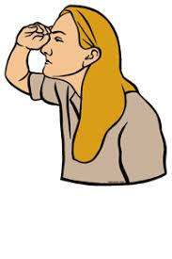
play=___________ come=________ look for=_________
Come on!=______
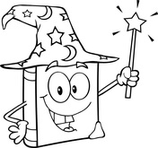
magic=_________
book=-________ things=_____________ all day long=______
Who?=____________
Who’s this?=______________

UNIT 1 – LESSON 2 (A magic key!)
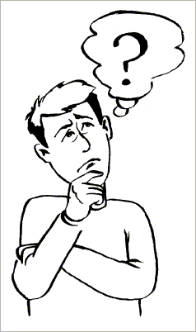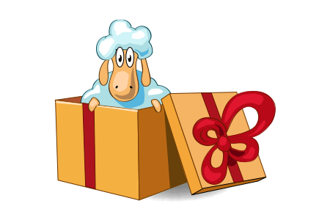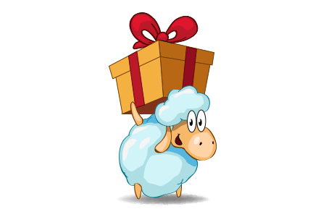
Where?=________ What?=________ in=________ under=_______
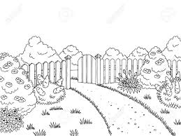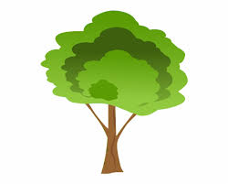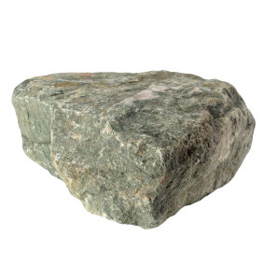
garden=________ tree=_______ grass=________ stone=____
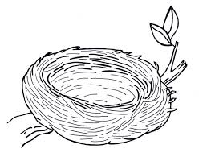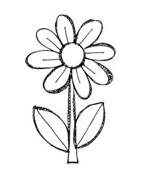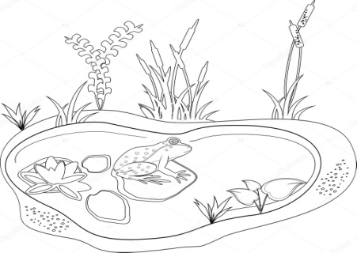
nest=_________ flower=________ pond=__________

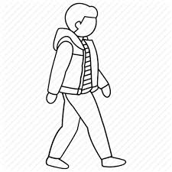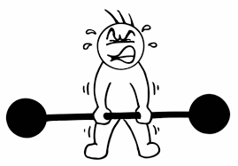
look=__________ walk=_________ try=_______
Let’s try it!=___________

I’m so excited=____________ Great!=______________
In here=_________ of course=___________ Me too!=__________

UNIT 1 – LESSON 3 (We’re pirates!)
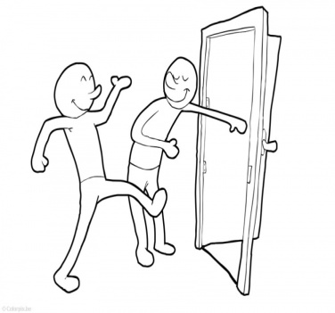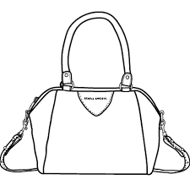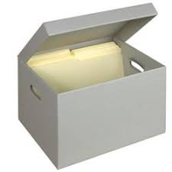
open the door=___________ bag=___________ box=_______
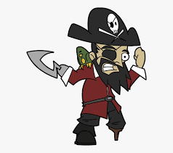
map=_________ pirate=__________ together=_________
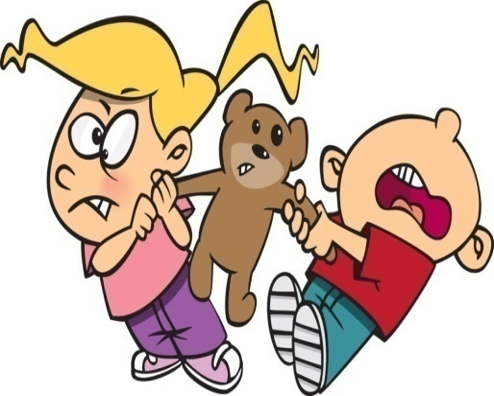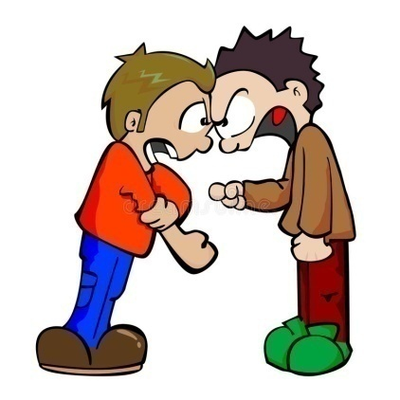
It’s mine!=___________ Friends don’t fight!=______________

Can you….? =______________
Yes, I can! =___________ No, I cant’!=_____________

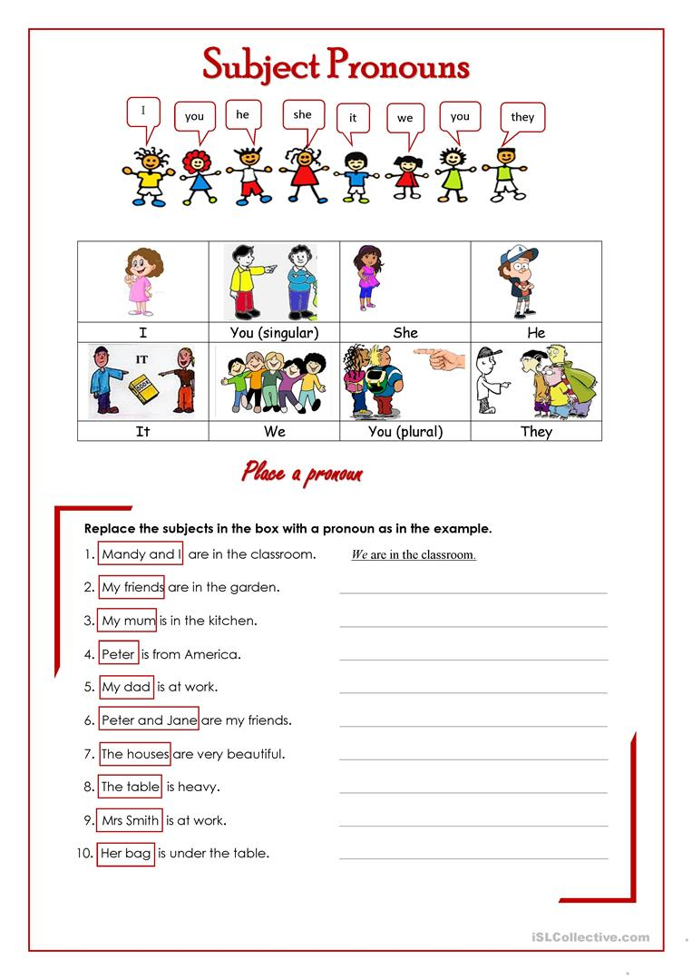
UNIT 2: CAPTAIN COOK- LESSON 1 (The magic map)
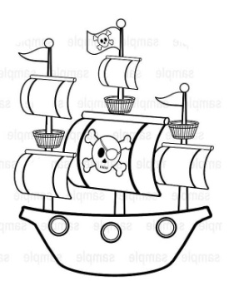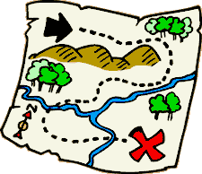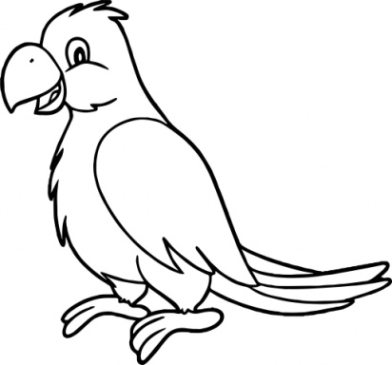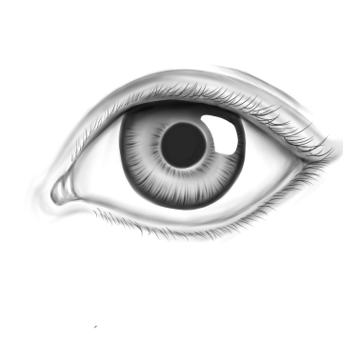
(pirate) ship= treasure hunt= parrot=_________ eye=______
__________ ____________
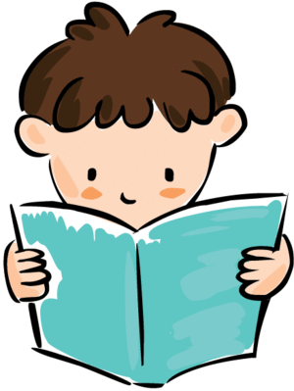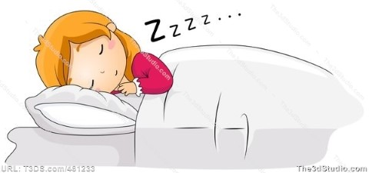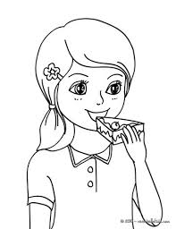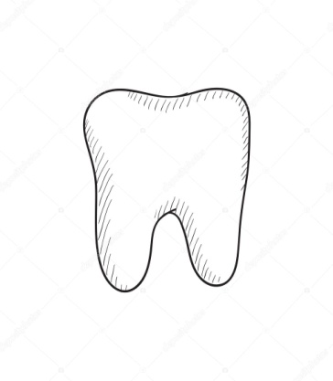
read=________ sleep=__________ eat=_________ tooth=______

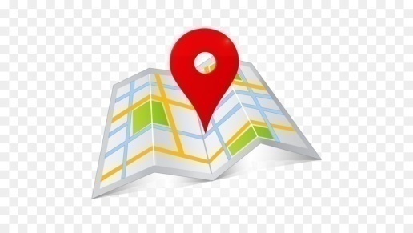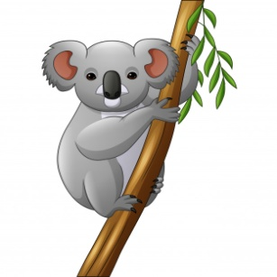
message=_________ find=___________ koala=_______

Can you help me?=________________
Of course!=___________
I want to…… =___________
Where can you find……?=_____________
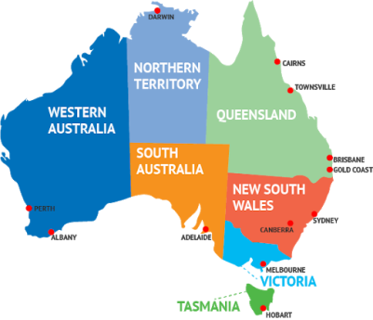 Australia=________

UNIT 2- LESSON 2 (On the big island)
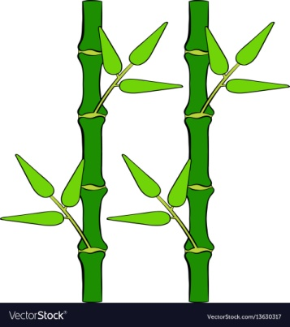
welcome=_______ bamboo=_______ leaf=______
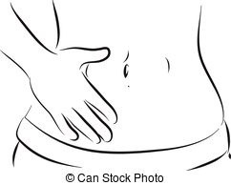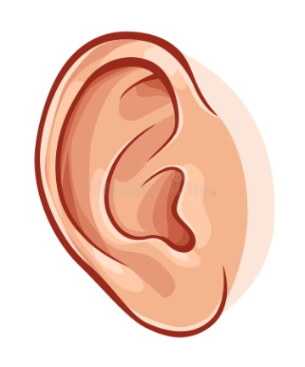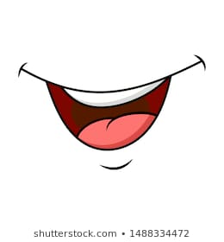
tummy=___________ ear=_________ mouth=_________
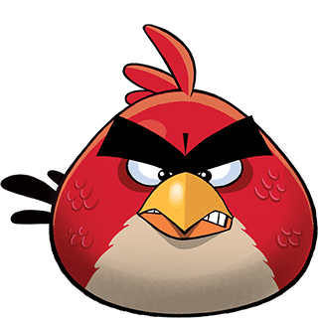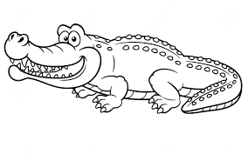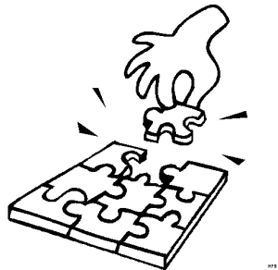
angry=___________ crocodile=_________ puzzle=___________
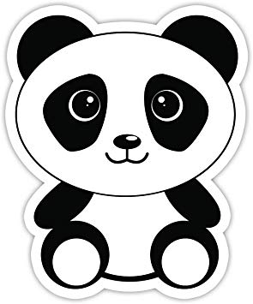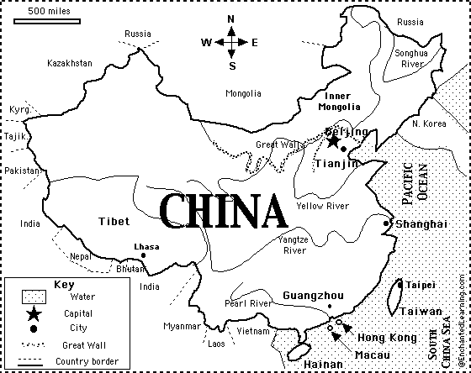
panda=______ Don’t be afraid! =__________ China=_________
afraid=_____________

UNIT 2- LESSON 3 (The dragon’s house)
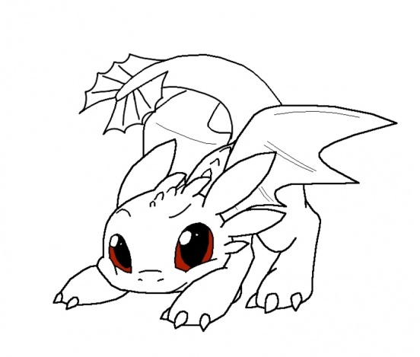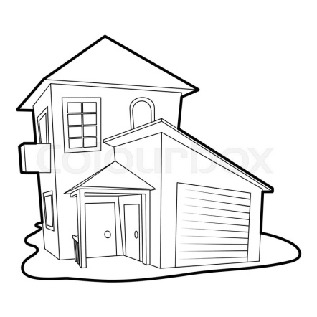
follow=_________ dragon=_________ house=________
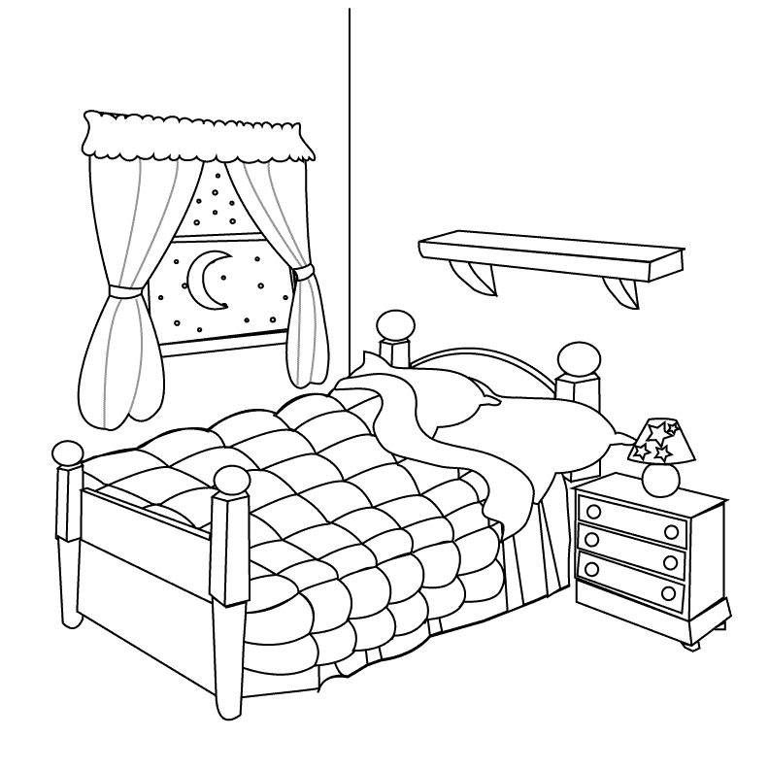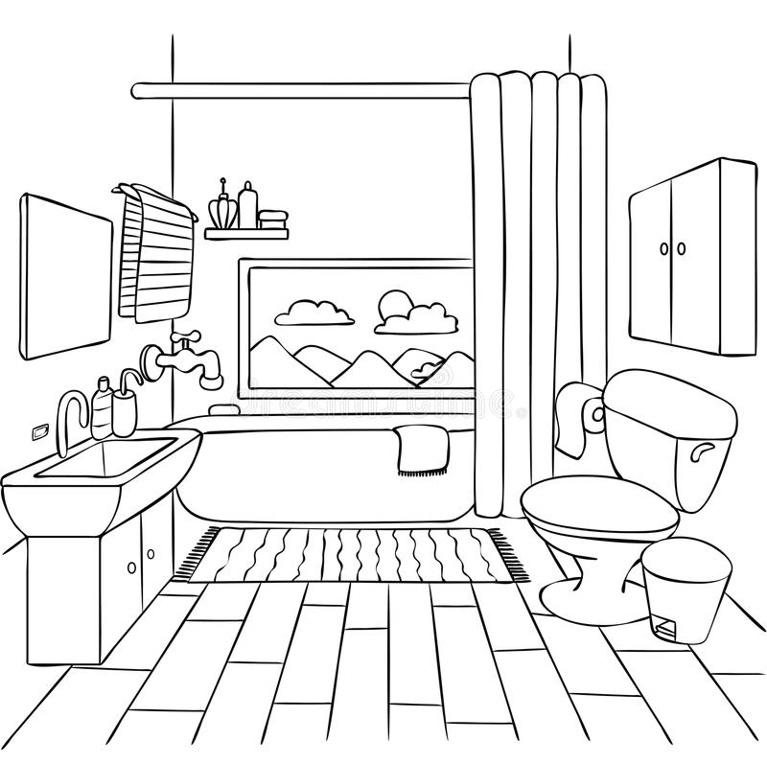
bedroom=__________ bathroom=____________
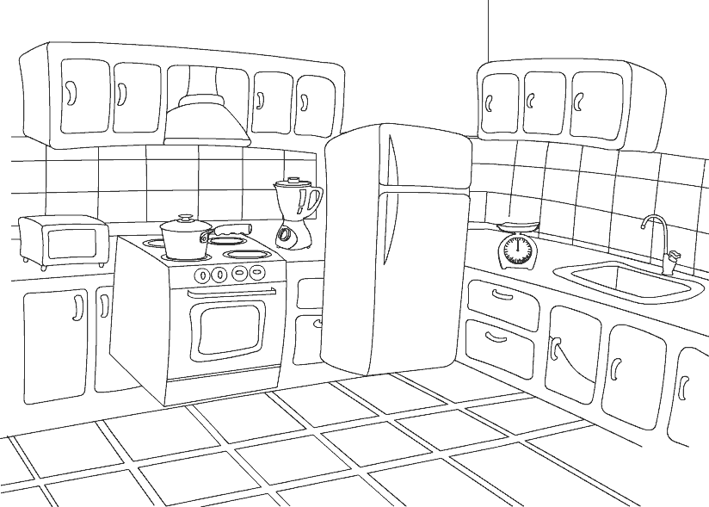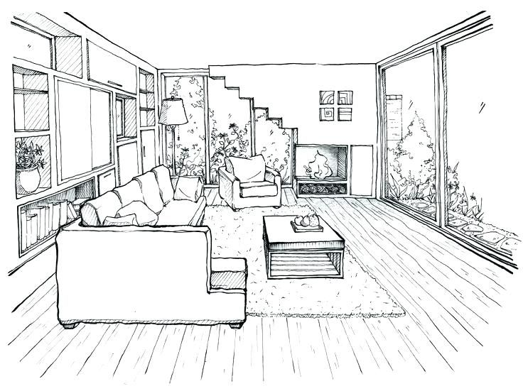
kitchen=____________ living room=____________

Nice to meet you!=_____________

UNIT 3: THE ANT AND THE CRICKET- LESSON 1 (It’s summer!)
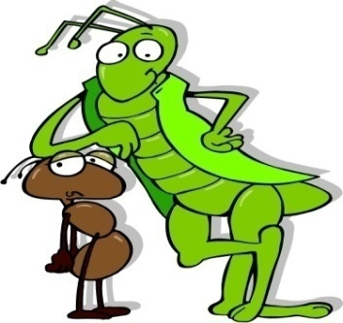
cricket=__________
ant=____________
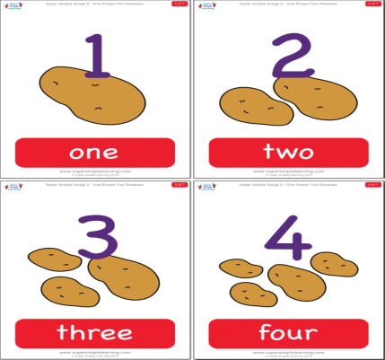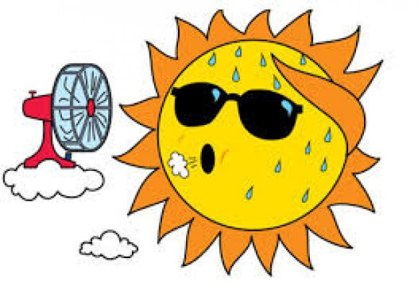
potato= ___________
potatoes= _________
It’s (so) hot=
____________ work=_________

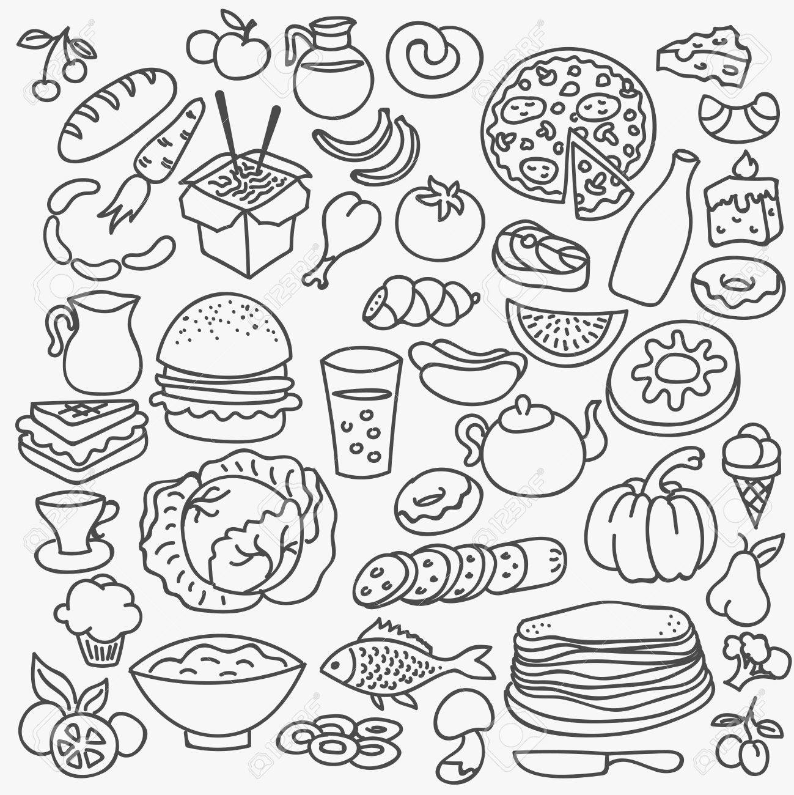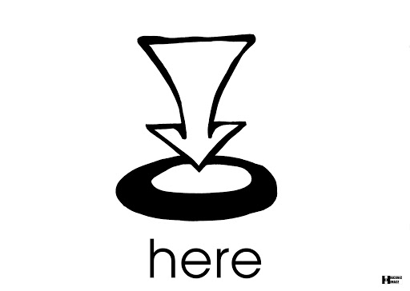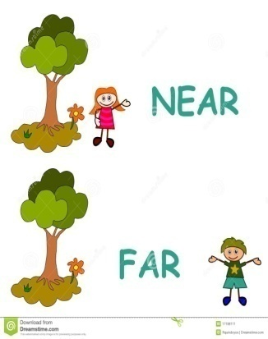
save=_________ food=__________ here=________ near=_______
I’m saving food=__________________
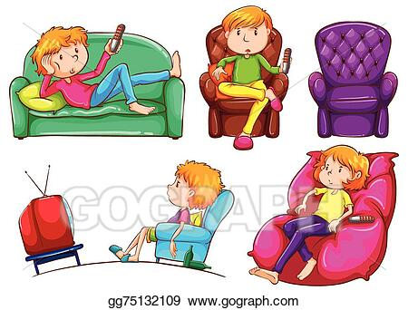
Why?=____________
only=________
today=__________
another day=____________
Don’t be lazy=_________
UNIT 3 – LESSON 2 (Autumn’s here)
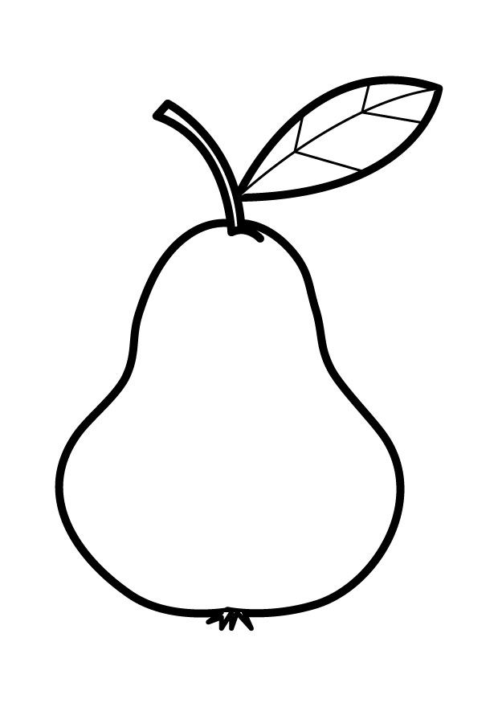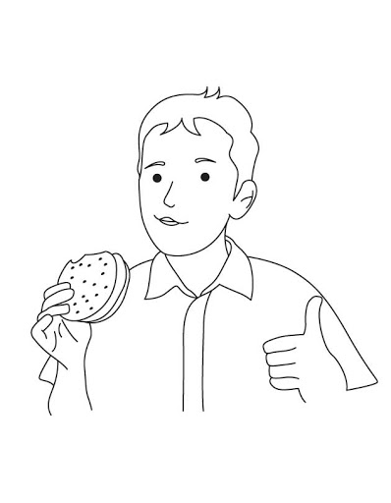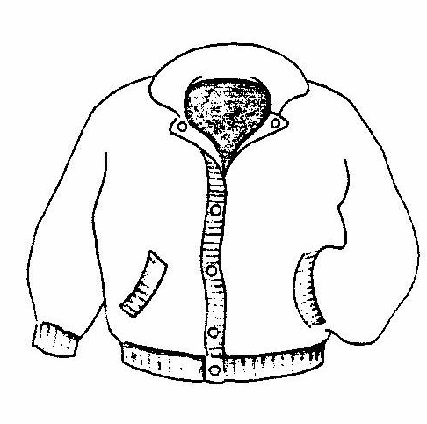
pear=___________ yummy=___________ jacket=__________
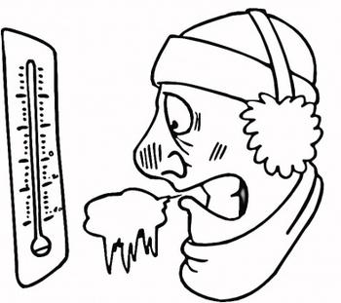
It’s cold=______________
I’m cold=______________
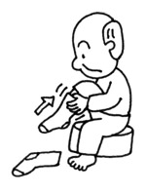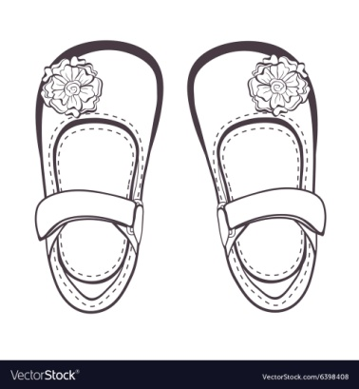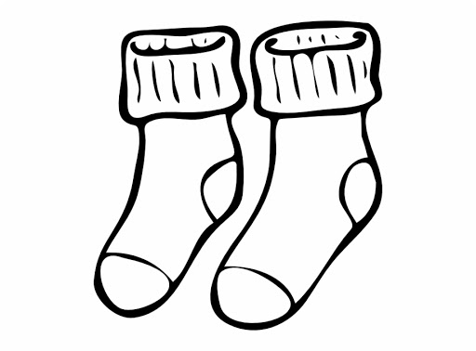
put on=___________ shoes=___________ socks=___________
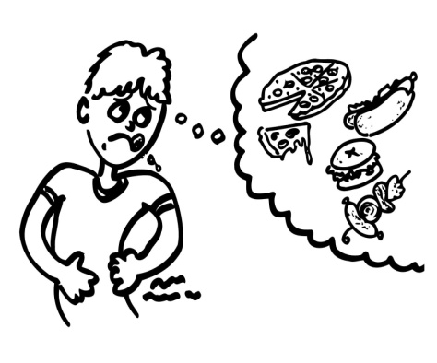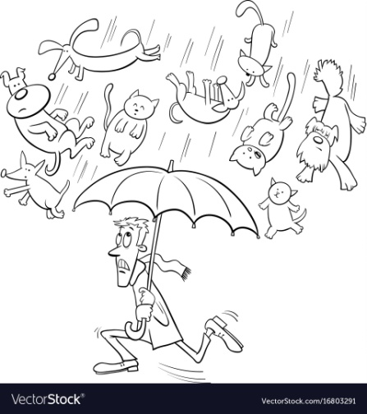
I must…=Εγώ πρέπει να…
(He must wash his hands)
hungry=_______________ It’s raining=__________
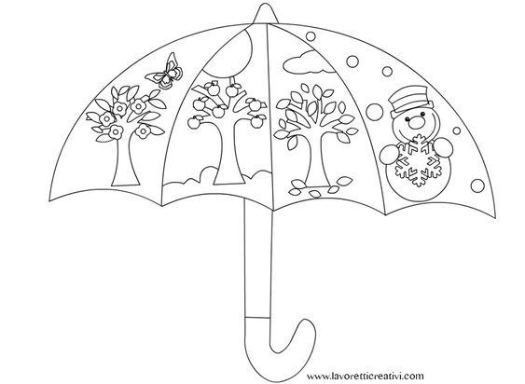
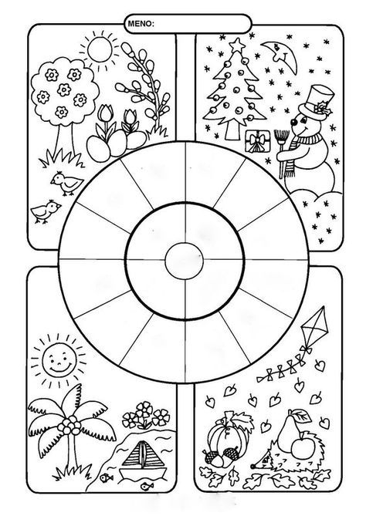

UNIT 3 – LESSON 3 (It’s winter!)
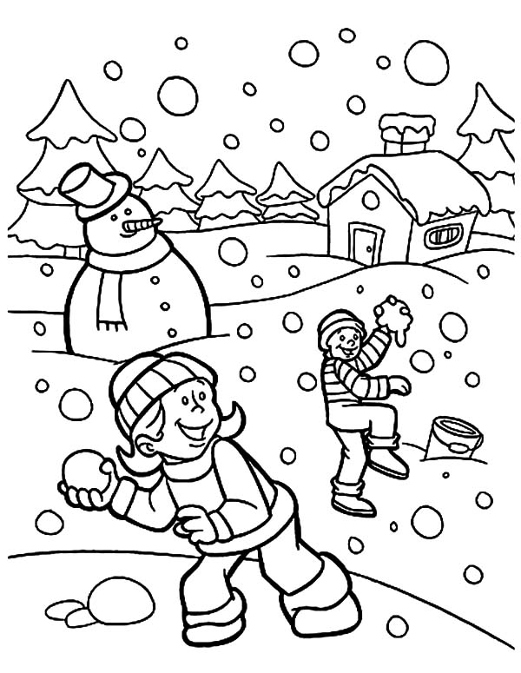
sun=_______

sky=_______
It’s snowing=___________
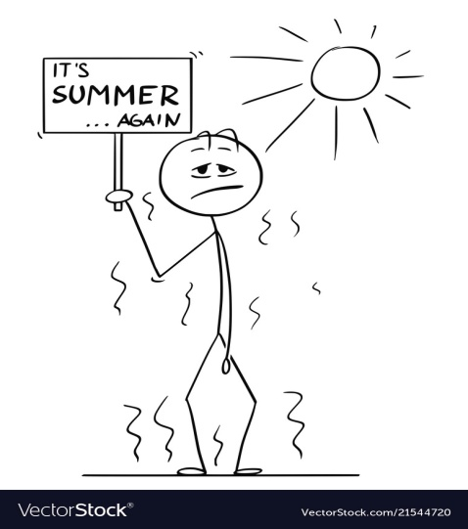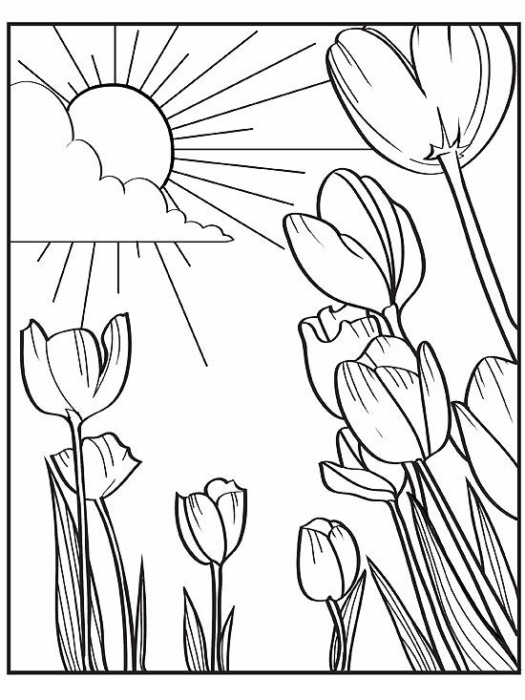
It’s cold=_________ It’s hot=__________ It’s warm=____________
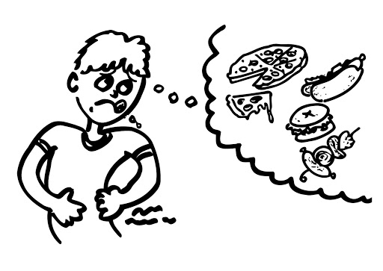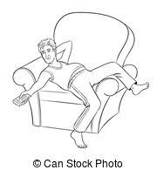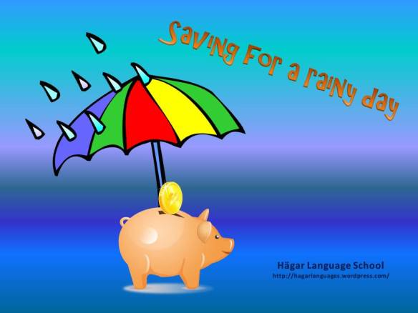
hungry=___________ lazy=_________ save for a rainy day=_____
I’m hungry=__________ ____________________

UNIT 4: THE WEASEL AND THE MOLE- – LESSON 1 (In the cellar)
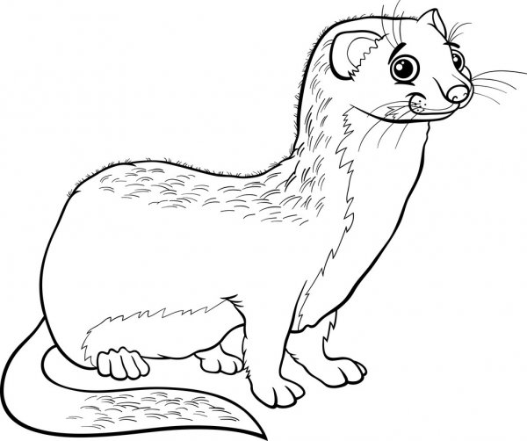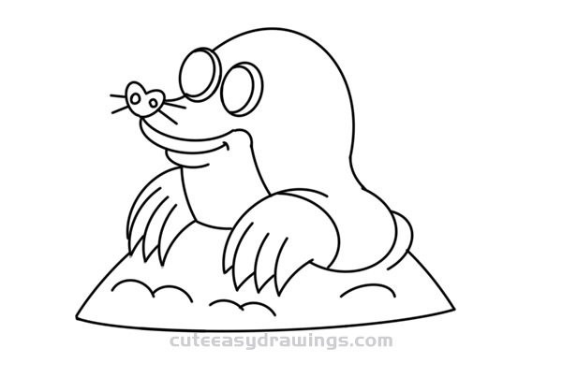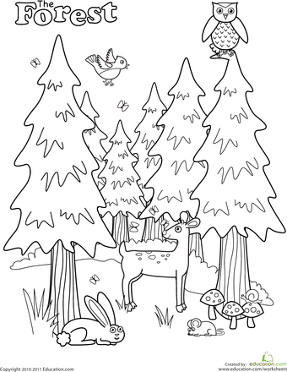
weasel=__________ mole=____________ forest=_____________
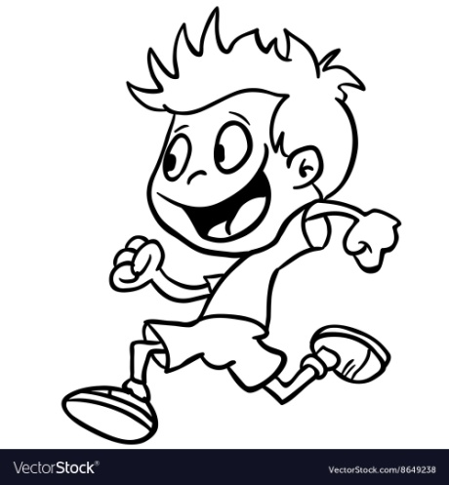 run=________ 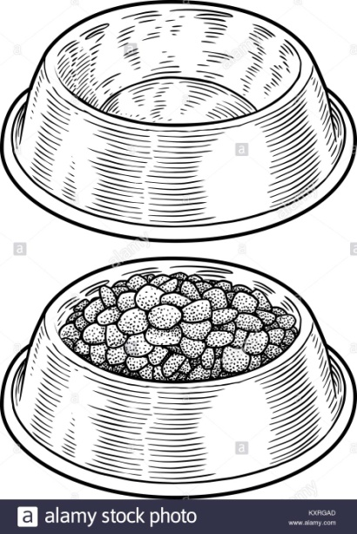
empty=
________

full=
_________
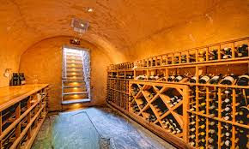
cellar=__________ wall=_________ hole=____________
small=____________ 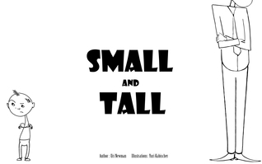 tall=_________

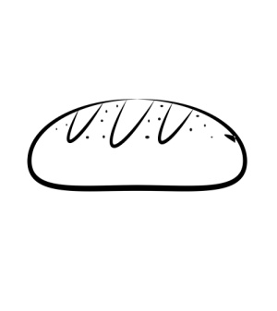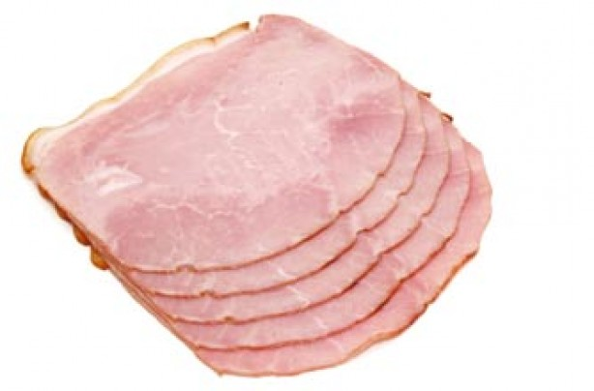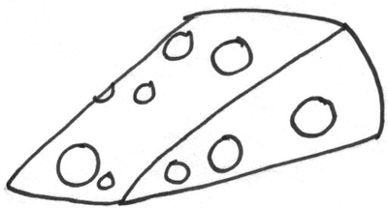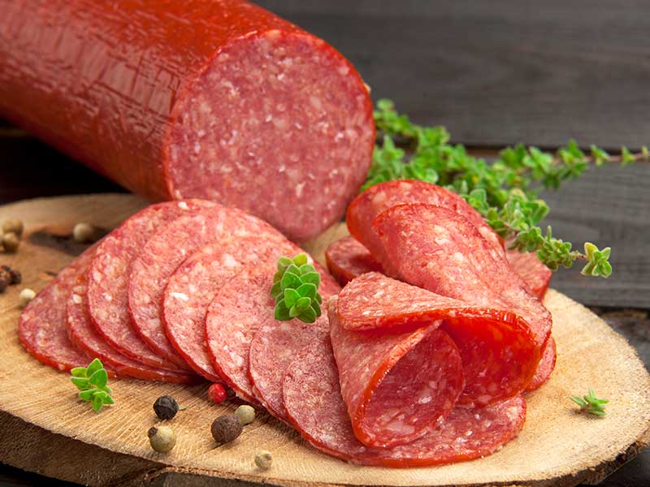
bread=_______ ham=_______ cheese=________ salami=_________

There’s … =_________
Join me! =___________
Have some =_________
Time for lunch=_______

What? = ________
What are you eating? =____________

Why? =________
Why is he running? =_____________

PRESENT CONTINUOUS
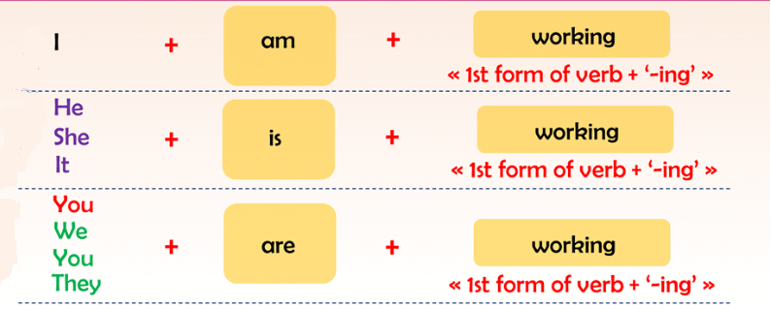
- για κάτι που κάνω ΤΩΡΑ!

UNIT 4 – LESSON 2 (Time for lunch)
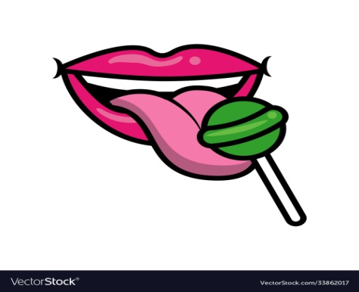
bacon=________ lips=_______ lick = ___________
lollipop=___________
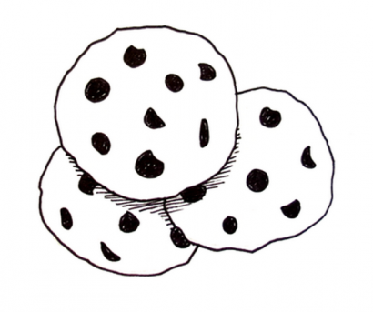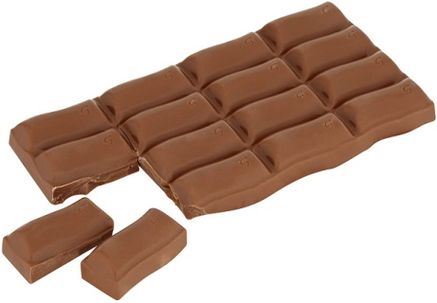

cookies=________ chocolate=_________ munch/crunch=_________
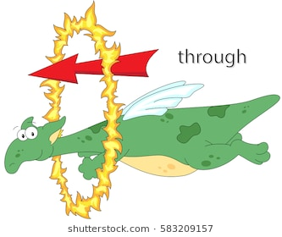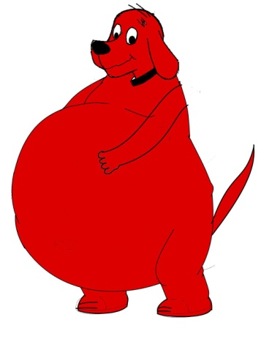
through=_________ big=_______
fat=_______

UNIT 4 – LESSON 3 (The right kind of food)
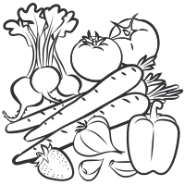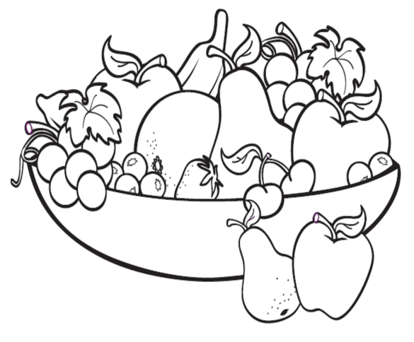
Don’t pout=__________ vegetables=__________ fruit=_________
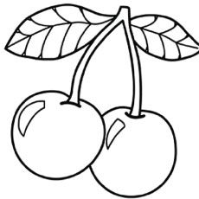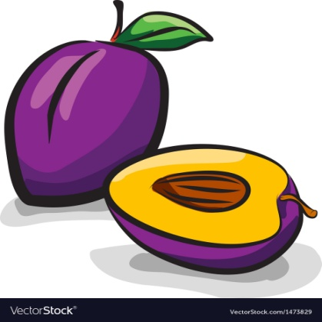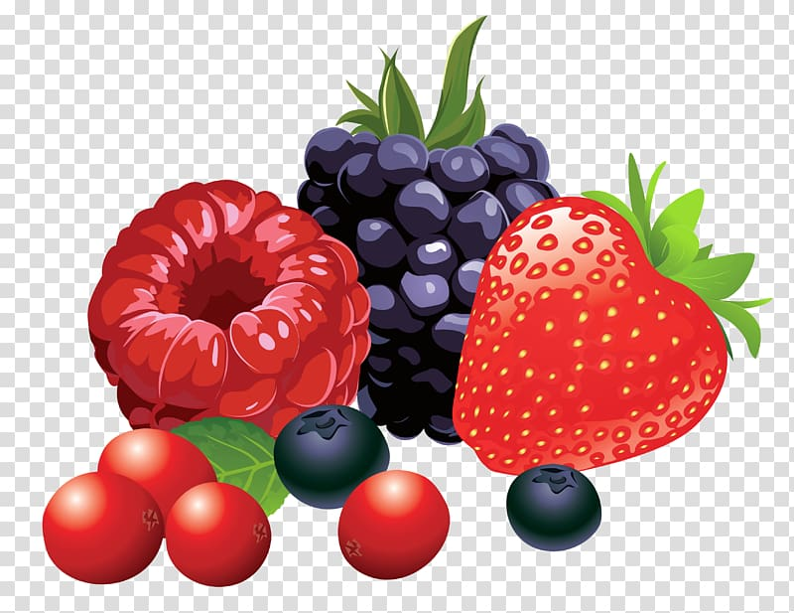
cherry=________ plum=__________ berries=___________
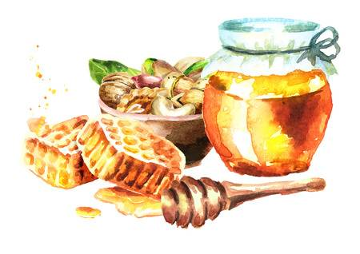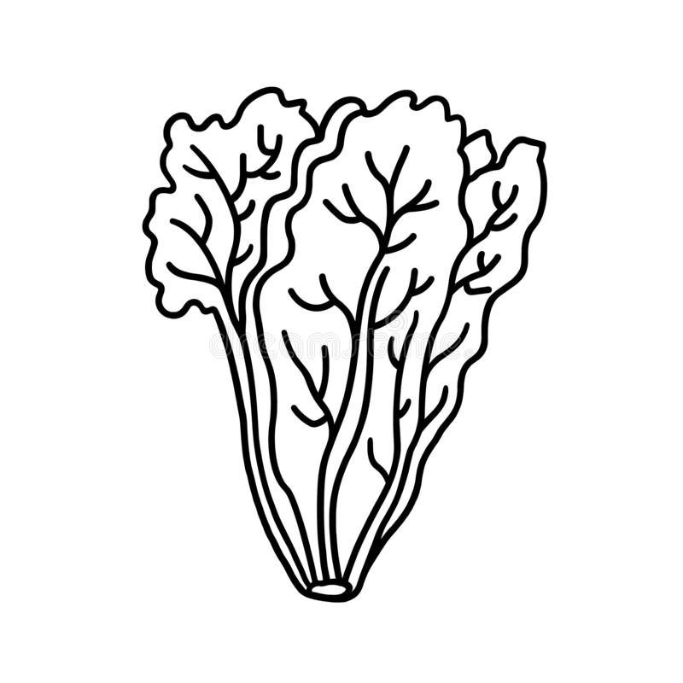
honey=_________ lettuce=__________ thin=________
nuts=___________
RIGHT! = Σωστά!- Σωστός
Υοu are right! = Έχεις δίκιο!
right kind of food= το σωστό είδος φαγητού
Ι’m out of here!= Φεύγω!
Thanks a million! = Χίλια ευχαριστώ
(million= εκατομμύριο)

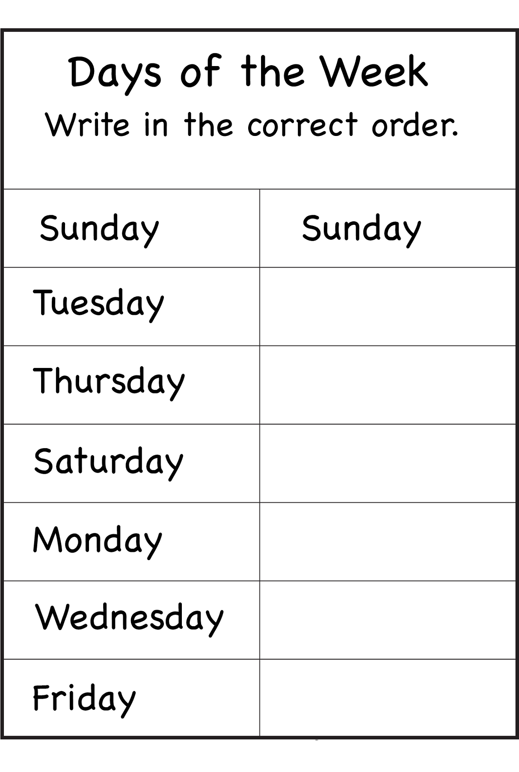
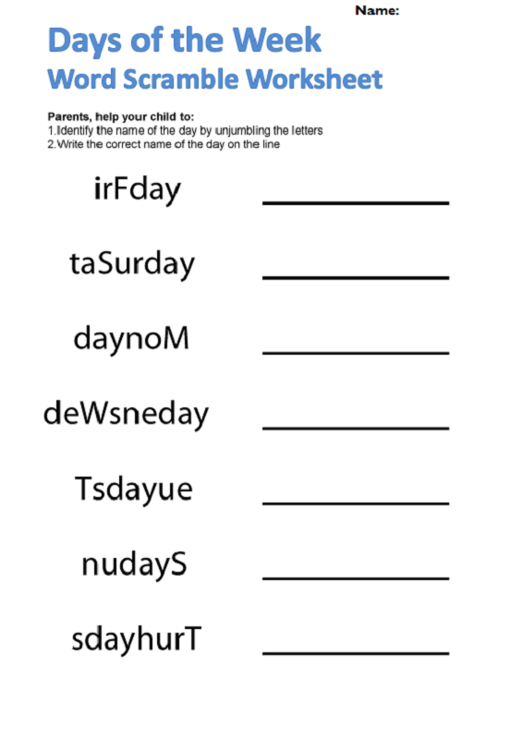

UNIT 5: THE ANIMAL SCHOOL – LESSON 1 (School is fun)
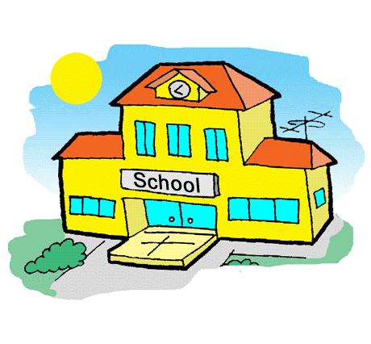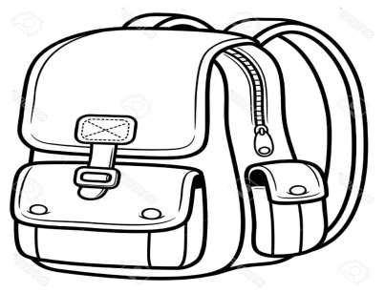
rubber = ________
pencil = ________
school =_________ schoolbag = _________
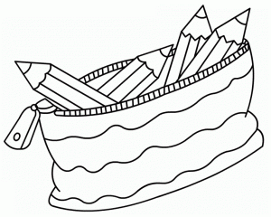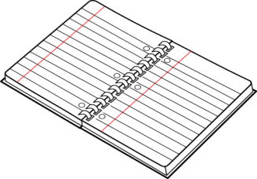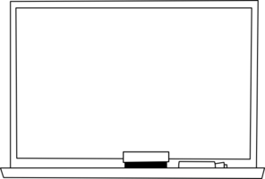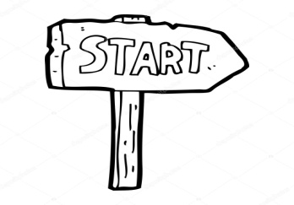
pencil case =______ notebook = _______ board =_________ start=______
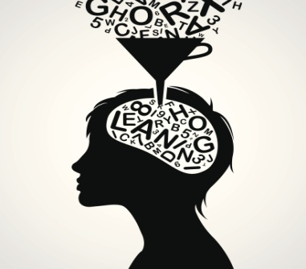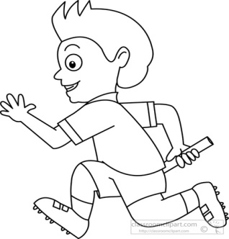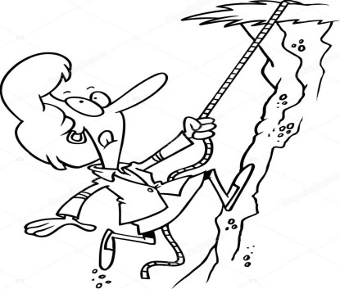
I’m so excited= learn= _________ running (run)= climbing (climb)=
___________ _____________ ____________
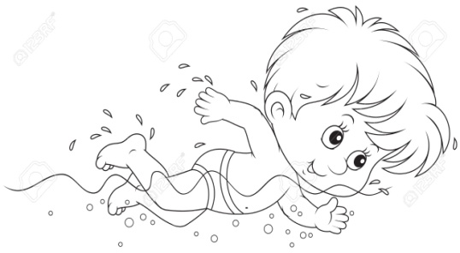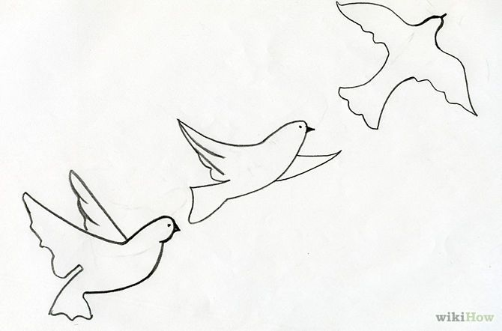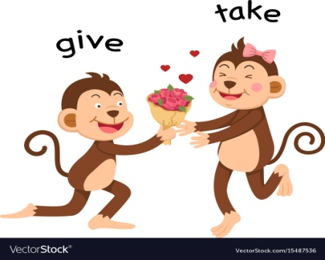
swimming (swim)=________ flying (fly)=__________ take=_______
We want to…= Εμείς θέλουμε να…
School is fun!= Το σχολείο είναι διασκεδαστικό!
We don’t need…= Εμείς δε χρειαζόμαστε…
Where?= Πού;

UNIT 5 – LESSON 2 (Lessons at the animal school)
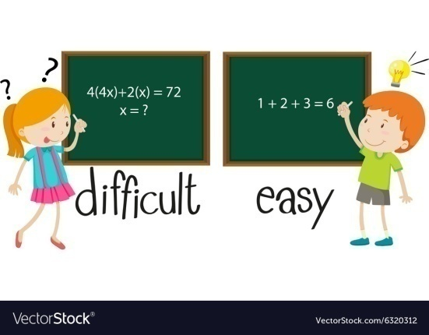
easy=
_______
hard=
_______
I love…=____________

Ι don’t like=________ try=___________ Don’t be angry!=_________
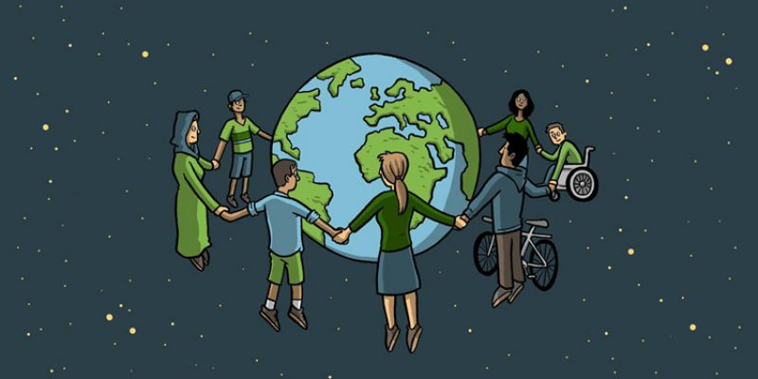 together=_________

Let me try = Άσε με να δοκιμάσω/προσπαθήσω
Let’s try =Aς δοκιμάσουμε/προσπαθήσουμε
Time for… = Ώρα για…
It’s……… o’clock = Είναι ………… ακριβώς
It’s half past ………= Είναι ……… και μισή

CAN = ΜΠΟΡΩ I can fly/I can’t fly/ Can I fly?
MUST= ΠΡΕΠΕΙ I must try/I mustn’t try/ Must I try?

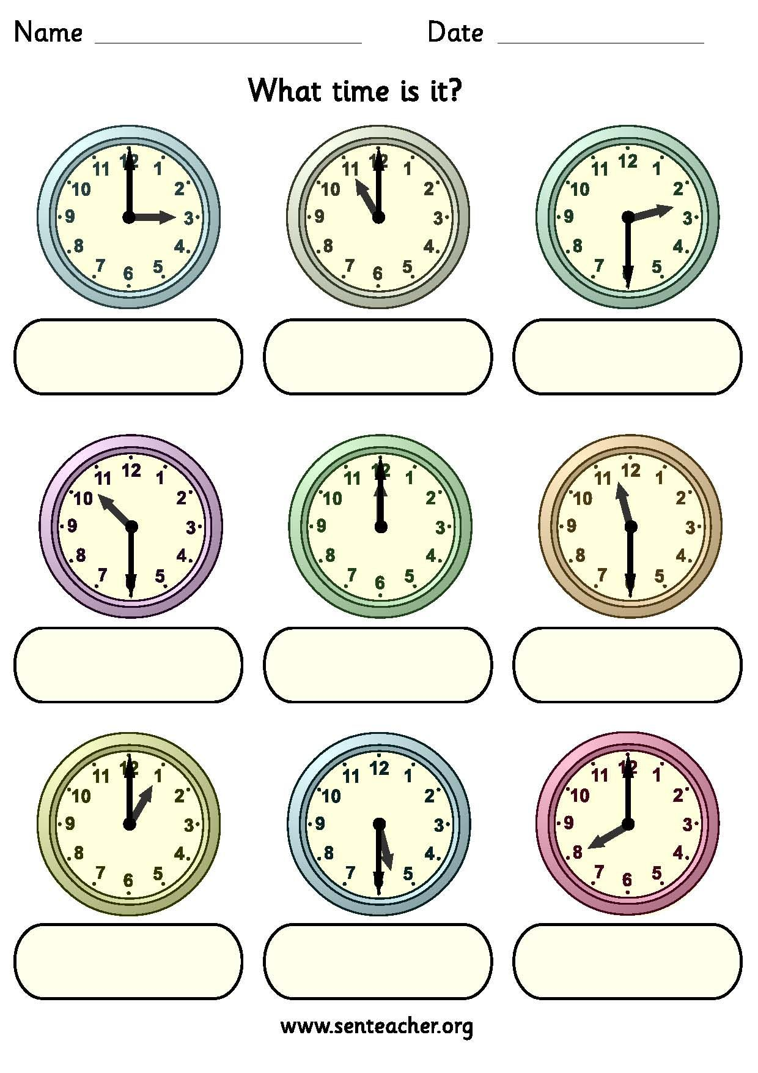

UNIT 5 – LESSON 3 (A bright world)

It’s cool=______ different=________ unique=____________
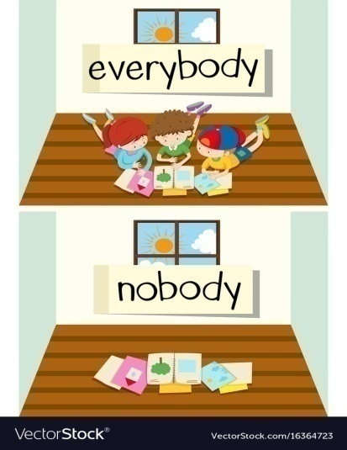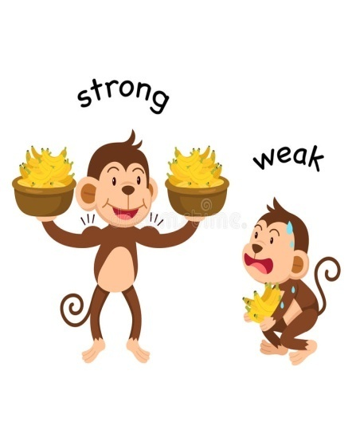
weak=________
nobody=________
everybody=_______
boring=________respect=______

What a pity! What a shame!= Τι κρίμα!
Respect my rights= Σεβάσου τα δικαιώματά μου (right=δικαίωμα)
Everybody can do something= όλοι μπορούν να κάνουν κάτι
Together we can do everything= μαζί μπορούμε να κάνουμε τα πάντα

UNIT 6: THE EMPEROR’S NEW CLOTHES – LESSON 1 (Nothing looks right)
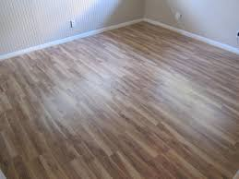
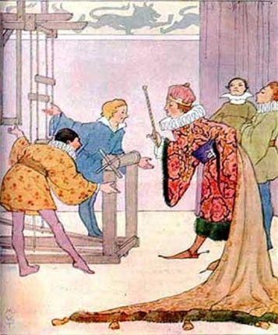

floor=_______ emperor=_________ change=____________
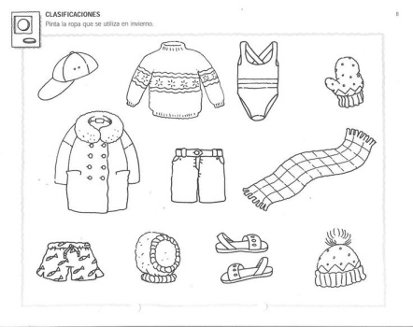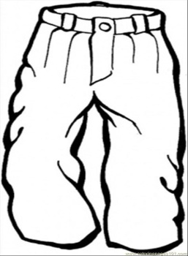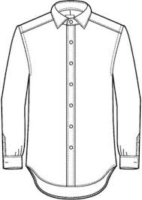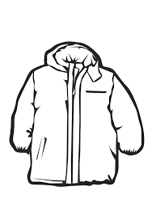
clothes=__________ trousers=______ shirt=______ jacket=_______
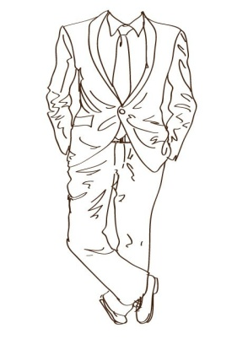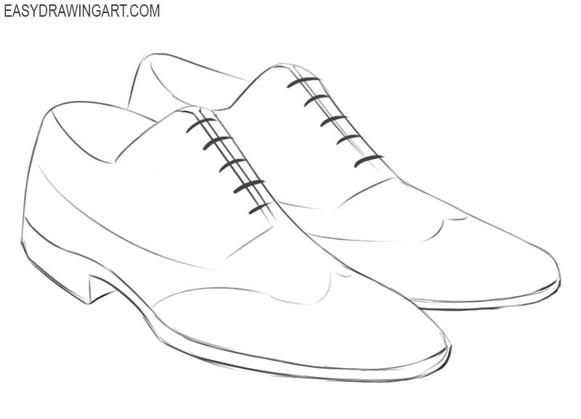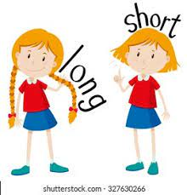
long=_____

short=____
suit=_________ shoes=________

It’s too bright= Είναι πάρα πολύ φωτεινό/ζωηρό (το χρώμα)
need=__________
choose=__________
I have nothing to wear= Δεν έχω τίποτα να _______

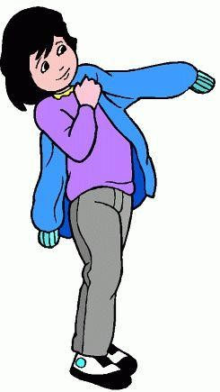

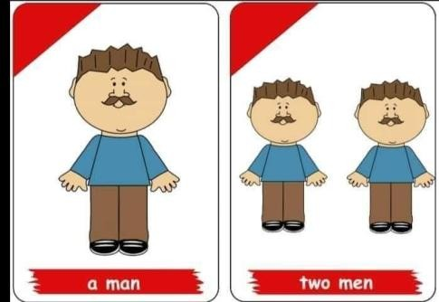UNIT 6 – LESSON 2 (The emperor’s special suit)
man=______ men=________ tailor=__________ put on (clothes)=________
Nice work!= Ωραία δουλειά!
Why can’t I see it?= Γιατί δεν μπορώ να το δω;
perfect= τέλεια

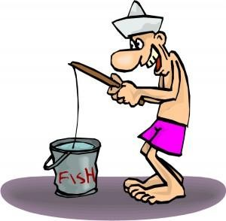

clever=___________ fool=____________

UNIT 6 – LESSON 3 (At the festival)
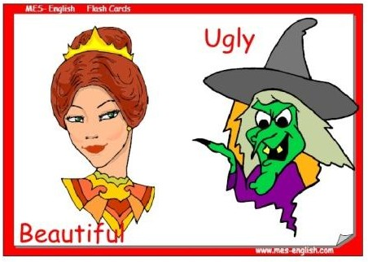

beautiful=__________ ugly=__________ laugh=__________

Τhe boy is right!= Το έxει δίκιο!
Τhe emperor has no clothes= Ο _ δεν έxει καθόλου ______
Τhe emperor is wearing nothing= O δε φοράει τίποτα
Love for things is wrong= Η __ _ για τα πράγματα είναι λάθος

UNIT 7: ΑRTHUR AND HIS FAMILY - LESSON 1 (Play with me)
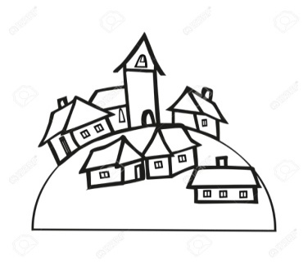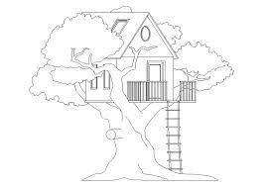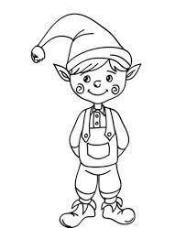
village=_________ tree house=________ elf =_________
elves=_________
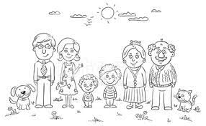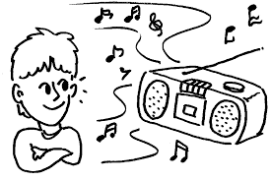
family=__________ busy=_________ listen to music=________
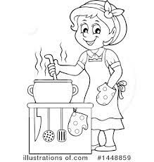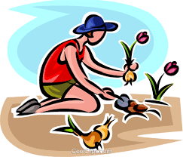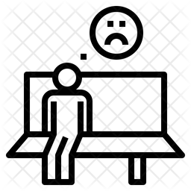
cook meals=_______ plant trees=__________ alone=________
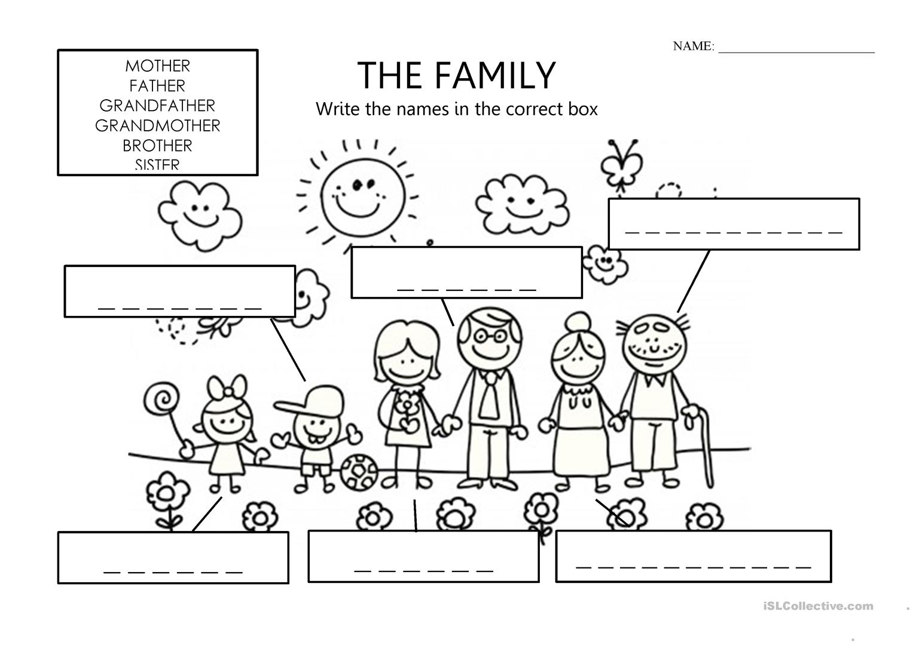
UNIT 7 - LESSON 2 (We can’t find Arthur!)
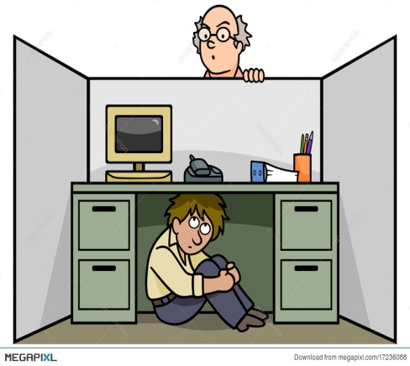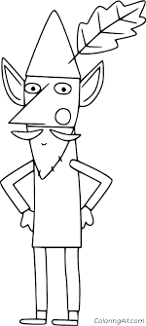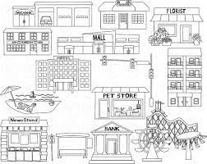
I can’t find him= wise (elf)=_________ places=__________
_____________
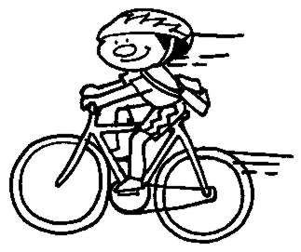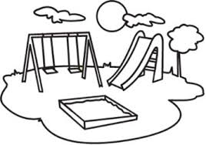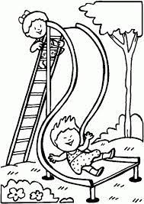
I ride my bike= playground=____________ slide=____________
______________
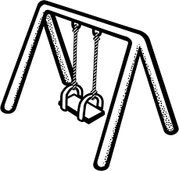
swing=___________

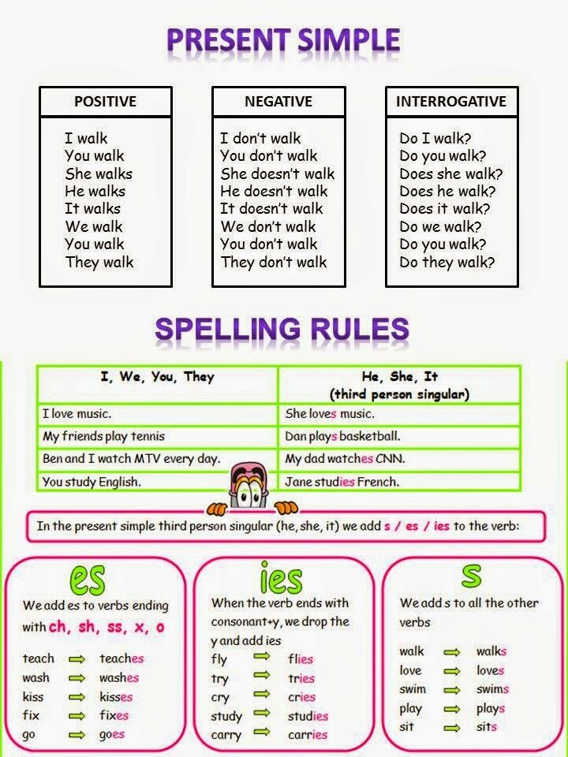

UNIT 7 - LESSON 3 (My favourite place)
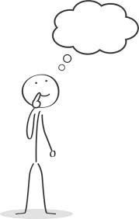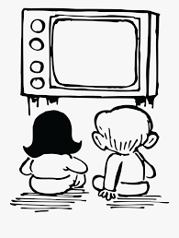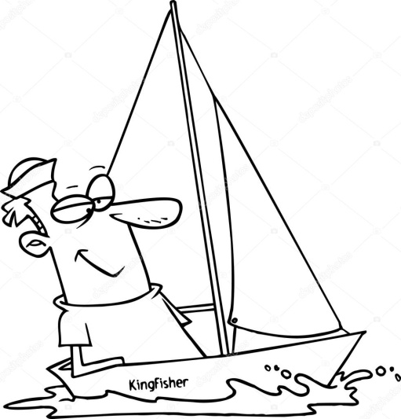
think=_________ watch TV=___________ sailing=___________
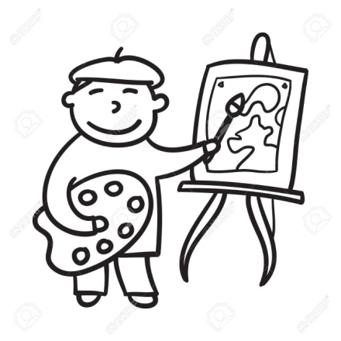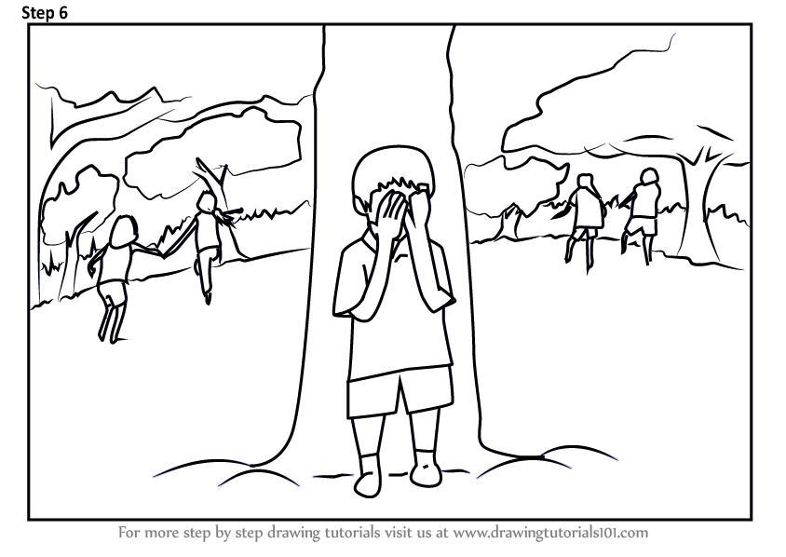
drawing=__________ fly a kite=________ hide-and-seek=____________


Join us!=__________

- What I like most is…= Αυτό που μου αρέσει περισσότερο είναι…
- Ι like + ρήμα-ing ( e.g. I like playing with my family= μου αρέσει να παίζω με την οικογένειά μου)
UNIT 8: DAEDALUS AND ICARUS – LESSON 1 (The palace of Minos)
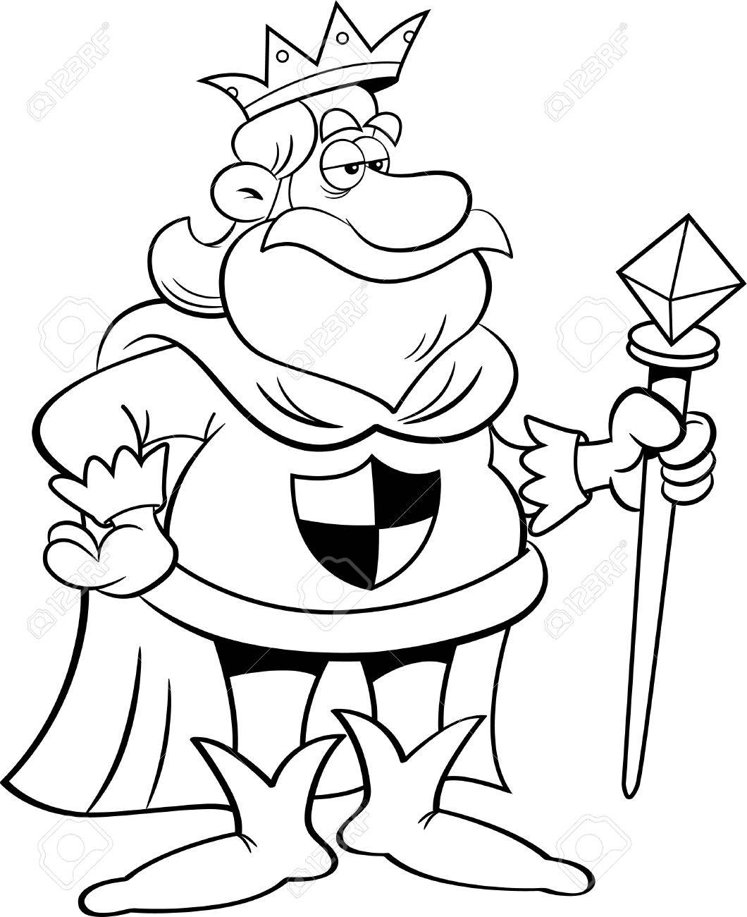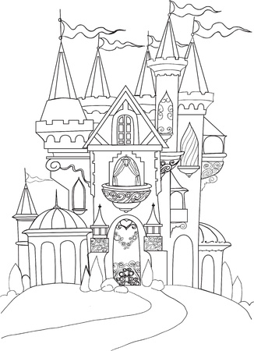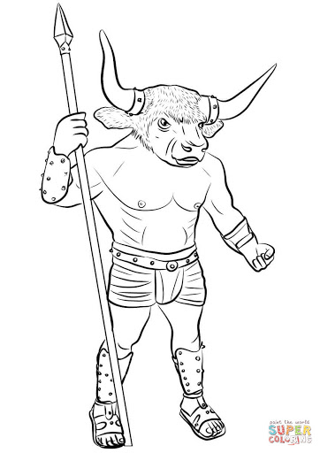
king=________ palace=________ Minotaur=_________
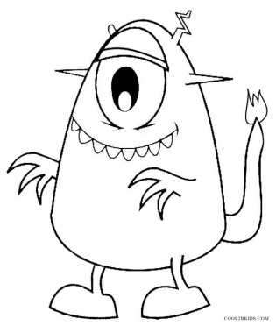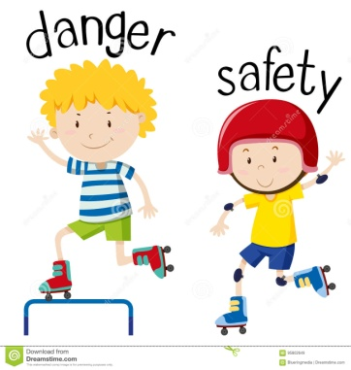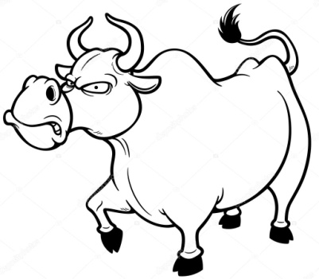

monster=__________ dangerous=___________ bull=_________
safe=____________
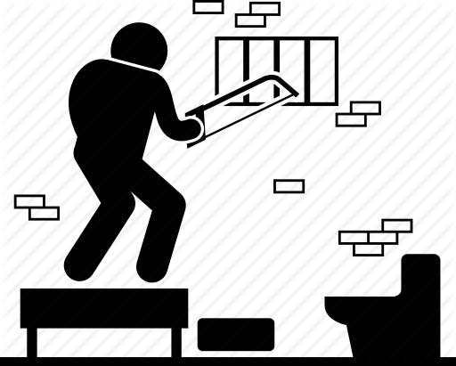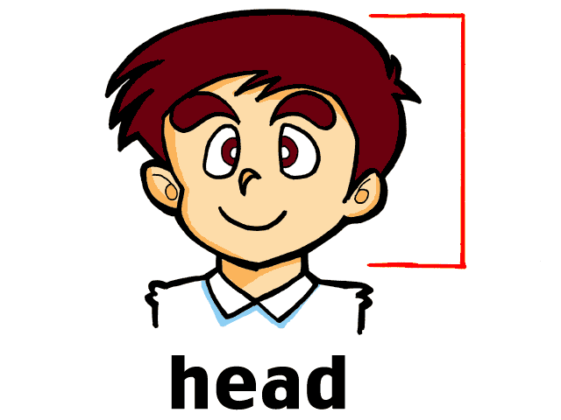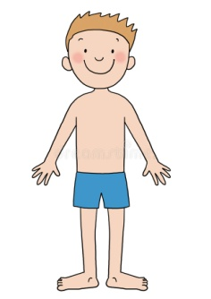
escape=__________ head=_________ body=_________
prison=__________
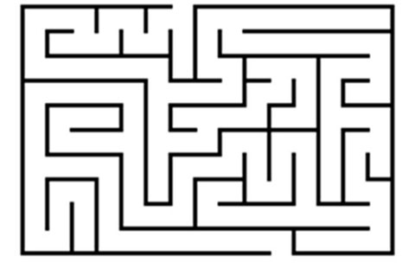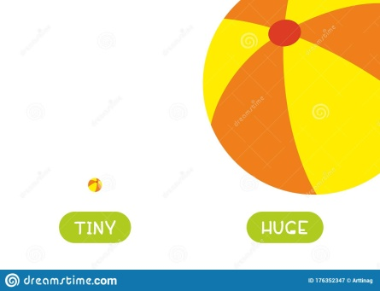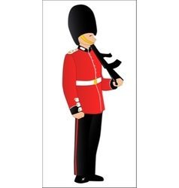
maze=__________ huge=__________ guard=_________
Thank you=___________
You’re welcome=__________
no one=nobody=_______
(he) can do no harm= δεν μπορεί να βλάψει
Ι can’t let you leave!= Δεν μπορώ να σας αφήσω να φύγετε!

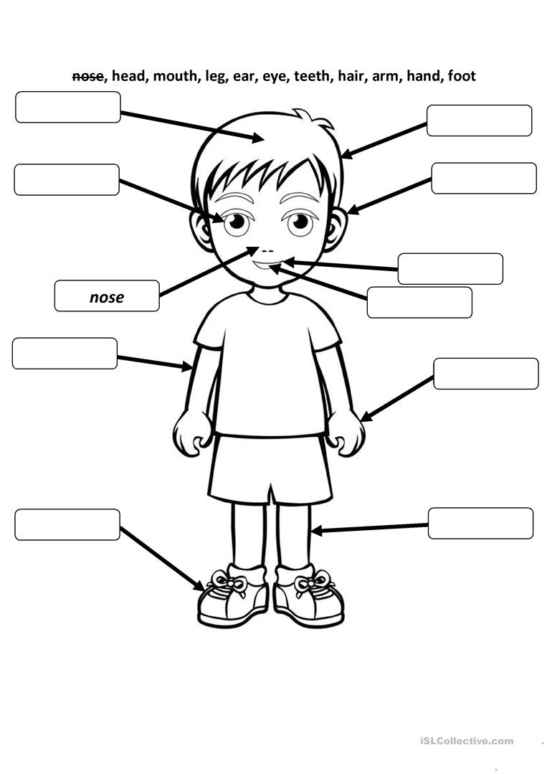

UNIT 8 – LESSON 2 (In prison)
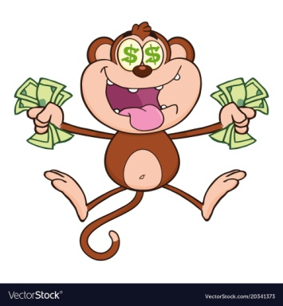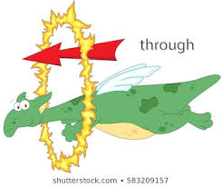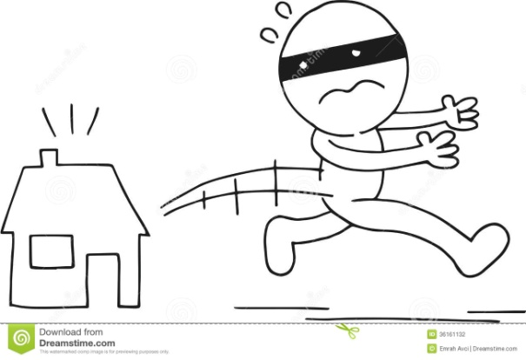
greedy=_________ through=_________ get away (from)=__________
wing=_______

feather=________
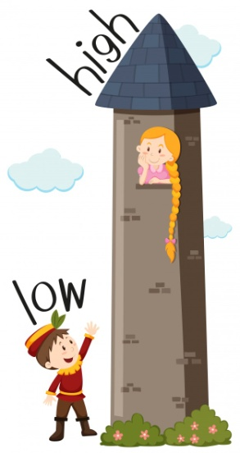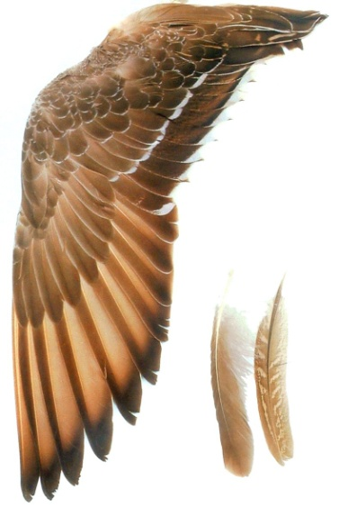
high=_______

low=________
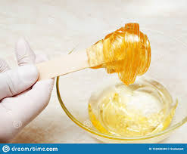
stick=_________ wax=____________ rest=____________

- have to=must= _________
- We have to find a way to escape=_________ να βρούμε έναν τρόπο να __________
- What about…? = Τι λες για…;
- brilliant idea= εξαιρετική/φανταστική/απίθανη ιδέα
- We only need…= Χρειαζόμαστε μόνο…

UNIT 8 – LESSON 3 (Icarus in the sea)

remember=_________ melt=_________ tiny=_________
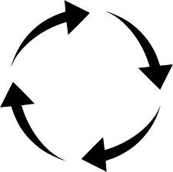
round and round=________ up and down=________ fall down=_______

- Stay close to me= Μείνε κοντά μου
- …and one more thing= …και κάτι ακόμα
- You are getting close to the sun= Πλησιάζεις τον ήλιο

UNIT 9: PLANET RECYCLON – LESSON 1 (In the forest)
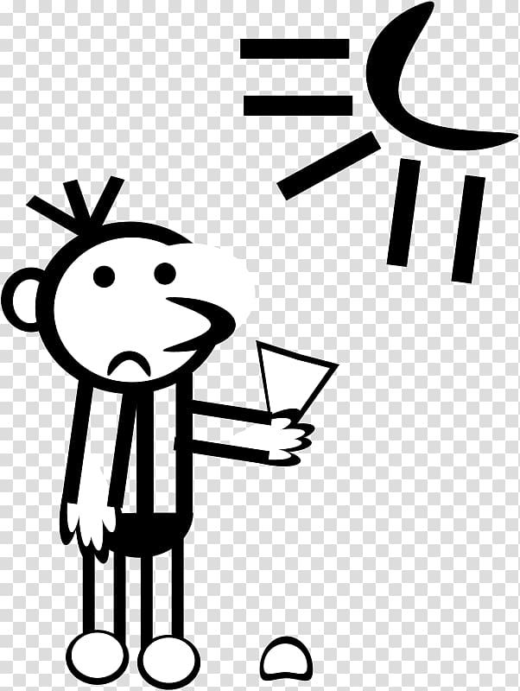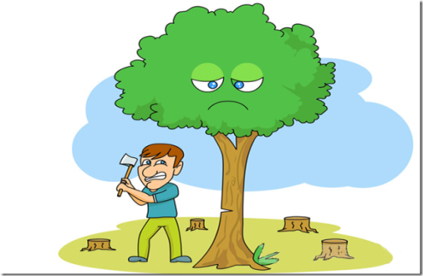
planet=__________ What a pity!=________ cut down trees=_______
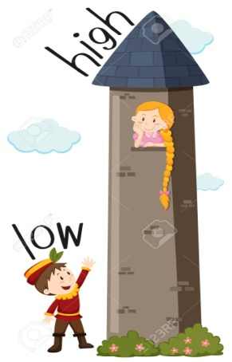 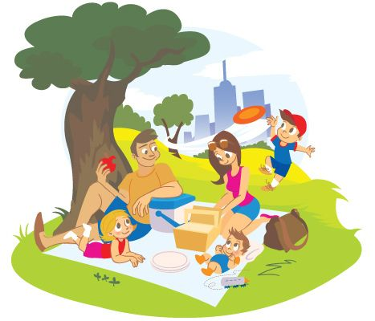 go for a
low=________
high=_______
picnic=___________
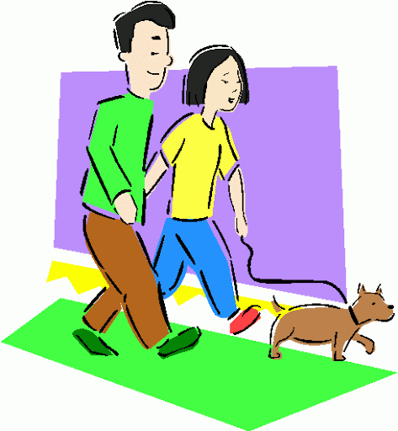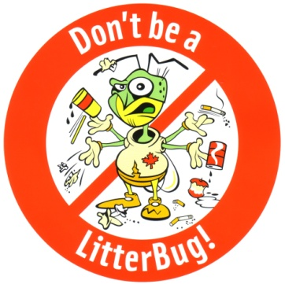
go for a walk=______ Don’t litter!=______ __ Save the forest!=_______
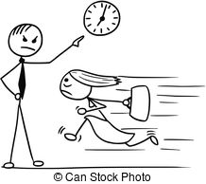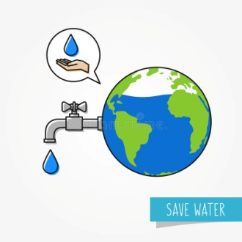
Don’t be late=_______ Don’t waste water=________ recycle=_______
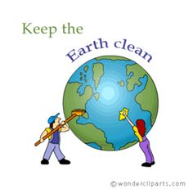
can=_________ Keep the planet clean!=__________

UNIT 9 – LESSON 2 (The green planet)
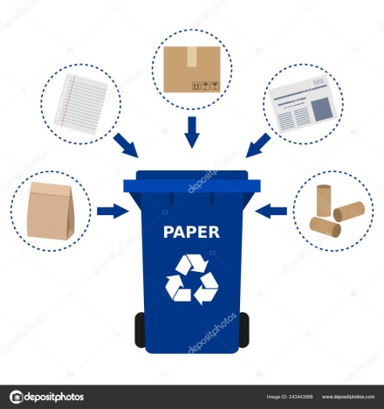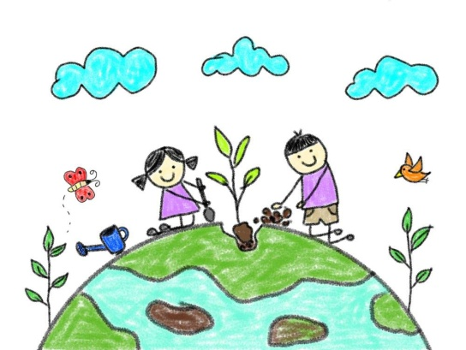
paper=__________ glass=________ plant a tree=____________

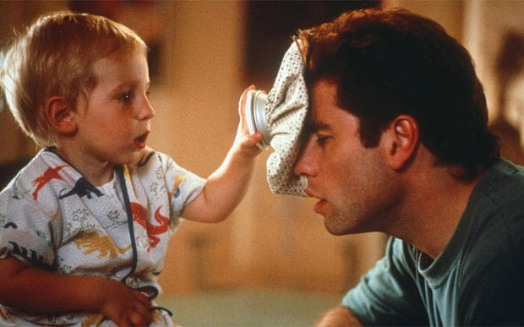 look after=take care of=____________

UNIT 9 – LESSON 3 (Help the planet)
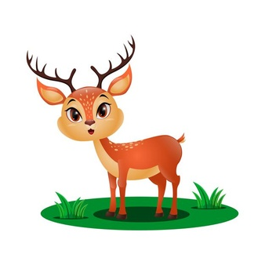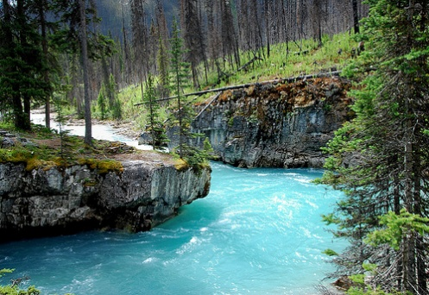
deer=_________ river=__________ What a shame=_________
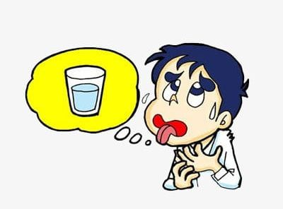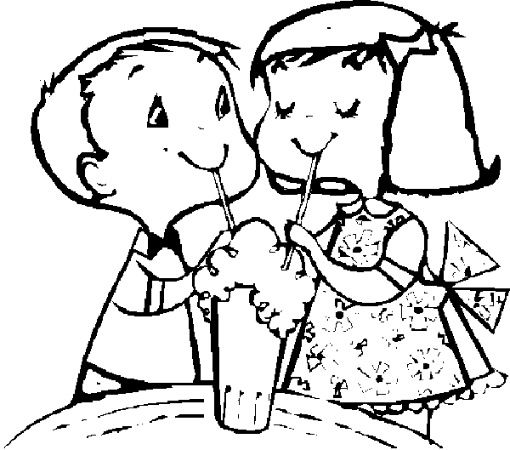

thirsty=___________ share=___________

