0pening hours
Admission
Location/Address
Bus
Phone
Website
Things to see

ARCHEOLOGICAL MUSEUM OF ALEXANDROUPOLIS
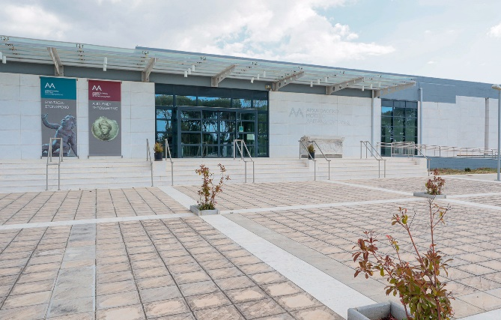
https://am-alexandroupolis.gr/

0pening hours
Admission
Location/Address
Bus
Phone
Website
Things to see

ARCHEOLOGICAL MUSEUM OF ANDROS
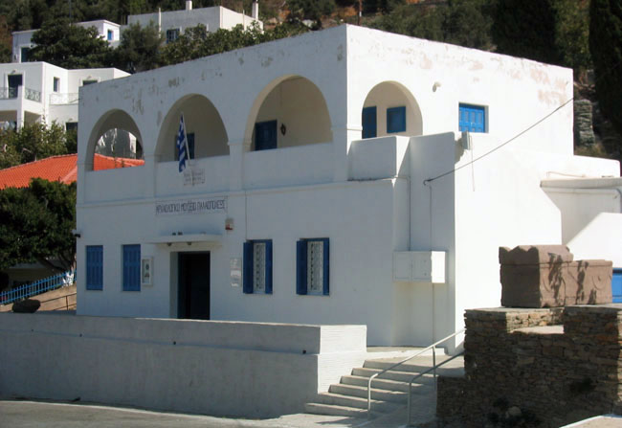
Ministry of Culture and Sports | Archaeological Museum of Andros (Chora)

0pening hours
Admission
Location/Address
Bus
Phone
Website
Things to see

The Museum of the Royal Tombs at Aigai
http://odysseus.culture.gr/h/1/eh155.jsp?obj_id=3297
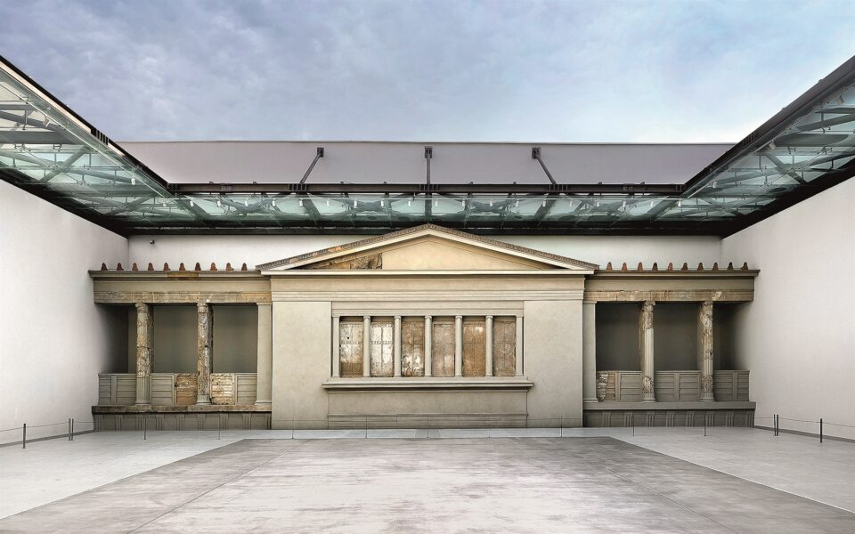
Ministry of Culture and Sports | The Museum of the Royal Tombs at Aigai

ARCHEOLOGICAL MUSEUM OF KNOSSOS
http://odysseus.culture.gr/h/3/eh355.jsp?obj_id=2369
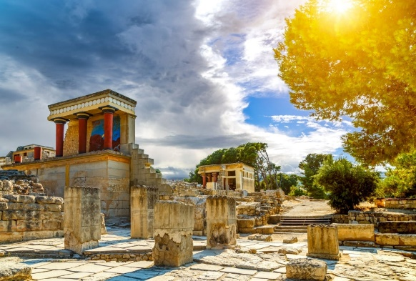

0pening hours
Admission
Location/Address
Bus
Phone
Website
Things to see

0pening hours
Admission
Location/Address
Bus
Phone
Website
Things to see

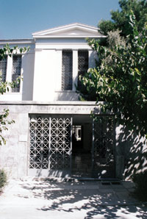
http://odysseus.culture.gr/h/1/eh151.jsp?obj_id=3348
EPIGRAPHIC MUSEUM

0pening hours
Admission
Location/Address
Bus
Phone
Website
Things to see

The Archaeological Museum of Delphi
http://odysseus.culture.gr/h/1/eh151.jsp?obj_id=3404
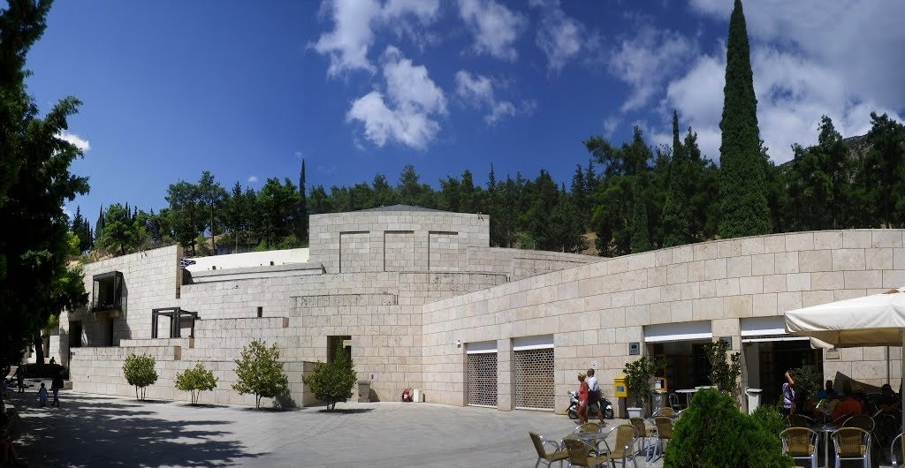

ARCHEOLOGICAL MUSEUM OF RHODES

0pening hours
Admission
Location/Address
Bus
Phone
Website
Things to see

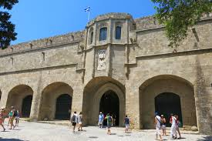
http://odysseus.culture.gr/h/1/eh155.jsp?obj_id=3312

0pening hours
Admission
Location/Address
Bus
Phone
Website
Things to see

ARCHEOLOGICAL MUSEUM OF SAMOS
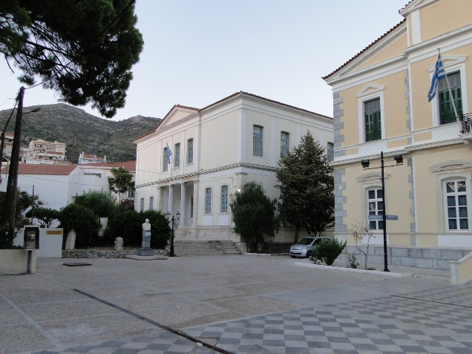
https://archaeologicalmuseums.gr/el/museum/5df34af3deca5e2d79e8c13b/archaeological-museum-of-samos

0pening hours
Admission
Location/Address
Bus
Phone
Website
Things to see

Museum of Chlemoutsi Castle

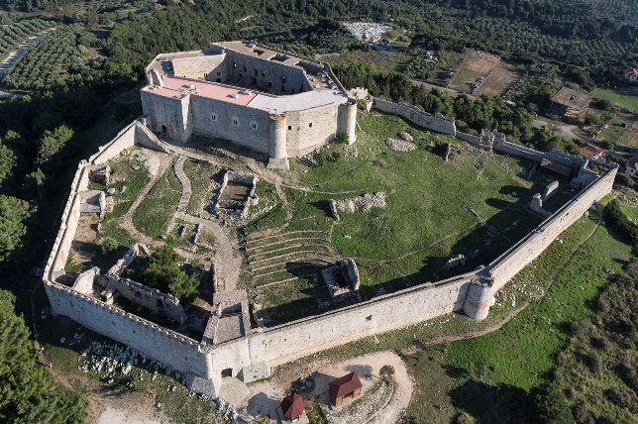
https://archaeologicalmuseums.gr/en/museum/5df34af3deca5e2d79e8c1ce/museum-of-chlemoutsi-castle

Museum of Ancient Agora of Thessaloniki

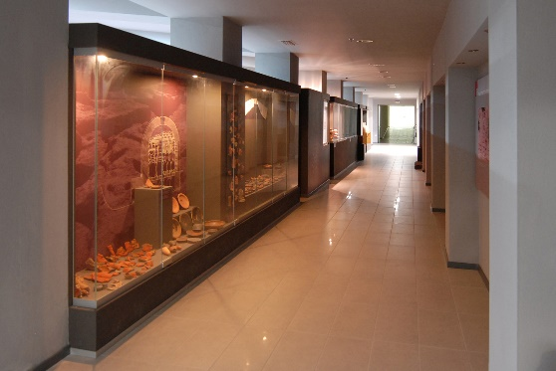
https://archaeologicalmuseums.gr/en/museum/5df34af3deca5e2d79e8c1c1/museum-of-ancient-agora-of-thessaloniki

0pening hours
Admission
Location/Address
Bus
Phone
Website
Things to see

