D’ .....Class Name....................................................................
Unit 6 – Lesson 2_Exercise 1
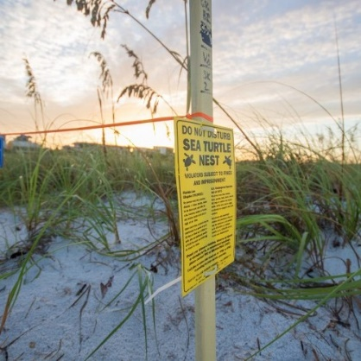
Match the pictures to the words. There is one EXTRA word, be careful!
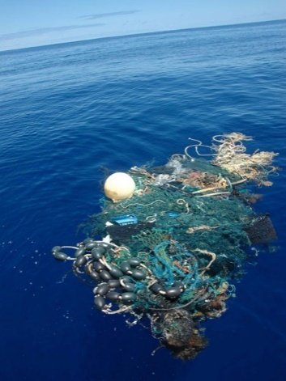
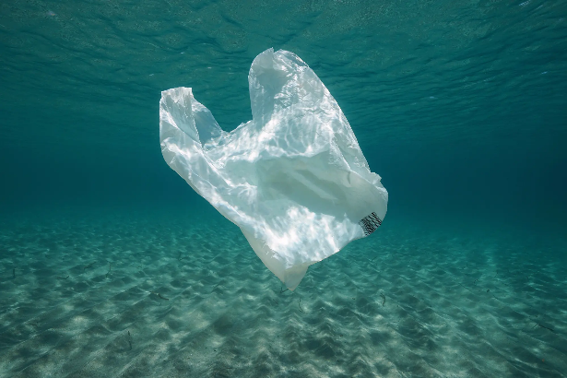
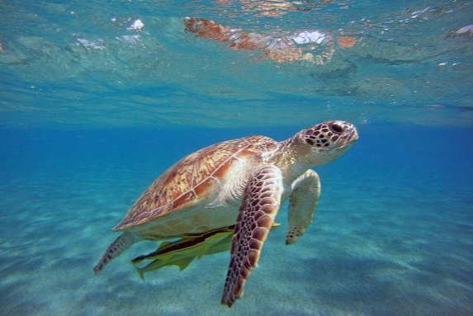
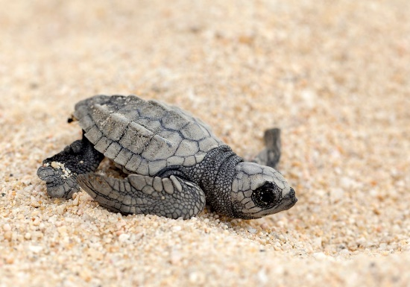

a.) plastic bag b.) hatchling c.) nets d.) loggerhead sea turtle (caretta-caretta)
e.) bin f.) nesting beach

1…....... 2…....... 3…........ 4…....... 5….......

Exercise 2

Write TWO facts that you learnt about the loggerhead sea turtle (caretta-caretta).
…………………………………………………………………………………………
…………………………………………………………………………………………
…………………………………………………………………………………………
…………………………………………………………………………………………
…………………………………………………………………………………………
…………………………………………………………………………………………
…………………………………………………………………………………………
…………………………………………………………………………………………
…………………………………………………………………………………………

