D’ Class_Unit 4
What’s the weather like?
Name…………………………………………………………………………………………… Class: D…
- What’s the weather like today? ………………………………………………………………………
- Get a dice with the weather pictures. Throw the dice 3 times to see what the weather is like in the morning, in the afteroon and in the evening in ……………………….
Colour the city on the map. Write the weather conditions in the city in the box next to the map and draw the weather sign.

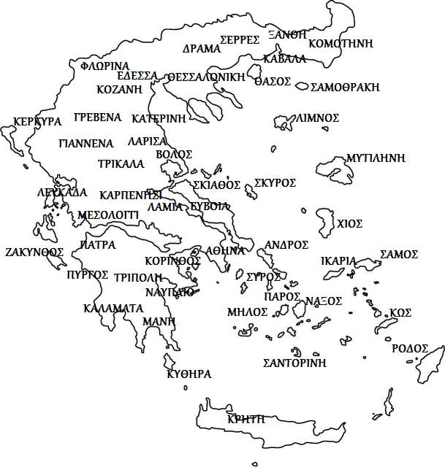 | In the morning  In the afternoon  In the evening

- Become a weather forecaster FOR THE DAY and tell the weather forecast on TV.
Come to the map of Greece on the board and stick the appropriate weather signs.

……………………………………………………………………………………………………………………………………………………………………………………………………………………………………………………………………………………………………………………………………………………………………………………………………..

