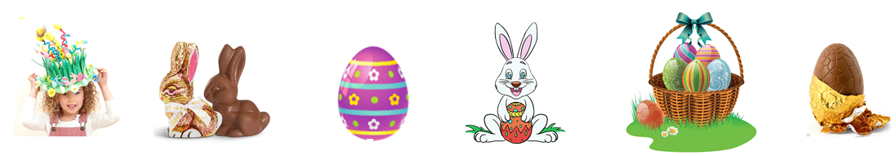
Easter vocabulary pack

Easter bonnet
Chocolate bunny
Easter bunny
Chocolate egg
Easter basket
Easter egg

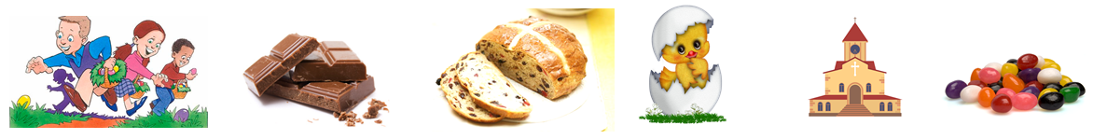

|
Church
Chick
Jelly beans
Chocolate
Hot cross bun
Egg hunt
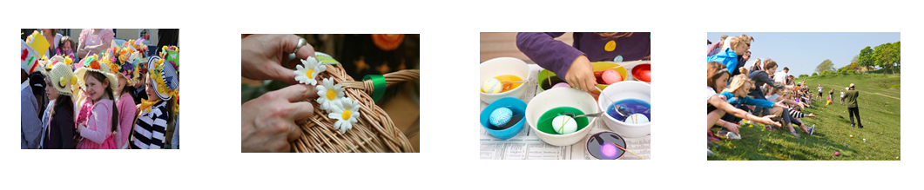

Easter bonnet parade
Dye eggs
Easter egg rolling
Decorate

b | o | n | n | e | t | a | b
a | d | y | x | g | e | s | u
s | v | c | e | g | u | w | n
k | c | h | u | r | c | h | n
e | o | r | q | c | o | r | y
t | a | u | g | g | p | o | w
e | g | g | h | u | n | t | h
d | e | c | o | r | a | t | e
Word search. Find the words.
Bonnet
Basket
Bunny
Egg
Church
Egg hunt
Decorate

Listen and circle the correct picture. audio https://english-portal.com.ua/worksheet/Easter_Vocabulary_Pack#topadv
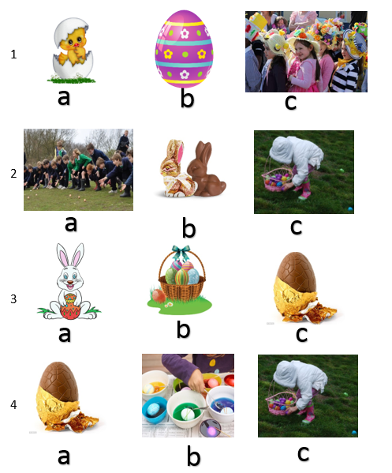
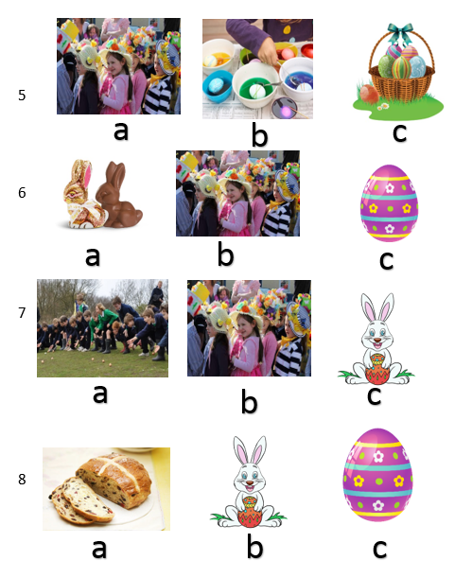

1…. 2…. 3…. 4…. 5…. 6…. 7…. 8….

Unscramble and match. Read and colour.
The basket is brown. The bunny is grey. The chick is yellow. The bow is green. The flowers are red and yellow. The eggs are blue, orange and red
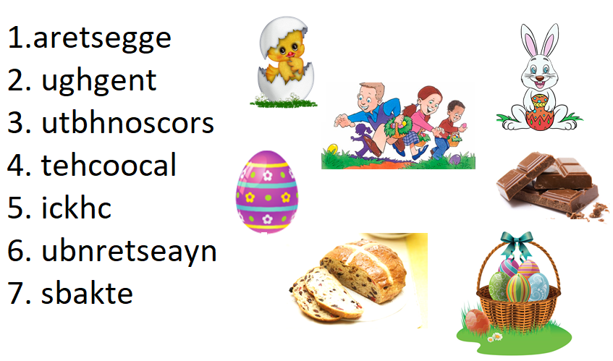

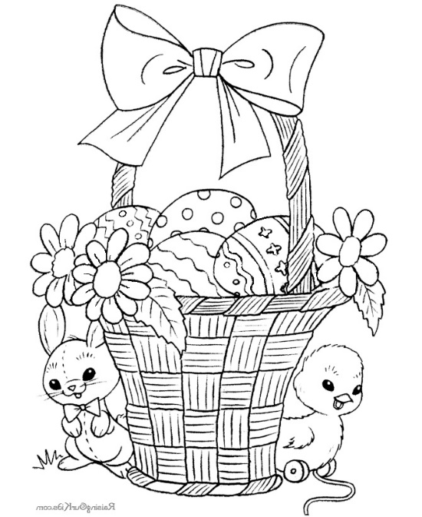

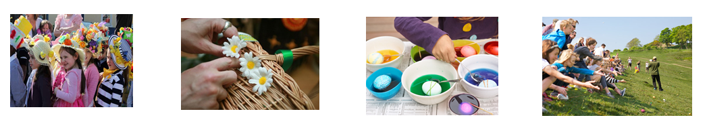
Label the pictures

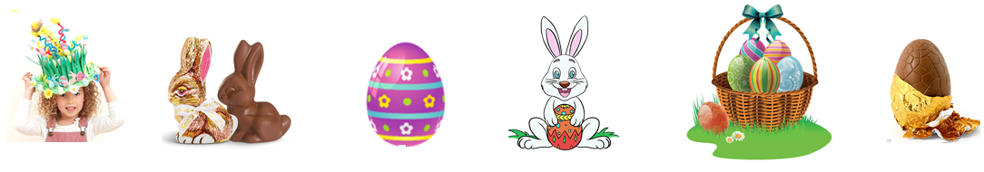

What are they talking about? Listen and number.
audio https://english-portal.com.ua/worksheet/Easter_Vocabulary_Pack#topadv
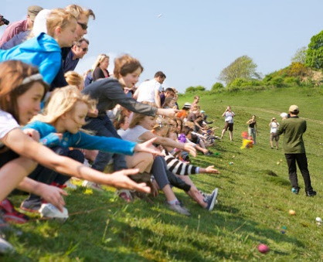
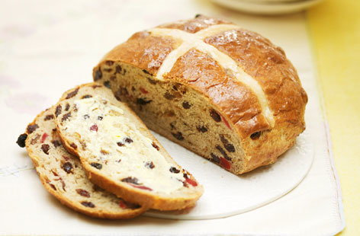
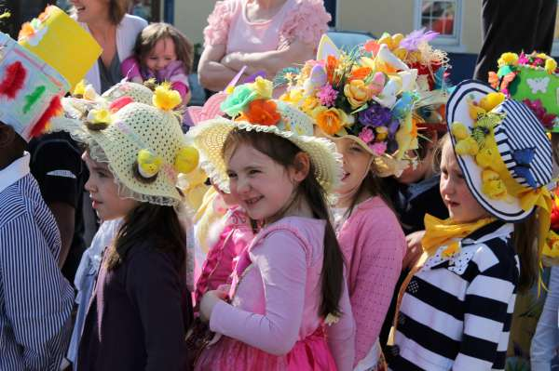
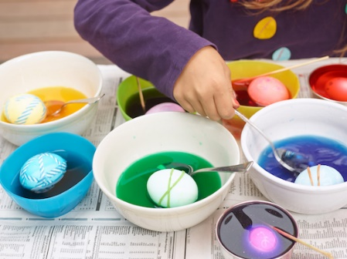

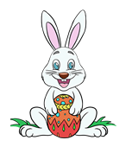
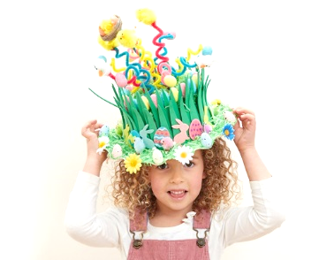
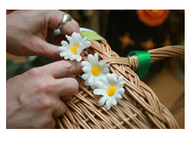
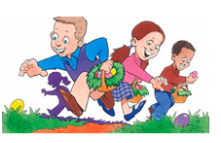

Multiple choice.
This animal hides the eggs
for you to find.
- Chick
- Bunny
- Bird

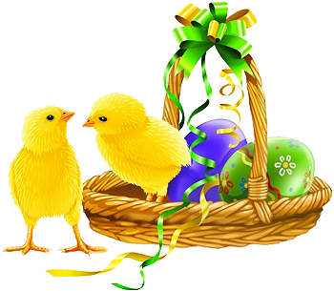
A baby chicken
- Chick
- Duckling
- Calf

The Easter bunny hides them.
- Eggs
- Baskets
- Bonnets

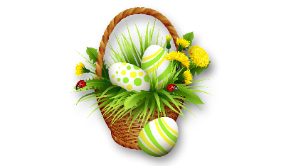

You collect eggs in this.
- Bonnet
- Pail
- Basket

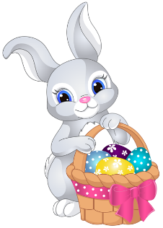
The season when Easter
is celebrated.
- Spring
- Summer
- Autumn

Children like to go on an
Easter egg…
- Party
- Hunt
- Parade

A pretty Easter hat.
- Bonnet
- Basket
- Cap

Colourful little candies
- Lollipop
- Jelly beans
- Candy cane

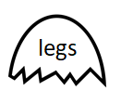
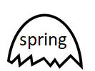
Match the rhyming words.
