Name: ​ ​ Date: ​
​

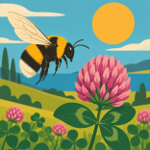 | Busy Bee Matching
​
Choose the correct word from the word bank and write it under each picture.
​

 | honeybee |  | flower |  | beehive
 | queen bee |  | pollen |  | nectar
​

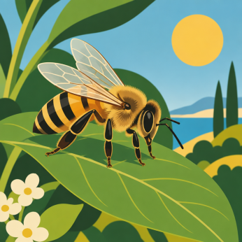  ​  1.  ​ |  | 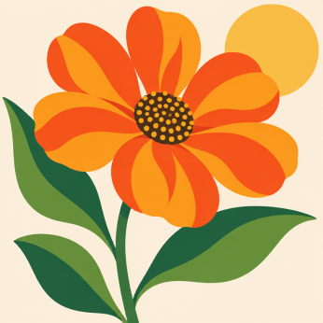  ​  2.  ​ |  | 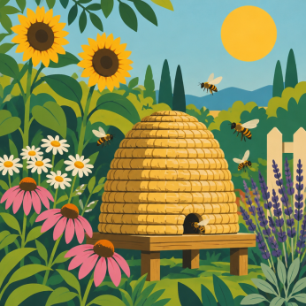  ​  3.  ​
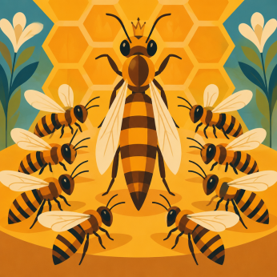  ​  4.  ​ |  | 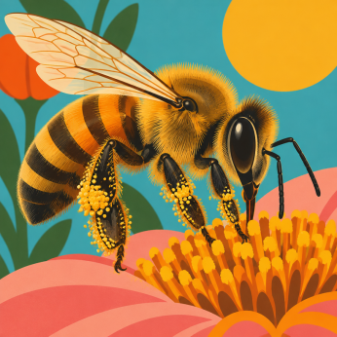  ​  5.  ​ |  | 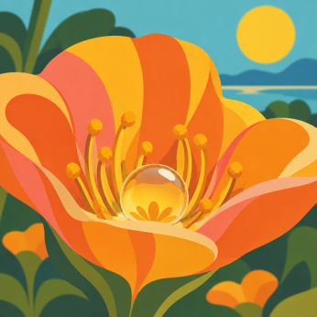  ​  6.  ​
​
Buzzing Sentences
​
Use words from the word bank to complete each sentence.
​
7. A honeybee visits a blossom to sip sweet ______________.
​
8. Inside the hive, the ______________ lays all of the eggs.
​
9. Sticky grains of ______________ stick to the bee's hairy coat.
Answers
​
1. honeybee
​
2. flower
​
3. beehive
​
4. queen bee
​
5. pollen
​
6. nectar
​
7. nectar
​
8. queen bee
​
9. pollen

