I am |  | I'm
you are |  | you're
he is |  | he's 
she is |  | she's 
it is |  | it's 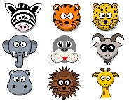
we are |  | we're
you are |  | you’re
they are |  | they’re

