I am not I’m not
You are not You aren’t
He is not He isn’t 
She is not She isn’t 
It is not It isn’t 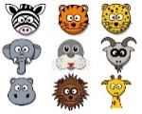

We are not We aren’t
You are not You aren’t
They are not They aren’t

