Verb “to be”
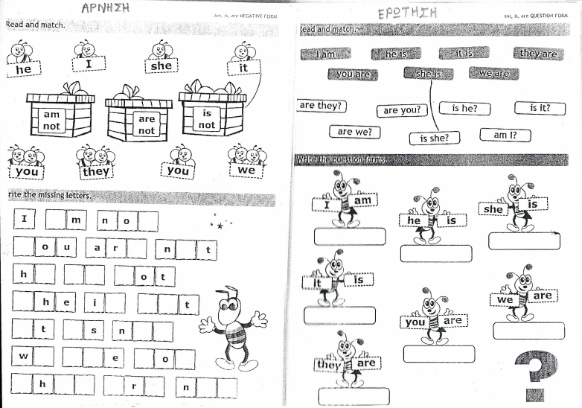
-Συμπλήρωσε με am, is, are
1. I _____ ten. 5. We ______ sisters.
2. He ____ my brother. 6. She ____ my mum.
3. It ____ great! 7. They _____ cool!
4. You _____ friends. 8. Kelly ______ happy.

-Γράψτε τον σύντομο τύπο
1. It is an ant. _____________
2. He is a pirate. ________________
3. You are ten. ________________
4. She is an Indian. _____________
5. They are friends. ______________
6. We are strong. ________________

