GIVING DIRECTIONS

1. Study the vocabulary! Μελετήστε το λεξιλόγιο!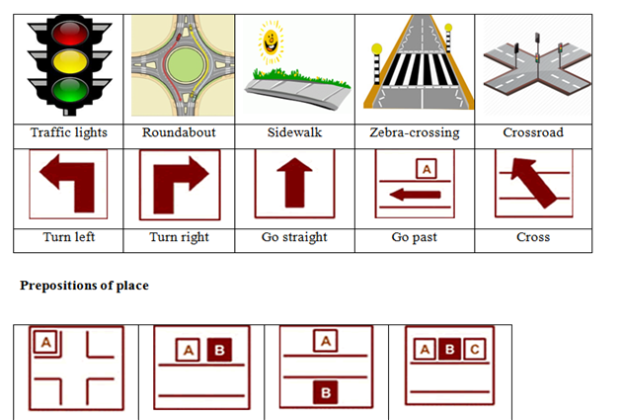 on the corner of next to opposite between

2. Remember!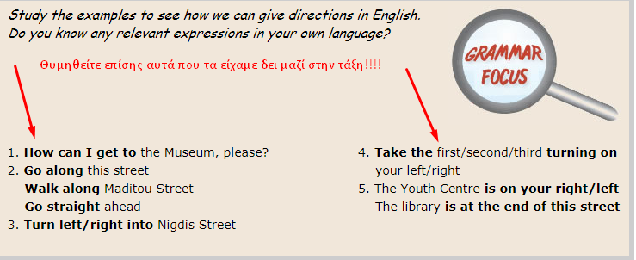
3. Study the map and fill in the correct word! Μελετήστε το χάρτη και βάλτε τις λέξεις που σας δίνονται στις προτάσεις!
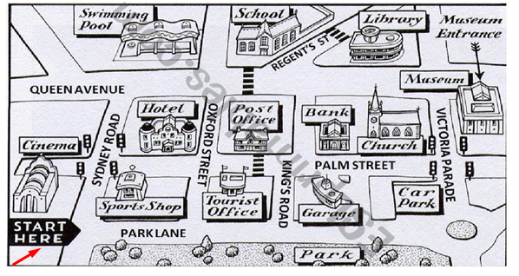
past (x2), straight, opposite, left, into, turning, at , ahead, along, on (x2) , to

1. To go to the swimming pool, go ______________ ahead Sydney Road, cross Queen Avenue and the swimming pool is _________ your right.

2. To get to the church, go straight ____________ Park Lane, walk _________ the park, turn __________at the roundabout _______Victoria Parade and you will see the church on your right, _____________ the museum and next ________ the bank.

3. To get to the museum, go ___________ Sydney Road, take the second __________ on your right into Queen Avenue, go ________ the post office and the museum is _________ the end of the street ________ the corner of Queen Avenue and Victoria Parade.

