Worksheet – Group 1




Look at the picture from the 1960s below. Discuss with your group and choose adjectives from the box to describe the picture. Then, write 1-2 sentences about the picture using the phrase “used to”.
e.g. In the 1960s women used to wear colourful dresses.
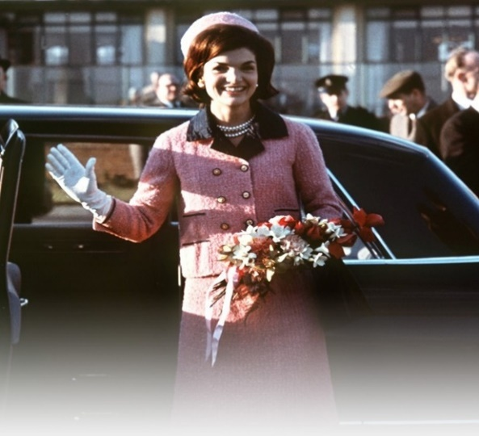

floral bold beautiful boring stylish short colourful simple long casual comfy tight high-waistedelegant chic serious fun patterned bell-bottomed mini

In the 1960s, __________________________________________________________ __________________________________________________________________________________________________________________________________________

Group Work

Worksheet – Group 2

Look at the picture from the 1960s below. Discuss with your group and choose adjectives from the box to describe the picture. Then, write 1-2 sentences about the picture using the phrase “used to”.
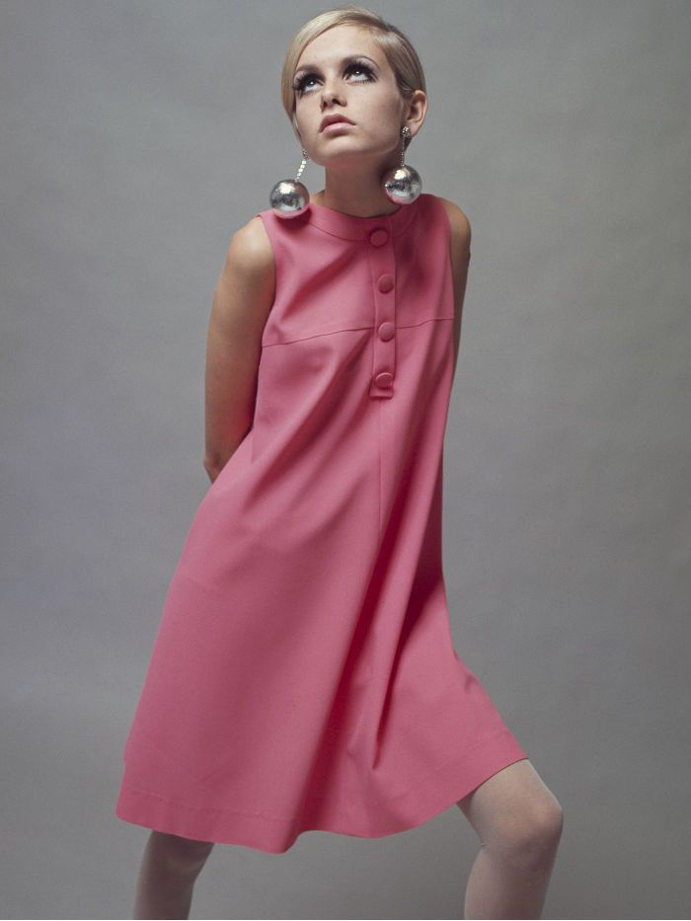
e.g. In the 1960s women used to wear colourful dresses.

floral bold beautiful boring stylish short colourful simple long casual comfy tight high-waistedelegant chic serious fun patterned bell-bottomed mini

In the 1960s, __________________________________________________________ __________________________________________________________________________________________________________________________________________
Group Work

Worksheet – Group 3

Look at the picture from the 1960s below. Discuss with your group and choose adjectives from the box to describe the picture. Then, write 1-2 sentences about the picture using the phrase “used to”.
e.g. In the 1960s women used to wear colourful dresses.
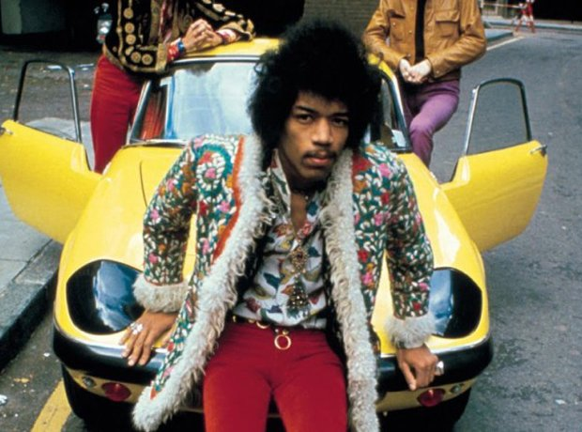

floral bold beautiful boring stylish short colourful simple long casual comfy tight high-waistedelegant chic serious fun patterned bell-bottomed mini

In the 1960s, __________________________________________________________ __________________________________________________________________________________________________________________________________________
Group Work

Worksheet – Group 4

Look at the picture from the 1960s below. Discuss with your group and choose adjectives from the box to describe the picture. Then, write 1-2 sentences about the picture using the phrase “used to”.
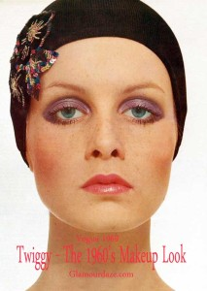
e.g. In the 1960s women used to wear colourful dresses.

floral bold beautiful boring stylish short colourful simple long casual comfy tight high-waistedelegant chic serious fun patterned bell-bottomed mini

In the 1960s, __________________________________________________________ __________________________________________________________________________________________________________________________________________
Group Work

Worksheet – Group 5

Look at the picture from the 1960s below. Discuss with your group and choose adjectives from the box to describe the picture. Then, write 1-2 sentences about the picture using the phrase “used to”.
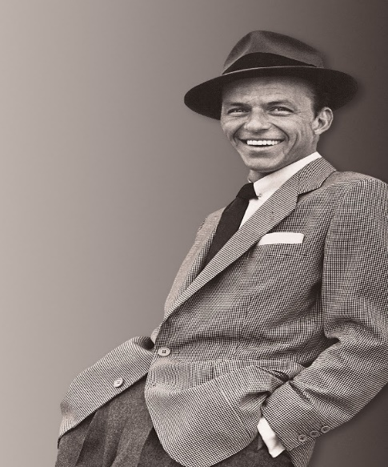
e.g. In the 1960s women used to wear colourful dresses.

floral bold beautiful boring stylish short colourful simple long casual comfy tight high-waistedelegant chic serious fun patterned bell-bottomed mini

In the 1960s, __________________________________________________________ __________________________________________________________________________________________________________________________________________
Group Work

Worksheet – Group 6

Look at the picture from the 1960s below. Discuss with your group and choose adjectives from the box to describe the picture. Then, write 1-2 sentences about the picture using the phrase “used to”.
e.g. In the 1960s women used to wear colourful dresses.
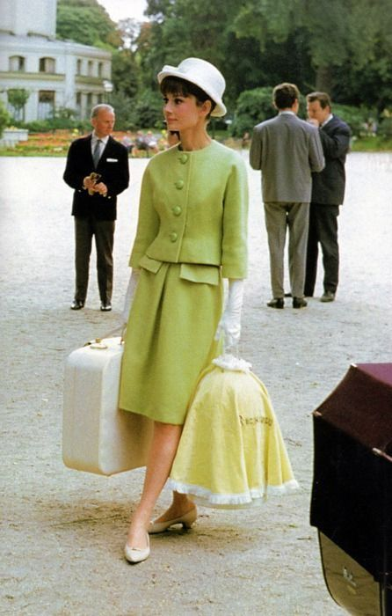

floral bold beautiful boring stylish short colourful simple long casual comfy tight high-waistedelegant chic serious fun patterned bell-bottomed mini

In the 1960s, __________________________________________________________ __________________________________________________________________________________________________________________________________________
Group Work

Worksheet – Group 7

Look at the picture from the 1960s below. Discuss with your group and choose adjectives from the box to describe the picture. Then, write 1-2 sentences about the picture using the phrase “used to”.
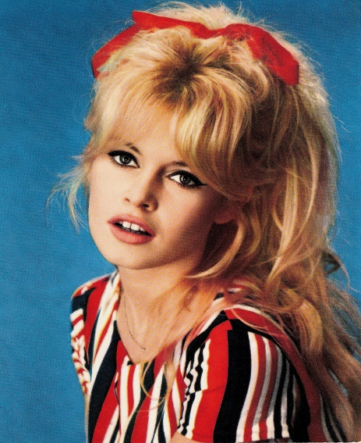
e.g. In the 1960s women used to wear colourful dresses.

floral bold beautiful boring stylish short colourful simple long casual comfy tight high-waistedelegant chic serious fun patterned bell-bottomed mini

In the 1960s, __________________________________________________________ __________________________________________________________________________________________________________________________________________
Group Work

