B_____________________________________________________________________________
b_____________________________________________________________________________
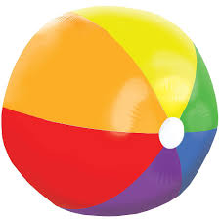
ball___________________________________________________________________________
(διαβάζεται ‘’μπολ’’)
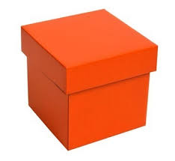

box___________________________________________________________________________
(διαβάζεται ‘’ μποξ’’)

