A___________________________________________________________________

a___________________________________________________________________

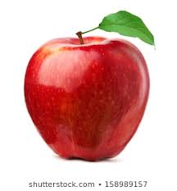apple_____________________________ __________________________________
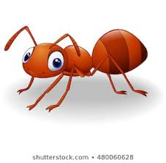ant__________________________________________________________________

