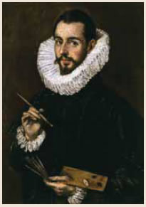

El Greco (Doménikos Theotokópoulos)

El Greco was born in Hania, Crete in 1541. At that time Crete was part of the Republic of Venice.

As a young man he studied Byzantine icon painting in Hania.
He moved to Venice in 1567 where he continued to study painting. In 1570 he went to Rome. He lived and worked in Rome until 1577.

In 1577 he moved to Spain in Toledo, near Madrid where he lived and worked until the end of his life. He died in 1614 at the age of 73.

El Greco had a very individual style. His paintings show both Byzantine and Italian styles. They also show strong Catholic religious elements from Spain.

He is one of the most famous painters of the 16th century. His paintings influenced many famous artists after him, for example Picasso and Cézanne.

In honour of El Greco, Nikos Kazantzakis called his autobiography "A Tribute to Greco".

