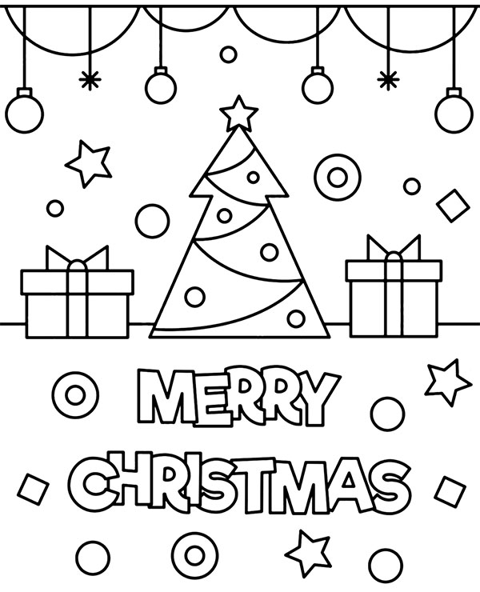



Children usually make their own Christmas cards using paper, glue, crayons and scissors. They write season’s greetings and send them to friends and family, wishing them Merry Christmas and a Happy New Year!!

