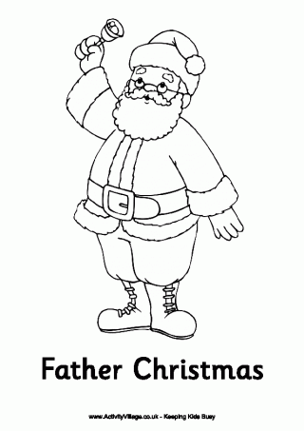
Father Christmas is a jolly, fat man in a red suit with a long, white beard. On Christmas Eve he visits all the houses in his magic sleigh and leaves presents for all the good boys and girls when they are fast asleep in their warm beds.
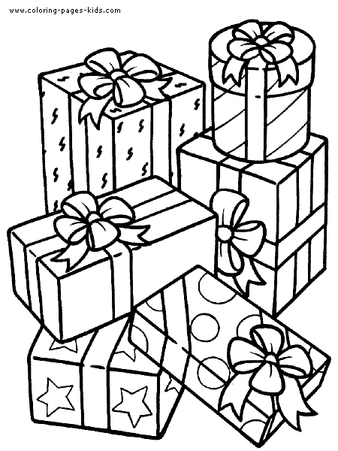
Boxing Day is the day after Christmas ,that is on December 26th.People drop in on friends to exchange small gifts. It the day when families get together, watch sports and play board games.

