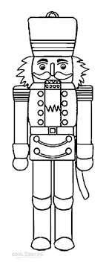
The Tin Soldier is a fairy tale written by Hans Christian Andersen about a tin soldier’s love for a paper ballerina.

