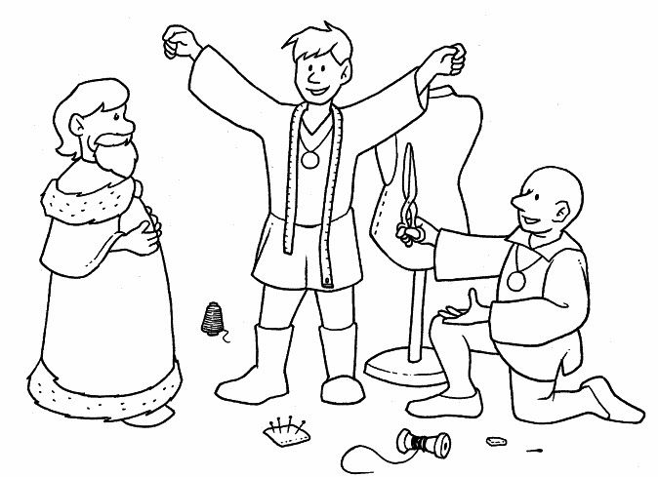

The Emperor’s new clothes is a fairy tale written by the Danish author H.C. Andersen. It is about a vain emperor who is fond of new clothes that he spent all his money on being well dressed. He cared nothing about the people in his Kingdom.

