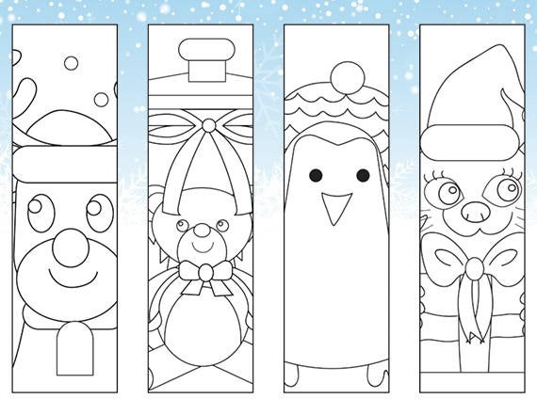

COLOUR AND CUT THE CHRISTMAS BOOKMARKS!!

