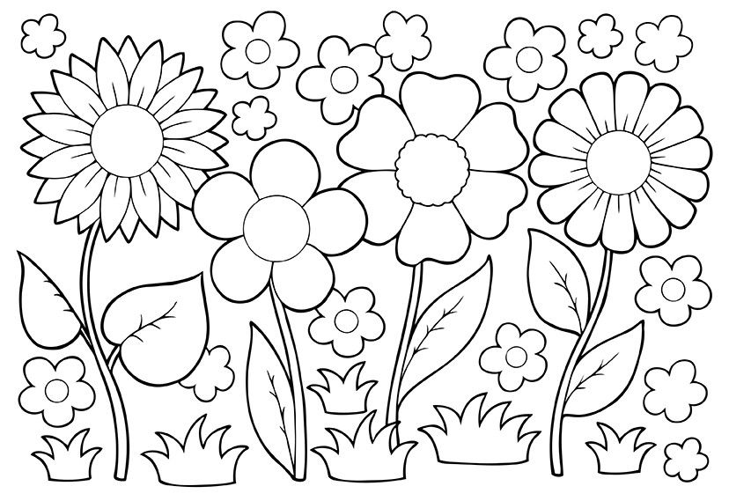

April showers bring May flowers!!!!!
Welcome May!!!

