Melina Merkouri
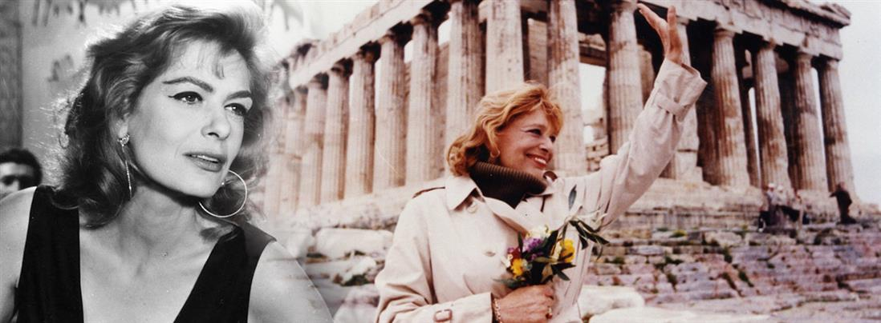
Melina Merkouri was born in Athens in 1920. She was a famous actress and politician all over the world. In 1938 Melina started studying at the Drama School of the National Theatre. During the 2nd World War Melina lived in her first husband’s luxurious house but she gave money and shelter to the communists who worked against the German Nazi. She also supported her friends whom Nazi took them in prison.
In 1944 Melina first appeared in the theatre and acted in «Το μονοπάτι της Λευτεριάς» and later in «Το Πένθος ταιριάζει στην Ηλέκτρα», «Το πορτραίτο του Ντόριαν Γκρέυ», «Δεν θα τα πάρεις μαζί σου», «Ο Βασιλικός». One of her most successful performances was in the play «Λεωφορείον ο Πόθος» for which Manos Hatzidakis composed the song «Χάρτινο το Φεγγαράκι». In 1951 Melina started acting in the theatre successfully in Paris. In 1955 Melina starred in the film ‘’Στέλλα’’, which took part in the film festival of Cannes and she won the First Prize. There she met Zil Dasen, who became her husband in 1966 until her death. Another successful film was ‘’Ποτέ την Κυριακή’’ (1960) with which she became famous all over the world. She was nominated for the Oscar Awards for this film. In 1967 Melina with Dasen and Manos Hatzidakis moved to Broadway, USA to play ‘’ Ίλια Darling’’. Other important films were ‘’Φαίδρα’’, ‘’Τοπ Καπί’’, ‘’Δοκιμή’’ and her last film «Κραυγή γυναικών». In 1980 Melina gave her last theatrical performance in «Ορέστεια» in the ancient theatre of Epidaurus.
During the dictatorship (1967 – 1974) Melina talked against the fascism and the dictators and she organised demonstrations and concerts in Paris and London. She also wrote the book ‘’Γενήθηκα Ελληνίδα’’ and the money was given to people who suffered from the dictatorship. The dictators took her Greek identity and her property and she answered «Γεννήθηκα Ελληνίδα και θα πεθάνω Ελληνίδα». The fascists organised her shooting and her death many times in the USA, Switzerland and Italy.
When the dictatorship ended in 1974, Melina moved back in Greece and from 1977 until her death she was a Member of the Parliament. She was also the Minister of Culture for ten years and she tried to take the stolen Marbles of the Parthenon back from the British Museum. When the British Government told her that there is no place for the Marbles in Athens she thought that a new museum should be built. That museum is the Museum of Acropolis which Melina did not see it as she died earlier, in New York in March 6th, 1994. Hundreds of thousands people attended her funeral. Many politicians of other countries expressed their sadness and the importance of Melina’s personality.
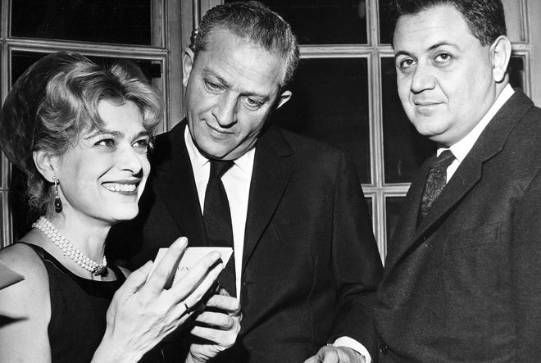
M. Merkouri – Z. Dasen – M. Hatzidakis
- Melina Merkouri was born in Athens in ………………….
- 1900 b. 1910 c.1920
- She was a famous actress and ……………….
- poet b. actress c. director
- Which song did Hatzidakis compose for Melina in the play «Λεωφορείον ο Πόθος»?
- Ο Βασιλικός b. Στέλλα c. Χάρτινο το φεγγαράκι

- Melina won the First Prize at the festival of Cannes for the film ……......................................
- Melina’s husband was ………………………….
- Melina was nominated for the Oscar Awards for the film …………………………………

TRUE OR FALSE
- In 1967 Melina with Dasen and Manos Hatzidakis moved to Broadway, USA to play ‘’ Ίλια Darling’’. _____
- The fascists organised her shooting and her death many times in the USA, Switzerland and Italy. _____
- As a Member of the Parliament Melina asked the stolen Marbles of the Parthenon from the British Government back in Athens. _____
- Melina died in Athens in 1994. _____

