Manos Hatzidakis
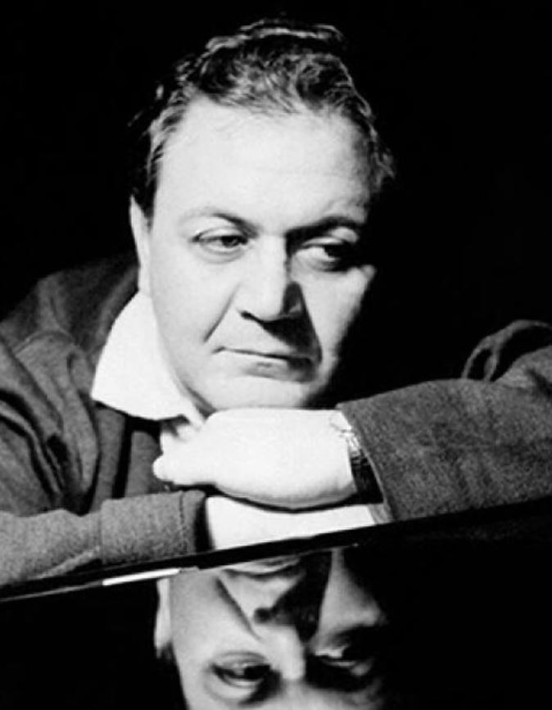
Manos Hatzidakis was born in Xanthi in 1925. When he was four years old, he started studying the violin and accordion. In 1938 Hatzidakis moved to Athens with his mother and his sister because his parents got divorced. In 1938 Hatzidakis’ father was killed in a plane accident and this caused economic problems to his family. This is why he worked at the harbor, a factory, a photo studio and a hospital. During the 2nd World War he met many artists and poets such as Gatsos, Seferis, Elytis, Sikelianos and Tsarouhis. Hatzidakis also met Mikis Theodorakis and they became real friends.
Hatzidakis first appeared as a composer at the age of nineteen when he cooperated with the Karolos Koun Theatre. In 1946 he composed music for the film ‘’Αδούλωτοι Σκλάβοι’’ in which Elli Lambeti starred. Hatzidakis studied the ρεμπέτικο songs, made a successful lecture and a concert about it. He also composed music for performances of ancient theatre, such as «Μήδεια» (1956), «Κύκλωπας» (1959), «Βάκχες» (1962), «Εκκλησιάζουσες» (1956), «Λυσιστράτη» (1957), «Όρνιθες» (1959). From 1965 and on he composed music for many popular films, such as ‘’Στέλλα΄΄, ‘’Λατέρνα, φτώχεια και φιλότιμο’’, «Μανταλένα», «Η Αλίκη στο ναυτικό», «Το κοροϊδάκι της δεσποινίδος», «Η κυρία δήμαρχος», «Το κλωτσοσκούφι», «Ραντεβού στην Κέρκυρα».
In 1961 Hatzidakis won the Oscar Award for the song «Τα Παιδιά του Πειραιά» which Melina Merkouri sang in the film «Ποτέ την Κυριακή». In 1966 Hatzidakis moved to New York (USA) with Melina Merkouri and Zil Dasen to prepare the play ‘’Ilia Darling’’. He stayed there six years and studied the American pop and rock music. In 1972 he came back in Athens and he composed the masterpiece ‘’Μεγάλος Ερωτικός’’. From 1975 to 1982 the Greek Government made him the executive of the Athens State Orchestra, the Third Radio Program and the State Opera. From 1978 to 1981 he organised the ‘’Μουσικές Γιορτές’’ in Anogia, Crete and the ‘’Μουσικό Αύγουστο’’ in Iraklion. These events included contests for music, cinema, dance, theatre and painting. In 1989 Hatzidakis founded the ‘’Ορχήστρα των Χρωμάτων΄΄ because he wanted to present the music of classic and modern composers. Hatzidakis died in Athens in June 15th, 1994.
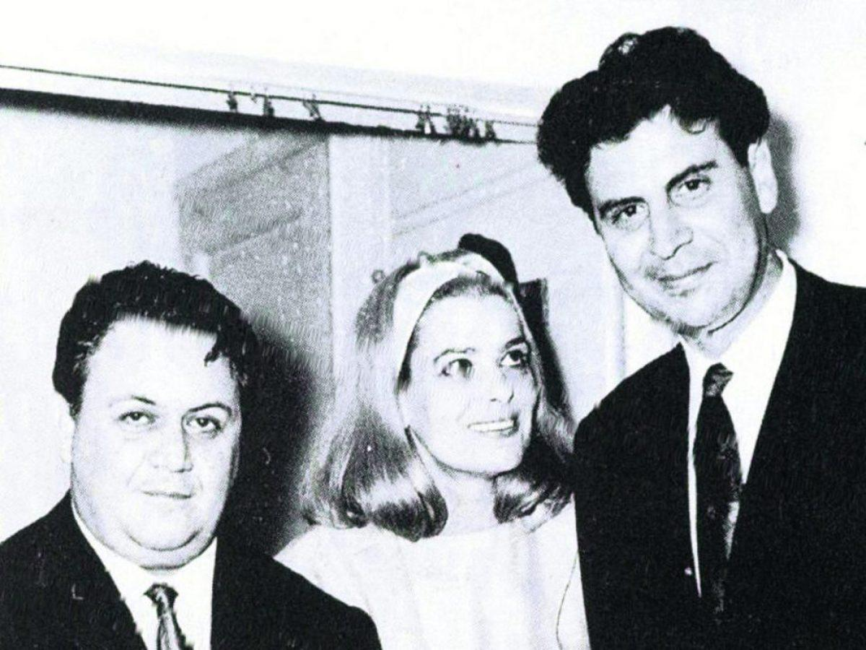
M. Hatzidakis – M. Merkouri – M. Theodorakis
TRUE OR FALSE
- Manos Hatzidakis was born in Athens in 1925. ____
- Hatzidakis worked at the harbor, a factory, a photo studio and a hospital. ____
- Mikis Theodorakis and Hatzidakis were real friends. ____

- In 1946 Hatzidakis composed music for the film
- Αδούλωτοι Σκλάβοι b. Μήδεια c. Βάκχες
- Hatzidakis composed music for the play of ancient theatre
- Μανταλένα b. Το κλωτσοσκούφι c. Λυσιστράτη
- Hatzidakis composed music for the film
- Κύκλωπας b. Στέλλα c. Όρνιθες

- In 1961 Hatzidakis won the Oscar Award for the song …………………………………….
- Hatzidakis, Merkouri and Dasen created the play ……………………………...........
- Hatzidakis organised the ‘’Μουσικές Γιορτές’’ in Anogia, Crete and …………………………………………………………………
- Hatzidakis died in Athens in ……………….

