George Seferis
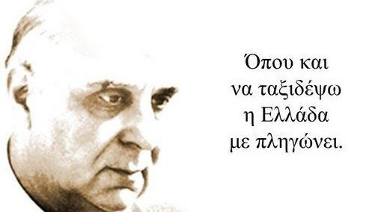
George Seferis was born in Smyrna in 1900. His real surname was Seferiadis. He was a poet and a diplomat. In 1914 his family moves to Athens. In 1918 his father who was a lawyer started working in Paris and the family moved there. Seferis studied Law, became a lawyer and liked studying literature, especially French writers, translating and writing his own poems. In 1925 he comes back in Athens and worked as a diplomat. In 1928 he publishes «Μια βραδιά με τον Κύριο Τεστ» and till 1937 he also publishes ‘’Στροφή’’, ‘’Μια νύχτα στην ακρογιαλιά’’, ‘’Στέρνα’’.
In 1941 Seferis gets married to Maria Zannou and they move to Alexandria in Egypt, Johannesburg, Cairo and Jerusalem to work as an ambassador of the Greek Government. In 1944 he comes back in Athens. In 1947 he is awarded the Palamas Prize and he moves to Turkey and London because of his work. Ten years later he becomes the Greek ambassador in London and he tries to support the union of Cyprus with Greece. The British diplomats do not like this idea. In 1960 Seferis meets Mikis Theodorakis, who composes music for Seferis’ four poems titled ‘’Επιφάνεια’’.
In 1963 the Swedish Royal Academy awarded Seferis the Nobel Prize of Literature. At that time he was the first Greek poet who took this prize. Only two Greek poets were awarded the Nobel Prize of Literature, Seferis (1963) and Elytis (1979). The years that followed the universities of Thessaloniki, Oxford, Princeton and Illinois (USA) named him professor. During the dictatorship he talked against fascism and the dictators in Russia, England, France and Germany. The dictators take Seferis’ diplomatic passport and he cannot use it. In 1970 he publishes ‘’Δεκαοχτώ Κείμενα’’. In 1971 Seferis dies and his funeral becomes a silent demonstration against the dictators. Seferis is one the most important and classic Greek poets of the 20th century.
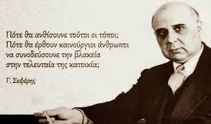
- George Seferis was born in Smyrna in ………….
- 1900 b. 1910 c. 1901
- His real surname was …………
- Seferopoulos b. Seferiadis c. Seferis
- Seferis studied ………
- Music b. Poetry c. Law

TRUE OR FALSE
- In 1928 Seferis publishes «Μια βραδιά με τον Κύριο Τεστ» and till 1937 he also publishes ‘’Στροφή’’, ‘’Μια νύχτα στην ακρογιαλιά’’, ‘’Στέρνα’’. _____
- Seferis lived only in Greece. ____
- In 1946 Seferis is awarded the Palamas Prize. ____

- In 1960 Seferis meets Mikis Theodorakis, who composes music for Seferis’ four poems titled …………….............
- In 1963 the Swedish Royal Academy awarded Seferis the ……………………………………………..
- During the dictatorship Seferis talked against fascism and …………………………………………….

