Mikis Theodorakis
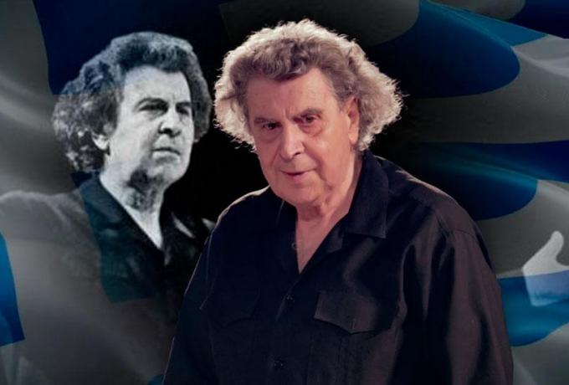
Mikis Theodorakis was born in Chios in 1925. During his childhood he lived in Mitilene, Yiannena, Ileia, Patra and Tripoli because his father was a civil servant. At the age of twelve he composed his first song and at the age of seventeen he presented ‘’Κασσιανή’’ at his first concert. At that time he was arrested and tortured by Italians dictators as a member of the party ΚΚΕ. In 1947, twenty-two years old, Theodorakis was exiled to Ikaria, where he was tortured and left Ikaria handicapped two years later. In 1954 he moves to Paris to study classical music and compose music. In 1960 Theodorakis comes back in Athens and he composes music for the Yiannis Ritsos’ poem ‘’Επιτάφιος’’. In this way he tried to combine Greek folk music with Greek poetry. This is important because Greeks had the chance to sing wonderful, poetic lyrics. At the same time he composes music for George Seferis’ poem ‘’Επιφάνεια’’. In 1964 he publishes Odysseas Elytis’ ‘’Άξιον Εστί’’. All these songs become very popular. That year Theodorakis becomes famous all over the world as he writes the music for the film ‘’Αλέξης Ζορμπάς΄΄ and he is also elected as a member of the Greek Parliament.
During the dictatorship in Greece (1967-1974) Theodorakis fights against dictators, is sent to prison and composes music, which he sends to Melina Merkouri and Maria Farantouri abroad. In France many famous writers, actors, musicians and politicians demonstrate and ask the dictators to free Theodorakis. Finally, in 1970 the dictators allow Theodorakis to move to Paris and live there. The first people who meet in Paris is Melina Merkouri, her husband, Zil Dasen and the director, Kostas Gavras. He organises demonstrations and makes speeches against dictatorship and fascism. He also travelled in London, Chile and Israel to talk against dictators. For million people is the symbol of Greek Democracy along with Melina Merkouri. When the dictatorship ends he moves back in Greece and he organises many concerts. In 1981, 1989 he is elected a member of the Greek Parliament In 1986 takes part in concerts in Turkey in order to support peace between Greece and Turkey. During the 1990’s he presents the operas Μήδεια (1991), Ηλέκτρα (1995) και Αντιγόνη (1999) and in 2002 ‘’Λυσιστράτη’’, which is an hymn to liberty.
From 2002 Theodorakis retires and writes books about politics, culture and music. He is also awarded many prizes in Greece, Russia, Luxemburg, Germany. At the age of ninety-six he dies in Athens on September 2nd, 2021. The Greek Government declares three days of national mourning for the most important composer.
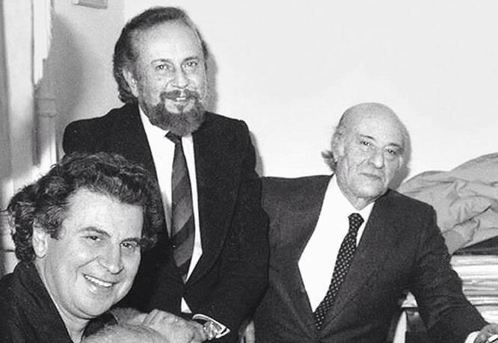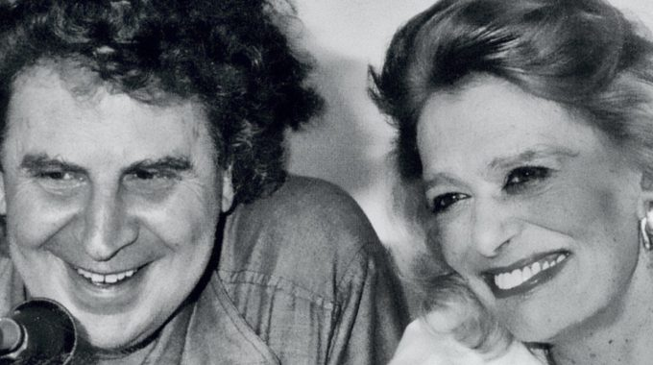
M.Theodorakis – Y.Ritsos – O.Elytis M.Theodorakis – M.Merkouri
- Theodorakis was born in Chios in …………..
- At the age of …………………. he composed his first song.
- When he was twenty-two years old, Theodorakis was exiled to ………………….

TRUE OR FALSE
- In 1960 Theodorakis composes music for the Ritsos’ poem ‘’Άξιον Εστί’’. ______
- In 1960 Theodorakis composes music for George Seferis’ poem ‘’Επιφάνεια’’. _____
- In 1964 Theodorakis publishes Odysseas Elytis’ ‘’Επιτάφιος’’. ___

- The dictators governed Greece from
- 1967-1974 b. 1970-1974 c. 1960-1974
- At first the dictators
- love Theodorakis b. sent him in prison c. allow him to move to Paris
- Who sang his songs?
- Kostas Gavras b. Zil Dasen c. Melina Merkouri
- Μήδεια, Ηλέκτρα and Αντιγόνη are
- songs b. operas c. plays

