https://captaindamley.net/e-modules/general-ship-knowledge/principal-parts-of-ship/

Principal Parts of Ship
As we move to identify different parts of a ship, first realize that this is new vocabulary. You MUST know these words and understand what they mean. Without these word you will be totally LOST on a ship. Along with diagrams, words have been explained.
Let us start with various decks.
Decks of a Ship
A ship has a number of different types of decks which are located at different levels and places on the ship. Every seafarer working on a ship should be aware of these decks. Especially Passenger ships, Cattle carriers, RO-RO ships, Car carriers etc have multiple decks. However, they may be identified as A,B,C…… decks.
As names of these decks are adopted from Sailing ships and/or naval ships, sometimes application is little confusing.
1. Poop Deck: The poop deck is located on the vessel’s stern.The poop deck is one deck above main deck and part(Roof) of accommodation.
2. Main Deck: As the name suggests, the main deck is the primary deck in any vessel. The main deck however is not the topmost deck in a vessel which is referred to as the weather deck. On most of Merchant ships Main deck and Weather deck is same.
3. Upper Deck: The deck that covers the hull of the vessel from its fore to its aft is the upper deck. It is the topmost deck on a ship. In all vessels, the upper deck is the biggest deck amongst all other decks. Again on most of Merchant ships it is same as Main deck.
4. Lower Deck: The deck located below the main deck is the lower deck. Generally the lower deck comprises of more than one deck.
5. Promenade Deck: Promenade refers to taking a lazy stroll in a feasible place like a beach or a park. In a vessel, the promenade deck serves as a place for the voyagers to take a calming and enjoyable walk on the ship, while enjoying the beauty of the oceanic vista. It is generally the area around the superstructure. It can have open railings or can be enclosed in a glass. This is found on Passenger ships.
6. Tween Deck: ‘’Tween’ means ‘between’. In a ship, the tween deck is between bottom and Main deck. It is used for loading cargo on General cargo ships and Reefer ships.
7. Weather Deck: A deck that is not roofed and thus is open to the ever-changing weather conditions of the sea is referred to as the weather deck. It is the upper most deck on the ship which is exposed to environment.
8. Bridge Deck: Bridge deck is the deck on which the navigational equipments of the ships are housed.
9. Quarter Deck: The deck located near stern of a vessel is referred to as the quarter deck. The quarter deck is a part of the upper deck. Term comes from Sailing and Naval ships as this part housed senior most officers and was control station of the ship.
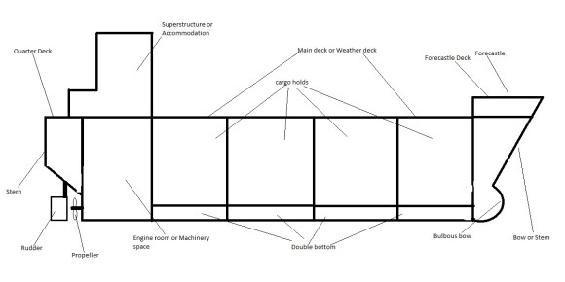
Bow or Stem: Forward part of a ship, shaped for aero dynamics, hydrodynamics and operational reasons.
Forecastle: Raised area on bow to house store and small operational equipment.
Forecastle deck: Rooftop deck of Forecastle
Bulbous bow: Spherical part of underwater bow, helps in reducing resistance of water.
Double Bottom: All ships have it, houses strength members of ship and gives clean deck for loading.
Cargo holds: Place where cargo is loaded.
Superstructure or accommodation: Place for ship’s staff and offices
Engine room or Machinery space: Place where propelling and associated machinery is located.
Propeller: A fan like structure designed to move ship when rotated.
Rudder: A vertical plate placed behind the propeller that guides ship when moving by diverting water.
Stern: Rear or Aft end of a ship.
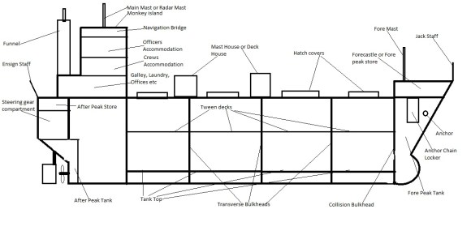
Anchor: Hook like device used to hold ships position in shallow water.
Anchor chain locker: Place used to store anchor chain.
Fore Peak Tank: Ballast tank at the forward end of the ship forward of Collision bulkhead.
Collision bulkhead: Foremost transverse bulk head. Strong bulkhead to protect ship in case of collision.
Forecastle or Fore peak store: An enclosed area on main deck below forecastle deck used as store.
Fore mast: A vertical pole used for placing Navigation lights, Whistle or Horn and antennas (Aerials).
Jack staff: Small pole used for hoisting Jack flag.
Hatch covers: Weather proof lids covering holds, placed on hatches.
Hatch: Opening on deck for accessing under deck areas.
Transverse bulkheads: Wall like watertight structure placed from keel to main deck and sides connecting ship side. They create watertight compartments for cargoes and give transverse strength to ship.
Tank top: Smooth deck on top of double bottom tanks for loading cargo.
Mast house or Deck house: Small weather tight rooms on deck used as stores or equipment rooms. Earlier they were part of mast structure, hence known as Mast house.
After Peak Tank: Aftermost ballast tank, normally propeller shaft goes through it. May be used for storing Fresh water.
After Peak Store: Store placed at the end of the ship below main deck or Quarter deck. Normally used for storing mooring ropes.
Steering Gear Compartment: Also known as Steering Flat. Steering gear equipment to operate Rudder is located here. It is on top of Rudder.
Ensign Staff: Small pole at the rear most end of the ship for displaying “Ensign flag”.
Funnel: All exhaust pipes from engine room go through it for releasing exhaust gases to atmosphere. Also company logo is displayed here.
Main mast or Radar Mast: A Pole structure on top of Navigation bridge used for displaying flags, locating whistle or horn, Radar scanners, Navigation lights and various Antennas.
Navigation bridge: This is command center at sea. Navigation is done from here.
Officer’s accommodation: Officer’s residential quarters.
Crew’s accommodation: Crew’s residential quarters.
Galley: Area for cooking food.
Laundry room: Place for washing clothes.
Provision stores: Place to store provisions.
Cold stores: Place to store frozen / chilled food stuff.
Bonded locker/store: Place to store “duty free” goods like alcohol, beer, chocolates etc.
Misc stores: Place to store various small stores.
Mess rooms: Place to eat food
Recreation room: Place for recreational activities.
Gymnasium: Place to do physical exercises.
Pantry: Place where food is handled before serving. FOOD IS NOT COOKED HERE.
Ballast tanks: Tanks that are used to fill seawater for purpose of adding weight to the ship for sinkage.
Fresh Water tanks: Tanks that store Fresh water.
Fuel oil tanks: Tanks that store fuel oil.
Lub oil tanks: Tanks that store lubricating oils.
Diesel oil tanks: Tanks that store diesel oil.
Waste oil / slop tanks: Tanks used for storing Dirty oil for disposal in ports.
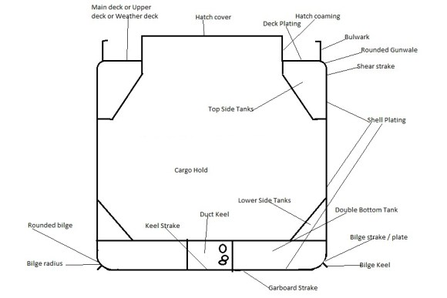
Deck plating: Plating covering the deck.
Hatch coaming: Vertical plating making hatch.
Bulwark: Railing or half height plate partition around ship side for protection of crew.
Rounded gunwale: where deck plates join shell plates. This may be without rounded part.
Shear strake: Topmost strake of shell plating.
Shell plating: Plating covering ships frames on shell (ship side and keel).
Bilge Keel: A longitudinal plate running fore and aft fixed on rounded bilge strake to reduce rolling.
Garboard strake: Strake adjoining KEEL strake.
Duct keel: Duct running fore and aft made over keel strake. Used for placing pipelines, remote valves and cables.
Top side tanks: Tanks placed below deck plating along ship side.
Lower side tanks: Tanks placed above double bottom tanks along ship side.
Keel strake: Centre strake of ship.
Bilge strake: Strake joining Side shell plating with Bottom shell plating.
Rounded bilge: Bilge strake is rounded plate for smooth underwater surface. Radius of rounding is known as “radius of bilge”.
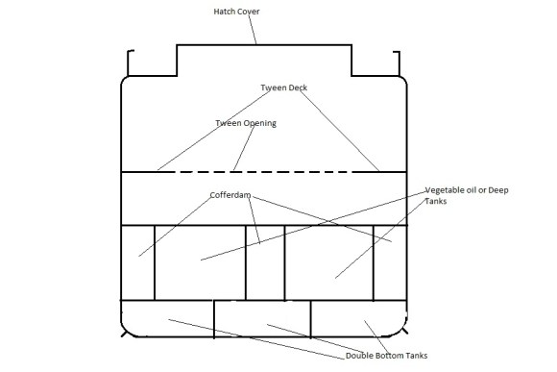
Tween deck opening: Opening in Tween deck for accessing lower hold.
Vegetable oil tanks or Deep Tanks: Tanks for purpose of loading non-inflammable liquid cargoes.
Cofferdams: Areas INTENTIONALLY left vacant for purpose of inspections.
Void spaces: Unusable areas of a ship resulting due to designing.
Double bottom Tanks: Tanks normally used for ballasting to give stability to ship.
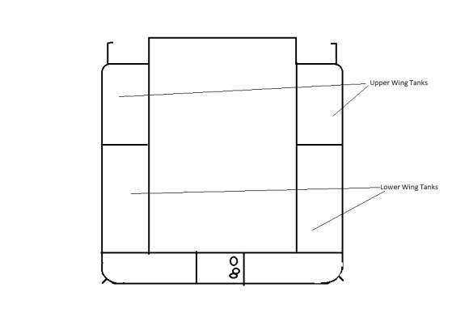
Upper wing tanks: Internal tanks along upper ship side used for ballast or Fresh water.
Lower wing tanks: Internal tanks along lower ship side (Above double bottom tanks) used for ballast or Fresh water.
Cargo Gear
Cargo gears depend on ship’s requirements. Earlier days, when ports were not developed ships had cargo gear to handle cargoes. Traditionally they were DERRICK (BOOM) system with few variations. Preparing gear was complex part and needed lot of man power. Over long period Derrick system lost to “CRANE” system. Today we rarely see Derrick system but Cranes have become very common. Cranes do have variations in designs and capacities. Smaller and Medium size bulk carriers have crane systems to handle cargoes in smaller ports. Container feeders may have Cranes to handle containers in smaller ports.
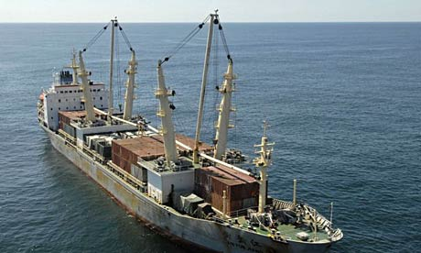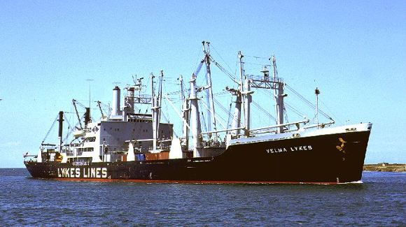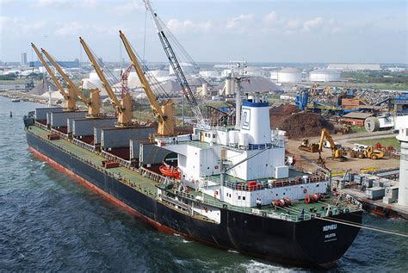Derrick system:: Along with booms they have MAST system for support. Masts may be of different types like “T” or “Goal post” or Stullken (Sort of angular). Masts may be supported by STEEL WIRE STAYS (A method to tie down top of mast with deck).
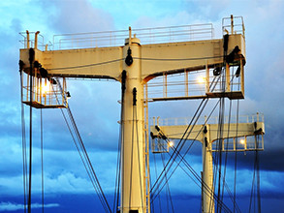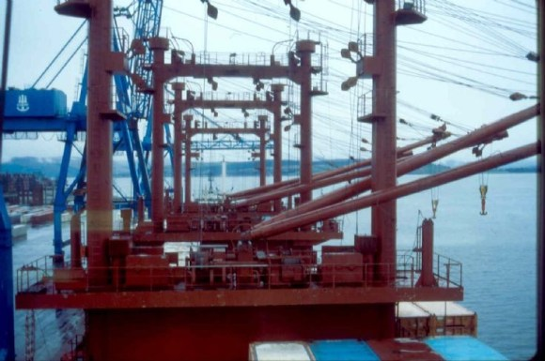Crane system: Cranes became popular as they do not need manpower for rigging. They are simple to operate and can work around 3600. Cranes can handle cargoes efficiently and do not need support from masts.
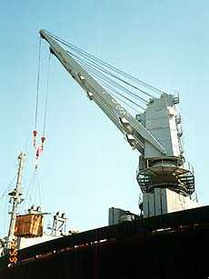I am not covering specialized cargo gear using self-loading or self-discharging systems.
Anchoring and Mooring Equipment
It consists of
Windlass: It is designed to handle anchors. Most of the time it also has attachment for handling mooring ropes. Handling means Pulling (Heaving) or Slacking anchor chain or mooring ropes. Clutch links/delinks various drums. Always placed on Forecastle deck where Anchors are.
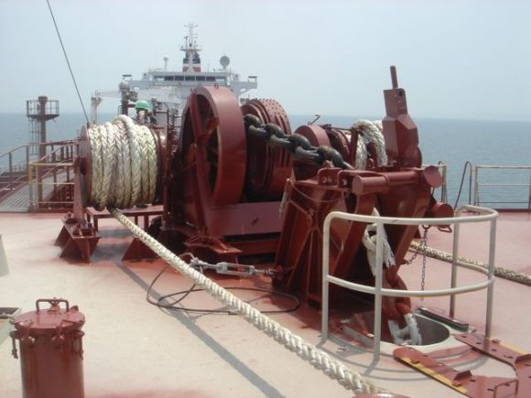Mooring Winches: They are specifically designed to handle mooring ropes. They consist of Rope/Wire rope drum as well as Warping drum. They are placed on Forecastle deck and Quarter decks.
Fairleads: These are sort of rollers for guiding ropes. They avoid chafing of ropes.
Panama leads or chocks: These are sort of strengthened holes and ropes/wire ropes are passed through them.
Pedestal fairlead: These are raised fairleads to guide rope to warping drum. Also known as “Old man” or “Dead man”.
Bollards or Bitts: A pair of cylindrical steel pieces where mooring ropes and wires are made fast (Tied).
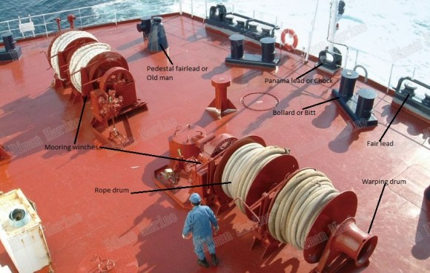
Great Lake leads: This is arrangement of horizontal and vertical rollers. Wore ropes are passed through them.
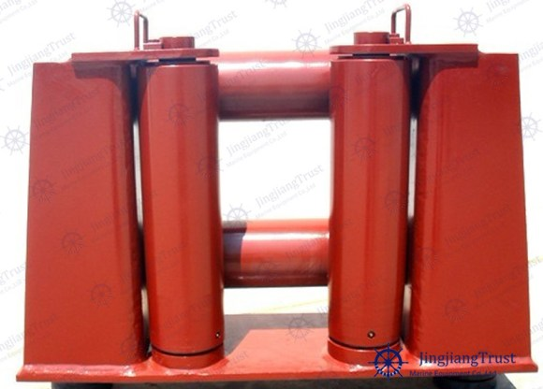

Capstan: It is a winch on vertical axis. Rarely seen today.
