Windlass and Capstans

Windlass : A winch, especially one on a ship, the windlass is an apparatus for moving heavy weights. Typically, a windlass consists of a horizontal cylinder (barrel) supported between cheeks at each end, it is rotated by the turn of a handspike inserted into the barrel (later designs are rotated by a crank). On a ship it is usually octagonal in shape to stop slippage, it also usually consists of a pinion and gear system to gain advantage with heavier loads. Due to restricted space on a ship, and as one man could only rotate the drum by a quarter of a turn per pull, the use was discontinued for large ships with heavy loads to shift.
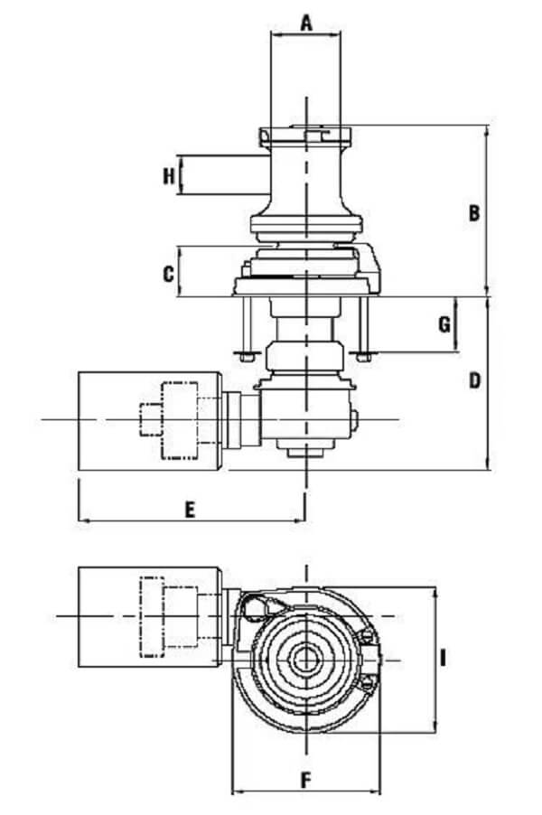

Capstan : A capstan is a broad revolving cylinder with a vertical axis used for winding a rope or cable. Originally this was also operated by turning by a handspike, so effectively a capstan could just about be described as a vertical version of a windlass which took up much less space on an already crowded deck. Later versions allowed for 2 capstans on the same spindle (axis) which could be operated separately. The shape and size of the capstan was proportional to the size of the spindle which by the mid 18th Century had become the size of the mainmast. This is a common trap for model makers, particularly those building from scratch.
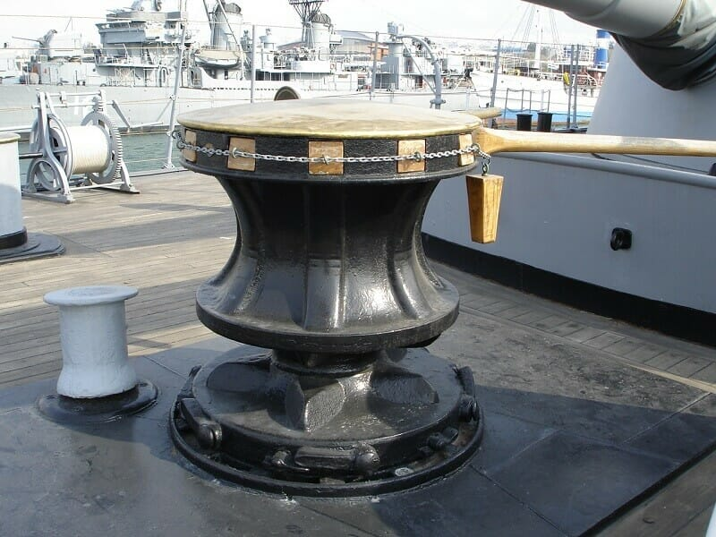
The main difference between a capstan and a windlass is that a capstan manages only rope, while a windlass manages chain and in some cases both chain and rope. Many windlasses also come with a capstan on top or on the side to manage a secondary anchor with an all-rope rode.

