Unit 6 - Leaders. Born or Made?
- What makes a good leader? Write down any qualities of good leaders that you can think of.
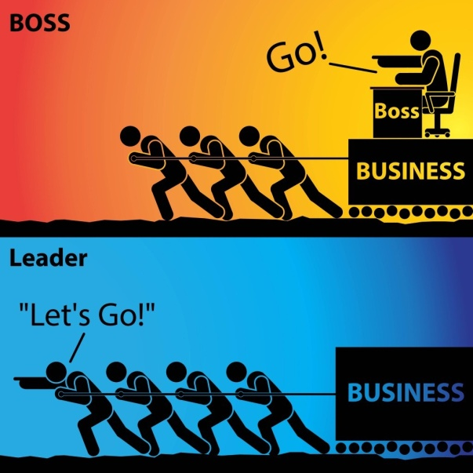

- You are going to watch a video about how to become a good leader.
  - Make notes as you watch. What are the nine tactics suggested?
  - Compare the traits of good leaders mentioned in the video with your answers in ex. 1 above.
https://youtu.be/R2qu_j6GAG8
- In groups think of examples of great leaders from the past or the present. Choose one you think is/was particularly gifted and say why.

- Read the following descriptions. Can you guess the leaders’ names?
- A communist revolutionary and founder of the People’s Republic of China, who made it a world superpower.
- Founding father and first president of the United States of America.
- A Nobel Peace Prize winner, activist and revolutionary of the civil rights movement of Afro – Americans.
- South African anti-apartheid revolutionary, political leader and first democratically elected black President of South Africa.
- Indian leader, famous for his non-violent resistance against the British rule in India.
If not here’s a list of names to match
- Nelson Mandela
- Mahatma Gandhi
- Martin Luther King
- Mao Zedong
- George Washington

Vocabulary practice
- Complete the table below.
Verb | Noun | Adjective
 | leader
 | movement
secure
 |  | legislative
 | discrimination
 | recognition
 | (in)equality
 | opposition
 |  | revolutionary
elect
 | abuse
 | reconciliation
commit

- Complete the following sentences with suitable words from the above table in the correct form.
- The professor is a ______________ expert in his field.
- He made a ________________ to stay at the job for another year.
- The national ______________ will take place on June 10th.
- He ______________ his wife for many years before she went to the police.
- The government has promised to introduce _______________ to limit fuel emissions from cars.
- It took hours of negotiations to bring about a ________________ between the two sides.

- Choose 10 words you learned from the text and write example sentences with them.

