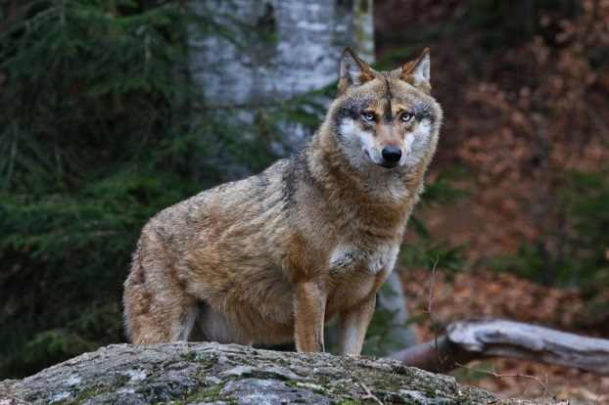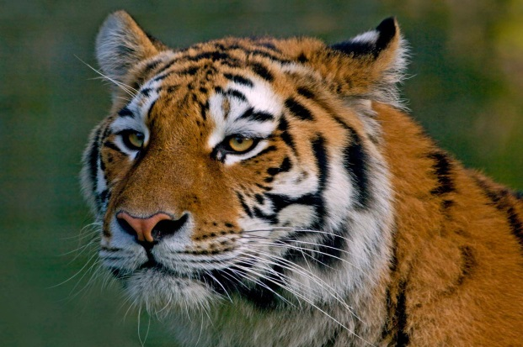
Endangered animals face numerous threats and it's crucial that we take immediate action to protect them. One of the major factors contributing to their decline is pollution. Pollution not only harms their habitats but also affects their health. To address this, we must promote eco-friendly practices such as reducing waste, recycling, and using sustainable energy sources. By minimizing pollution, we can create a safer environment for these vulnerable creatures.
Another pressing issue is the hunting of wild animals. It's essential to raise awareness about the importance of preserving biodiversity and the negative impacts of hunting. Stricter laws and regulations should be implemented to prevent illegal hunting and trade of endangered species. Education and community involvement are keys to changing attitudes towards wildlife and promoting conservation.
In addition to these measures, we can contribute with our own plans to protect endangered animals. Supporting conservation organizations financially or through volunteer work can make a significant impact. Creating wildlife sanctuaries and protected areas can provide safe havens for endangered species. Promoting sustainable practices such as responsible fishing and farming can help preserve their habitats.
In conclusion, safeguarding endangered animals requires collective efforts. By addressing pollution, combating hunting, and implementing our own ideas we can make a positive difference in protecting these magnificent creatures and ensuring their survival for future generations.

