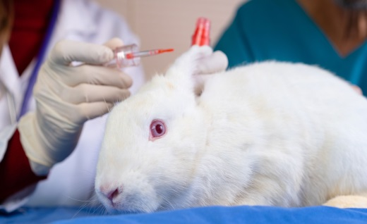
Animal testing in the cosmetics industry has long been a subject of debate. In my opinion, it's high time we put an end to this practice. Animal testing involves subjecting innocent creatures to painful experiments, causing unnecessary harm and suffering.
For instance, rabbits, mice, and other animals are often used to test the safety of cosmetics. They are subjected to skin irritation tests, eye irritation tests, and even lethal dose tests. These tests can cause immense pain and suffering to the animals involved.
Moreover, animal testing is not always reliable or accurate in predicting human reactions. Animals have different biological systems and the results may not necessarily reflect the effects on humans. Many alternative testing methods such as in vitro testing and computer models have proven to be more effective and reliable.
Therefore, banning animal-tested cosmetics would not only spare countless animals from unnecessary suffering but also encourage the development and use of alternative testing methods. Many countries and organizations have already taken steps towards this implementing bans or restrictions on animal testing in the cosmetics industry.
In conclusion, the use of animal-tested cosmetics should be banned. It is a cruel and outdated practice that can be replaced with more humane and reliable alternatives. Let's prioritize the well-being of animals and work towards a future where no innocent creatures are harmed in the name of beauty. 