My Vincent Van Gogh
Vincent Van Gogh is known was one of the most famous and influential artists in the history of art. Vincent was an unstable and volatile man, well known as the ‘‘tortured artist’’. His personality, combined with painting all day and the fact that no one could understand him and appreciate his talent undermined his health.
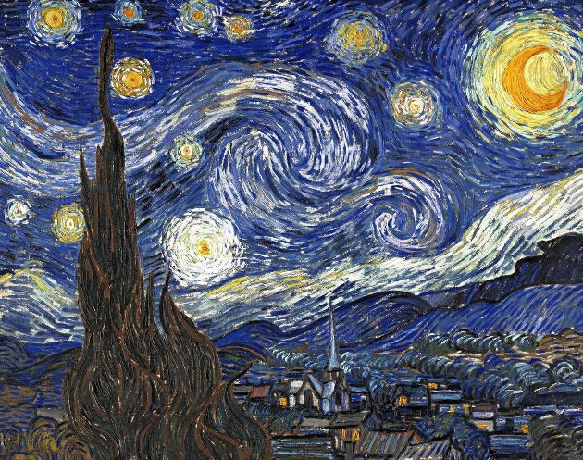
He was born in Zundert, Holland. At the age of 16 he started to work for an art dealer in The Hague. In 1880 he followed his brother Theo’s suggestion and took up painting. In 1886 they moved together in Paris, where Vincent met some famous artists. There he discovered impressionism. However, he is known as a post-impressionist, because he expressed emotions through his art. He also went in Arles with Gauguin, where he wanted to found a school of art. After lots of arguments their friendship ended up with a violent incident, leaving Van Gogh with an injured ear. After that he was sent to an asylum in Saint-Remy, suffering with depression, but painted there 150 paintings. In 1888 he committed suicide and died two days later with his brother at his side. He sold only one painting during his lifetime. However, today several of his paintings rank among the most expensive paintings in the world.
To me Vincent Van Gogh is more than a talented artist. He is an influential and aspiring person. Every single of his paintings has a story to tell and will always cause you a melancholic and aspiring feeling. A fact that distinguishes him from other artists is that he transfers his feelings through his art, as he tries to express his mental state. Moreover, he tries to show us that happiness can be found everywhere, even though he couldn’t find it himself. Unfortunately, he didn’t enjoy his life because of his mental state, along with the fact that his paintings didn’t get the recognition they deserved. However, he will always remain in our memory, as one of the most talented artists not only for his talent, but also for his personality.

