The Langlois Bridge
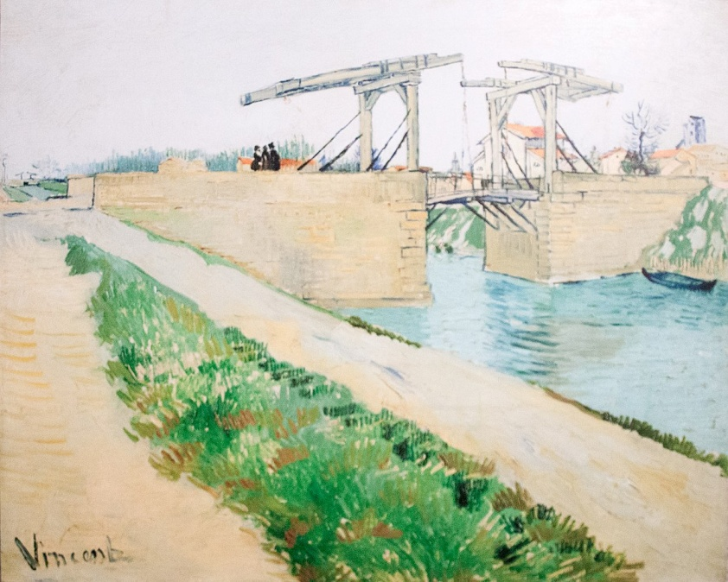

oil on canvas
59.6 cm x 73.6 cm

The sky was grey when Van Gogh painted this bridge. He worked in the open air more than once in this spot in the southern French city of Arles. Laundry was done in this canal, and linens have been laid out to bleach on the far bank. All that is missing are the washerwomen – who were included in an earlier version.
Van Gogh carefully organized his composition. He chose a place for his easel where he could paint the patch of land with the road in the foreground as a large diagonal leading into the left background. He had seen diagonals of this kind used in Japanese prints. Vincent and his brother Theo had accumulated a joint collection of these prints in Paris.

Bank of the Seine
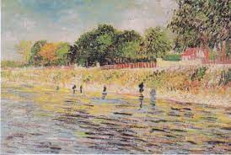

oil on canvas
32.0 cm x 46.0 cm

Van Gogh preferred the countryside to the city, so he liked to paint outdoors in the summer on the banks of the Seine, just outside Paris. He painted small studies that were easy to carry, like this one.
In this small painting, Van Gogh experimented with the stippling technique of the Pointillists, but he did so in his own way. He used long dashes for the water, small dots for the trees and plants, and larger brushstrokes for the sky. With this technique, he beautifully captured the reflection of the riverbanks in the water.

