Vincent Van Gogh
Title: View of Paris
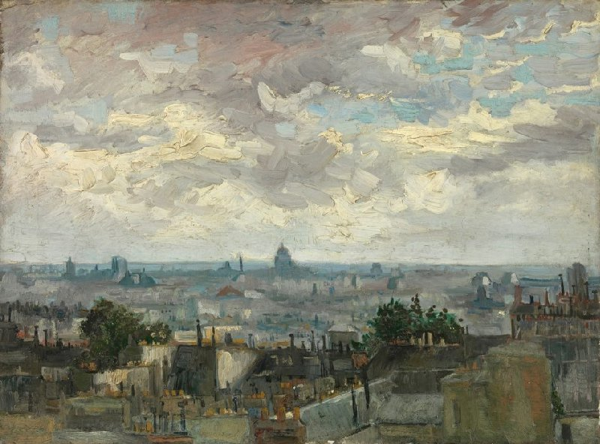
Type of painting: Oil on canvas
Height: 53.9cm Width: 72.8cm
Year it was painted: June - July 1886
Viewing notes: From the hill of Montmartre, Van Gogh painted the southerly view of Paris. He created depth in the composition by making the roofs and chimneys in the foreground seem close by. Further away, the outlines of monumental buildings are visible in the city centre. Panthéon, Louvre, Notre Dame; all of them have been identified. Van Gogh made the buildings fairly large and detailed in proportion to the rest of the landscape. He probably used a telescope. There are still telescopic viewers on the hill so that tourists can take in the view.
How does it make you feel?
The painting and the colours that have been used makes me feel relaxed, calm, nostalgic, melancholic and a sense of peace and tranquility.

Title: Garden with Courting Couples:
Square Saint-Pierre
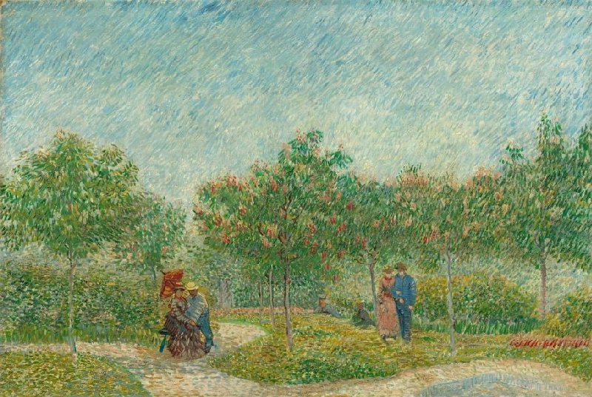
Type of painting: Oil on canvas
Height: 75cm Width: 113cm
Year it was painted: May 1887
Viewing notes: Van Gogh called this sunny park scene 'the painting of the garden with lovers'. Couples in love are strolling under the young chestnut trees and sitting along the winding paths. He used a free variation on the technique of the Pointillists. They built up their compositions from dots of paint. Van Gogh instead applied small brushstrokes of varying length in different directions. This helped him to create the effect of a radiant spring day, which fit the sense of intimacy and togetherness he wished to express. He too longed for a wife and a family, but he had 'the most impossible love affairs'. He eventually resigned himself to the situation; he was devoted to his art.
How does it make you feel?
The painting and the bright colours that have been used makes me feel happy, relaxed, calm and a sense of peace and tranquility.

Τάτση Άννα-Μαρία Α4

